Workpackage 6.2 & 6.3 Database 2: Training Resource Recommendations
Table of Contents
Summary 2
Background 3
Training Resources for Priority Tools 3
Priority Tools 3
Preferred Learning Approaches 4
Note on the Australian Training Landscape 5
Note Regarding AI Tools 6
Training Resources by Tool 7
Electronic Health Records (EHR) Analytics and Data Linkage 7
R Programming 11
Causal Analysis 14
Regression 17
SQL and Database Management 20
Clinical Trial Design and Analysis 22
GitHub 24
Clustering and Pattern Recognition 26
NLP Models 28
Community Engagement Methods 30
Model Interpretability and Explainability 31
Overall Recommendations 34
Training Development Priorities 34
Tools Not Recommended as Development Priorities 35
Learning Preferences and Implications for Training Design 35
Appendices 36
1. Search Protocol Selection / Rejection Protocol 36
2. Summary Plots by Tool 38
3. Training Resources by Tool 56

Summary
This report presents a review of online training resources for 11 priority analytics tools identified through a survey of Australian health researchers (Work Package 6.1 of the ARDC Advanced Analytics and AI Resource Hub (AAAIR) project). A gap analysis for each of the identified tools was conducted and compared to the training demand and community skill level identified in the survey.
Of the more than 700 training resources identified in the broader database, 376 were identified as relevant to one or more of the 11 priority tools. The review assessed each tool’s training landscape in terms of geographic coverage, delivery format, skill level, cost, health domain relevance, and the alignment between available training and the training demand and skill levels reported in the Work Package 6.1 survey.
The key findings are as follows. Australian-delivered training was limited across almost all priority tools, with many tools having fewer than five Australian resources identified, and some having none at all. Health-domain-specific training was similarly limited for most tools, with the obvious exception of Clinical Trial Design and Analysis. The majority of training resources across all tools were delivered online and on demand, consistent with the learning format preferences expressed by survey respondents in Workpackage 6.1.
Four tools are identified as priority candidates for the development of new training resources: Electronic Health Records (EHR) Analytics and Data Linkage, SQL and Database Management, NLP Models, and Model Interpretability and Explainability. In each case the recommendation is driven by high demand, limited Australian-delivered content, a mismatch between available training levels and the skill level at which demand is concentrated, or limited health-domain-specific content, or some combination of these factors. Clinical Trial Design and Analysis also warrant further investigation, as the absence of Australian resources in the search results is more likely to reflect a limitation of the search protocol than a genuine gap. Three tools, R Programming, GitHub, and Clustering and Pattern Recognition, are considered adequately served by existing online training and are not recommended as development priorities at this time, although Clustering and Pattern Recognition should be re-evaluated in the future.
The broader training landscape for Australian health researchers presents an ongoing discoverability challenge. Many relevant Australian training opportunities are delivered as one-off workshops embedded within conferences or offered through research organisations and industry bodies in formats not easily captured by automated search protocols. This represents a systematic limitation of the current approach and should be addressed in future iterations of the search protocol and database maintenance strategy.

Background

Training Resources for Priority Tools
In addition to the scraped database (containing over 700 training resources) generated through the search protocol outlined in WP6.2_Search_Protocol.docx a more focused analysis was conducted on a subset of the database restricted to the priority tools identified in Work Package 6.1. A gap analysis was conducted for each tool in the priority tool list. The sections below summarise the main features of available training for each tool, in terms of level, pace, price, location, format and health domain relevance, and provide recommendations for the development of future training materials based on these findings.
Of the more than 700 training resources in the broader database, 376 were identified as teaching one or more of the priority tools.
In the context of reviewing these tools, it is worth noting that undergraduate and post graduate courses delivered by universities, which are delivered as part of a degree programme were excluded from the database. The full selection/rejection criteria applied to the full database is detailed in Appendix 1

Priority Tools
This report focuses on a subset of training resources that teach to the 11 priority tools identified in Work Package 6.1. Tools were ranked in terms of training demand, training impact and training importance, with total score equal to the summation of demand, impact and importance. The final list is the union of the top 10 tools by total score and the top 10 tools by training demand score, with duplicates removed. This approach was taken because some tools were missing a total score due to a survey design error; by also including the top 10 tools by training demand, a tool with strong demand could not be excluded as a result of this error. The final list of priority tools is:
- Electronic Health Records (EHR) analytics + Data Linkage / Record Linkage
- R
- Causal Analysis
- Regression
- SQL & Database management
- Clinical trial design and analysis
- GitHub
- Clustering & Pattern Recognition
- NLP Models (BERT, bioBERT, etc.)
- Community Engagement Methods
- Model Interpretability & Explainability

Preferred Learning Approaches
The Work Package 6.1 survey also captured respondents’ preferred learning approaches and the time commitment they were willing to make to training. These results provide useful context for interpreting the tool-specific findings in the following sections, particularly with respect to delivery format and pacing.
The following features from the survey results are brought to the reader’s attention:
- Self-paced online courses, video tutorials, and reading research papers and documentation are the most preferred formats for learning, pointing to a preference for on-demand learning opportunities that can align with learners’ time constraints or just-in-time learning.
- Conference workshops and hands-on projects have a high percentage of ‘not preferred at all’.
- One-on-one mentoring was the most preferred learning format.
It is acknowledged that learning preferences likely differ between the types of tools and skills being learned. However, the survey did not ask about domain-specific preferences.
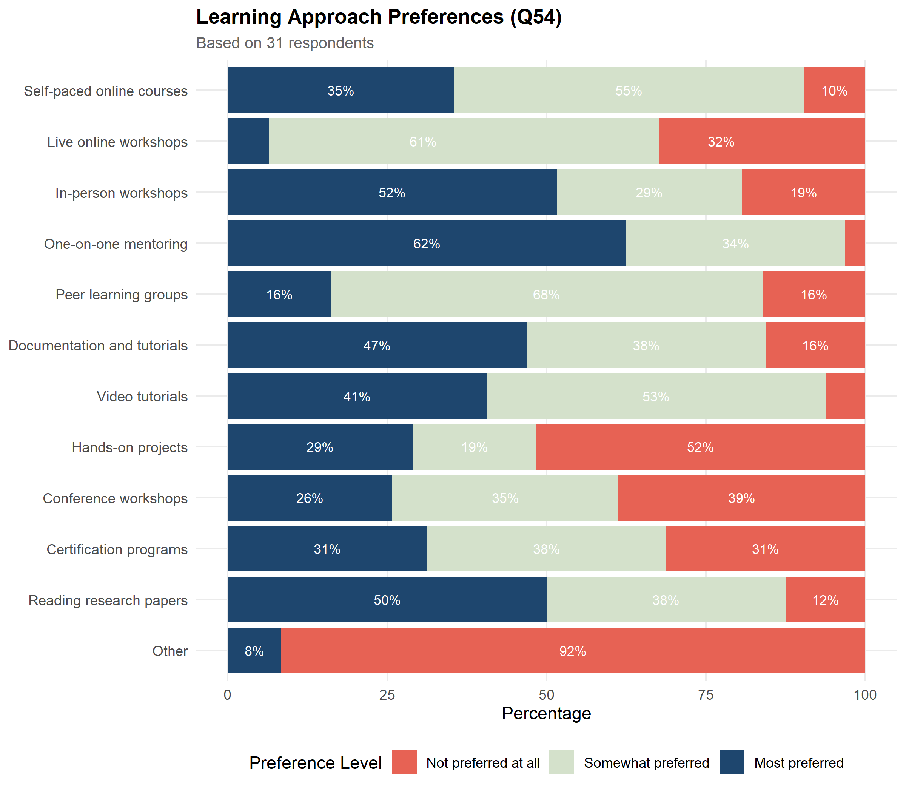
Preferred learning approaches and time commitment for training (Work Package 6.1 survey)
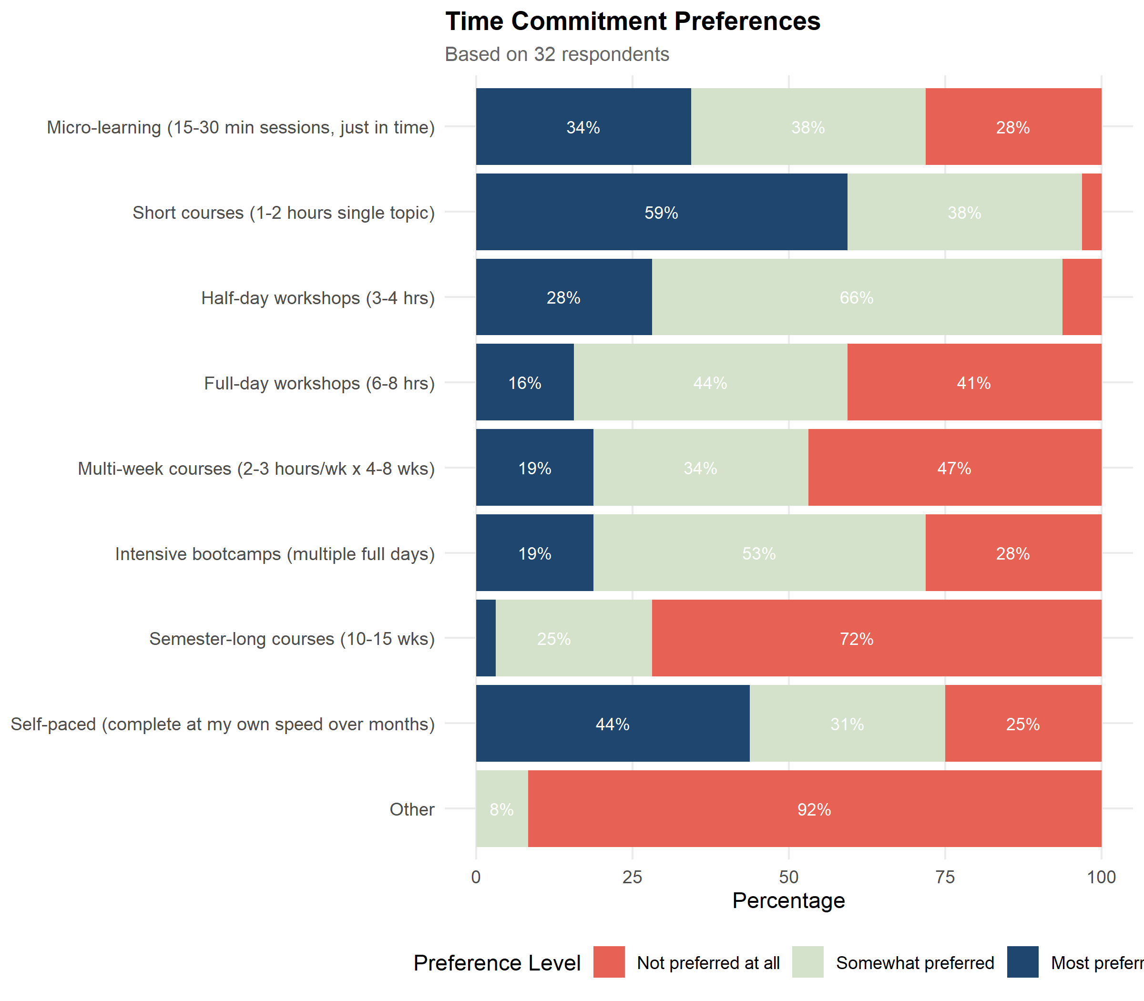
Preferred learning approaches and time commitment for training (Work Package 6.1 survey)

Considering the high preference for one-on-one mentoring, we make a special note of the Posit Academy, which is one of the very few programs that provides a mentor program. We highlight this programme as it may serve as inspiration in the future if the ARDC is considering the development of a mentor program focused on the development of Advanced Analytics and AI skills within the health research community. Further information can be found here - https://posit.co/products/enterprise/academy.

Note on the Australian Training Landscape
Many quality training opportunities in the Australian training landscape are not necessarily captured by the search approach detailed in this Work Package. As was discovered during the search process, much of the training tailored for Australian researchers is offered as one-off workshops or courses, delivered by industry bodies, or embedded within conferences. This includes training provided internally within Australian universities, the Research Bazaar conference, the Software Carpentries, and workshops delivered within research conferences. Unfortunately, courses within conferences are not always accessible using web scraping methods, and if they are identified they quickly become out of date, as they are often one-off offerings.
These opportunities present a specific challenge for a catalogue-based approach to discovery, that is, an approach that aims to collect all available training in an up-to-date, tagged and categorised catalogue that can then be searched. This represents a currency challenge. There is a workload involved in keeping the database current: capturing new courses as they come online, capturing courses embedded in GitHub repositories or conference programmes (which are difficult to identify through an automated search process), and removing courses that have since become outdated.
For the priority tools detailed in this report, an effort has been made to capture or highlight training providers who address the relevant training need, even where their specific course offerings may not have been fully surfaced by the search protocol. However, it should be noted that this is a weakness of the current search protocol and one that should be considered in future iterations of the search protocol, training development, and the recommender system or search/filter interfaces detailed in Work Package 6.5.

Note Regarding AI Tools
The landscape of AI tools has changed and evolved dramatically since this project began, and it is likely to continue doing so well beyond the publication of this report. Agent-based AI has emerged as a significant development, alongside ongoing discussion about the role large language models (LLMs) should play in research and programming. Uptake of LLM tools that support programming has been considerable, and this has been accompanied by broader debate about how LLM tools should fit into the research workflow more generally.
Pricing and infrastructure models are also shifting quickly. As model developers move from search-based pricing toward token consumption pricing, the cost implications of agent-based tools, which can consume tokens at a high rate, have become an increasingly relevant consideration for users and institutions alike. At the same time, interest in locally hosted LLMs continues to grow, driven by concerns about data privacy, the environmental impact of data centres, and the cost of token consumption. These developments sit alongside broader questions about how researchers and professionals retain their own intellectual edge in a landscape where powerful tools, trained on the world’s intellectual property, give the average researcher ready access to a vast base of existing knowledge.
Given this pace of change, it is likely that the database, tool list and search protocol underpinning this report will be at least partially out of date before this work is finalised. For this reason, the report does not include a dedicated section on AI and LLM tools; any such section would risk being outdated before publication. The more enduring question this raises for training providers responsible for advancing the analytics and research skills of the Australian health research community is how to keep pace with rapidly evolving technical capabilities and tools, alongside a training needs landscape that is itself shifting in response to these same developments.

Training Resources by Tool
For each tool detailed in the following sections, training demand and self-rated skill level from the Work Package 6.1 survey are compared against the availability of relevant training resources identified through the search protocol.

Electronic Health Records (EHR) Analytics and Data Linkage

Scope Note
Electronic Health Records (EHR) was treated as synonymous with Electronic Medical Records (EMR). To understand the training landscape relevant to EHR/EMR analysis, training resources covering data linkage and record linkage were also included in this category.
12 training resources were identified for Electronic Health Records / Data Linkage, of which 2 were Australian and 10 were international. Coverage by level: 7 beginner, 3 intermediate, 2 advanced.

Community Skill Level and Training Demand
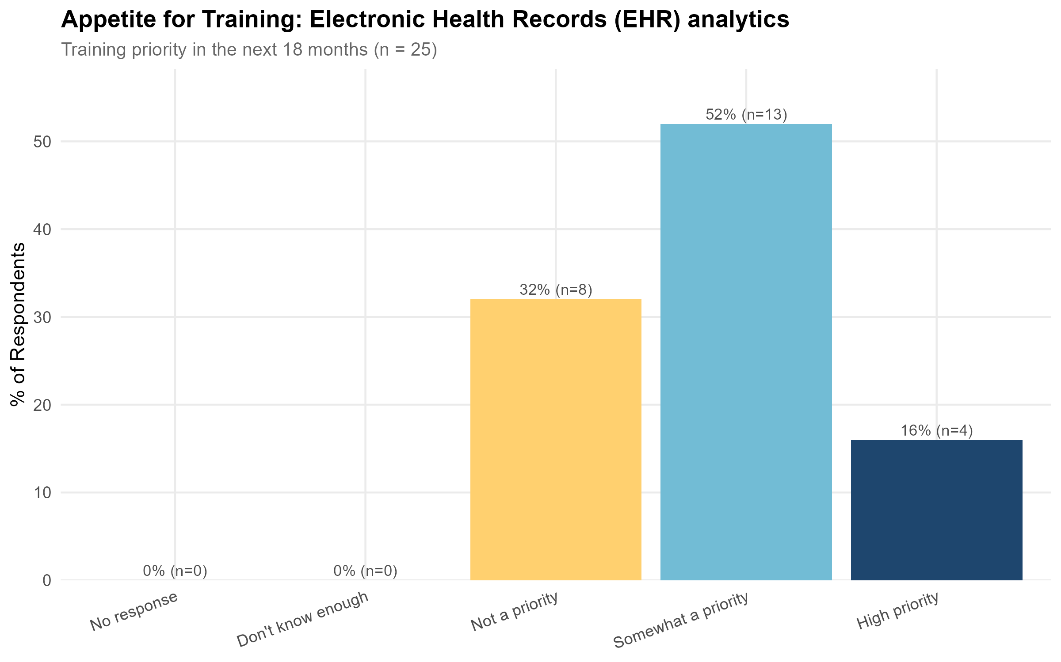  Electronic Health Records (EHR) Analytics and Data Linkage: training demand and skill levels | 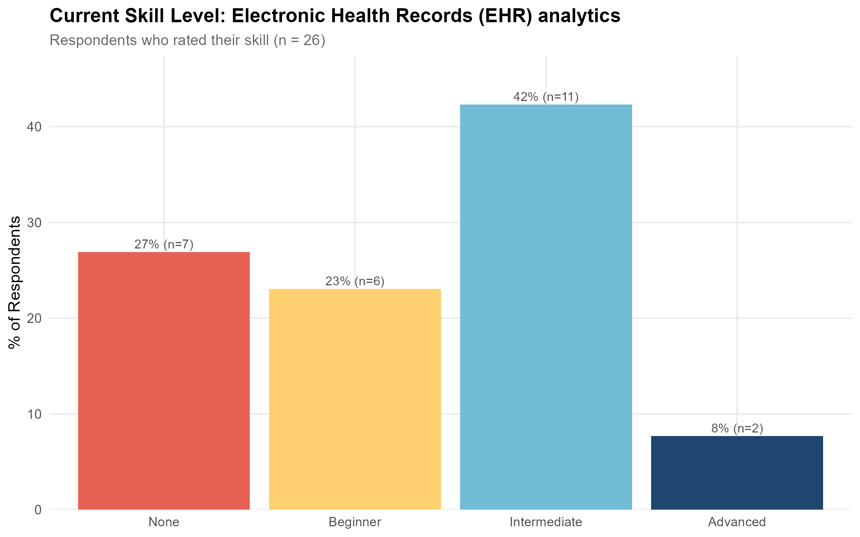  Electronic Health Records (EHR) Analytics and Data Linkage: training demand and skill levels
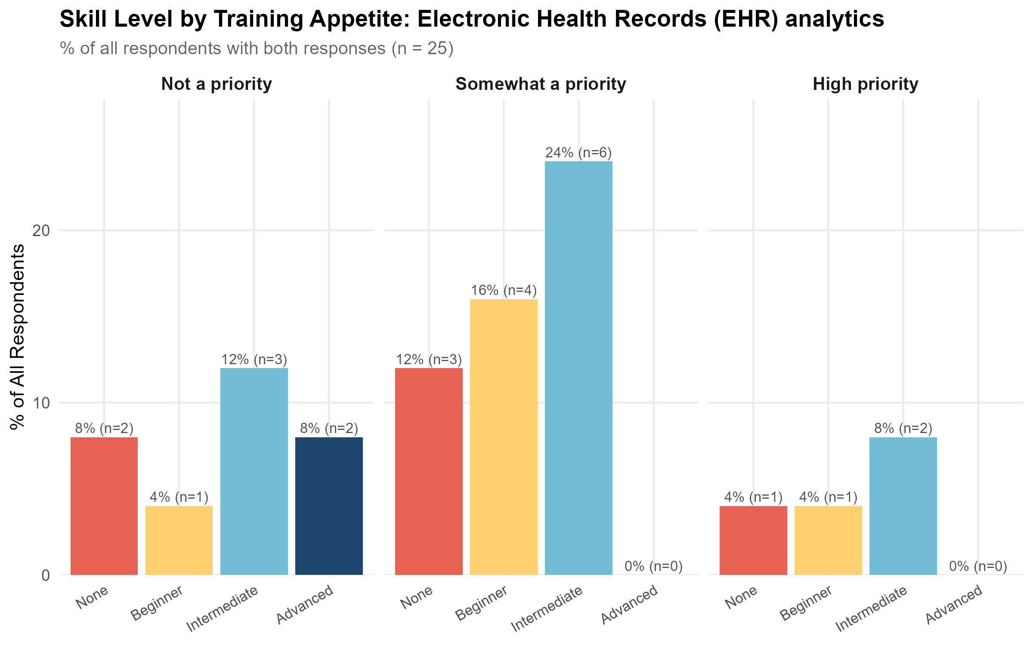
Electronic Health Records (EHR) Analytics and Data Linkage: training demand and skill levels
See Appendix 2 for summary plots.

Findings
Geographic coverage
Three Australian resources were identified: two courses and one training provider (the Sax Institute), which had no training available at the time of this report. The remaining 14 resources were international.
Delivery and format
Sixteen of the 17 resources were available online. The one international in-person course was retained in the database, as the breadth of its content may still be of value to some users. Most non-beginner courses were delivered as scheduled workshops or short courses. While the online delivery of most courses makes these resources highly accessible, only the MOOCs are available at any time; many of the more valuable courses are instructor-led and run at set times throughout the year.
Coverage by level
There was reasonable coverage of beginner and intermediate training (eight and six resources respectively); however, opportunities for advanced training were limited, with only two courses at this level. No advanced analytics training specific to Australian EHR data was identified.
Respondents with an intermediate self-rated skill level placed the highest priority on further training in this area, as shown in the plots above.
Cost
Course prices varied considerably, ranging from $0 to over $1,300 USD.
Providers
QCIF and the Sax Institute both offered courses targeting EHR or linked data analytics; however, these courses were outdated at the time of compiling this database and were therefore filtered out of the final selection.

Recommendations
Given the high demand for EHR analysis training identified in the survey, the low number of training opportunities available globally, the particularly low number of Australian-focused resources, and the low number of intermediate-to-advanced courses, the development of training in the use, access, management and linkage of EHR data for health research is considered a priority and is a clear candidate for inclusion in the VRE.
For EHR and linked data analytics specifically, locally produced courses are particularly important to address the specific nuances of Australian medical and health data. High-quality training developed overseas may not address requirements specific to Australia, including local data structures, differences in terminology, and data privacy and custodianship laws. Training material within the VRE would allow training to explore real world data while adhering to data privacy requirements.

Training Resources
Course / Programme | Provider | Level
Advanced Analysis of Linked Data (Theory) | Datacise Open Learning (ADR Wales / Swansea University) | Advanced
Advanced Analysis of Linked Data (Practical) | Datacise Open Learning (ADR Wales / Swansea University) | Advanced
Clinical Data Science Specialization | University of Colorado (via Coursera) | Beginner
Essentials of Genomics and Biomedical Informatics | IsraelX (Weizmann Institute of Science) | Beginner
Health Informatics for Better and Safer Healthcare | IsraelX | Beginner
AI-Driven EHR Management | Starweaver | Beginner
The Data Science of Health Informatics | Johns Hopkins University via Coursera | Beginner
How to Plan and Apply for Linked Data | Population Health Research Network (PHRN) | Beginner
Using Linked Data in Clinical Trials | Population Health Research Network (PHRN) / Australian Clinical Trials Alliance (ACTA) | Beginner
Clinical SAS: Clinical Data Management and Analysis with SAS | Udemy (Uplatz) | Intermediate
Introductory Analysis of Linked Data (Theory) | Datacise Open Learning (ADR Wales / Swansea University) | Intermediate
Introductory Analysis of Linked Data (Practical) | Datacise Open Learning (ADR Wales / Swansea University) | Intermediate

R Programming

133 training resources were identified for R, of which 29 were Australian and 104 were international. Coverage by level: 54 beginner, 62 intermediate, 13 advanced.

Community Skill Level and Training Demand
Training for R was identified as a high priority in Work Package 6.1, ranking second for both demand and importance. More than 54% of survey respondents indicated an interest in engaging in R programming training in the next 18 months. While a high proportion of survey respondents did not consider training a priority, the plots below show that these respondents are predominantly researchers who rate their current skill level as advanced and, it is assumed, feel confident developing their skills through documentation, research papers and vignettes rather than formal courses or workshops.
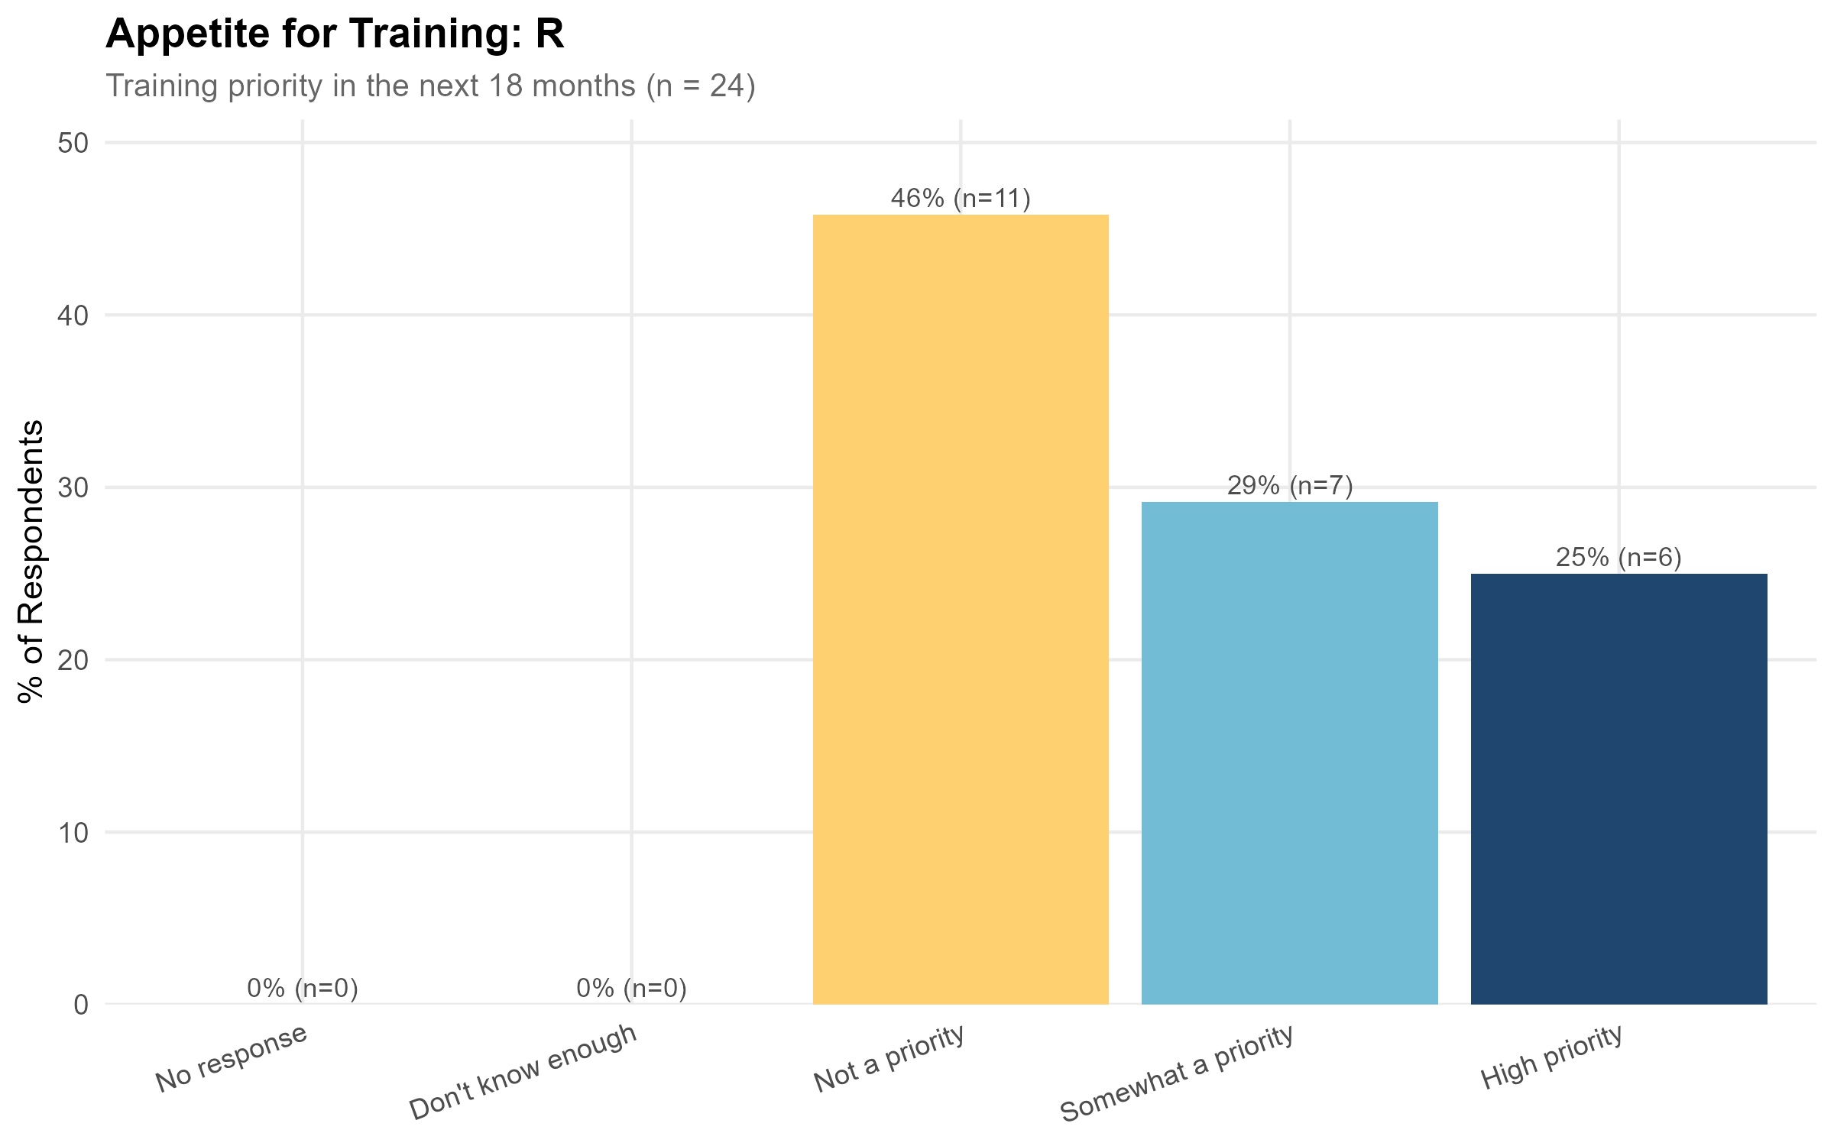  R: training demand and skill levels | 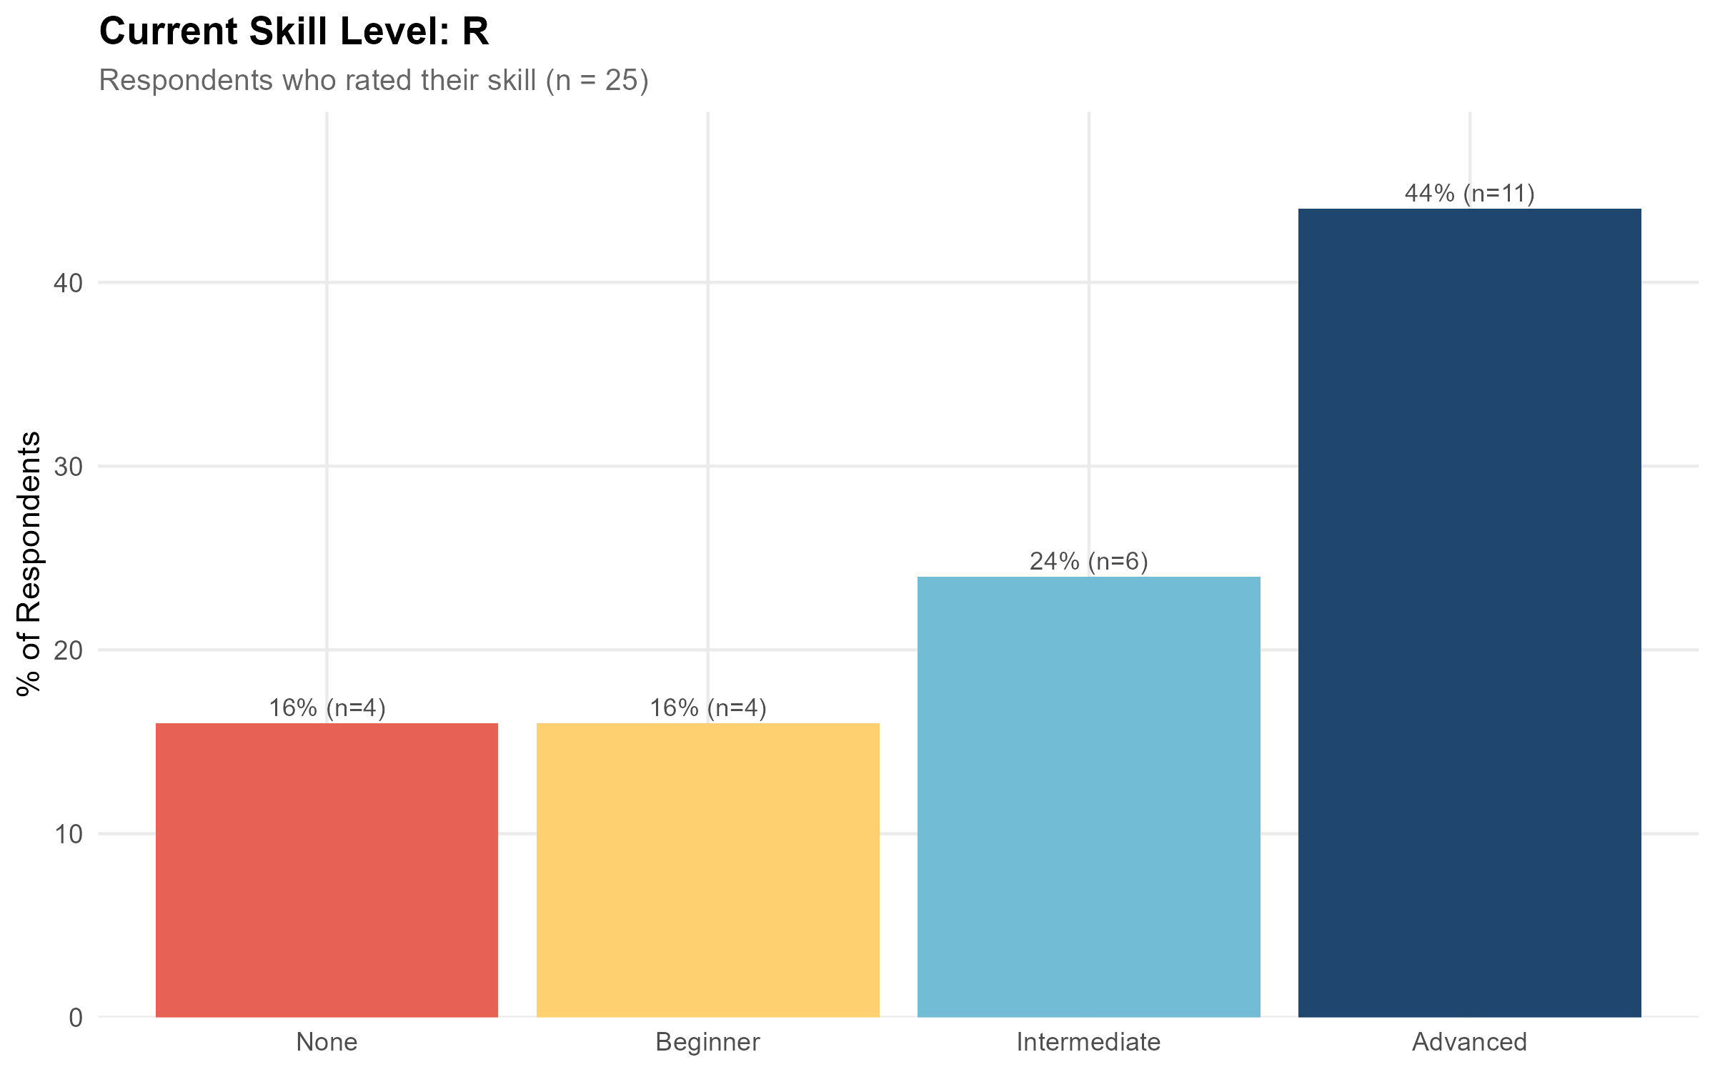  R: training demand and skill levels
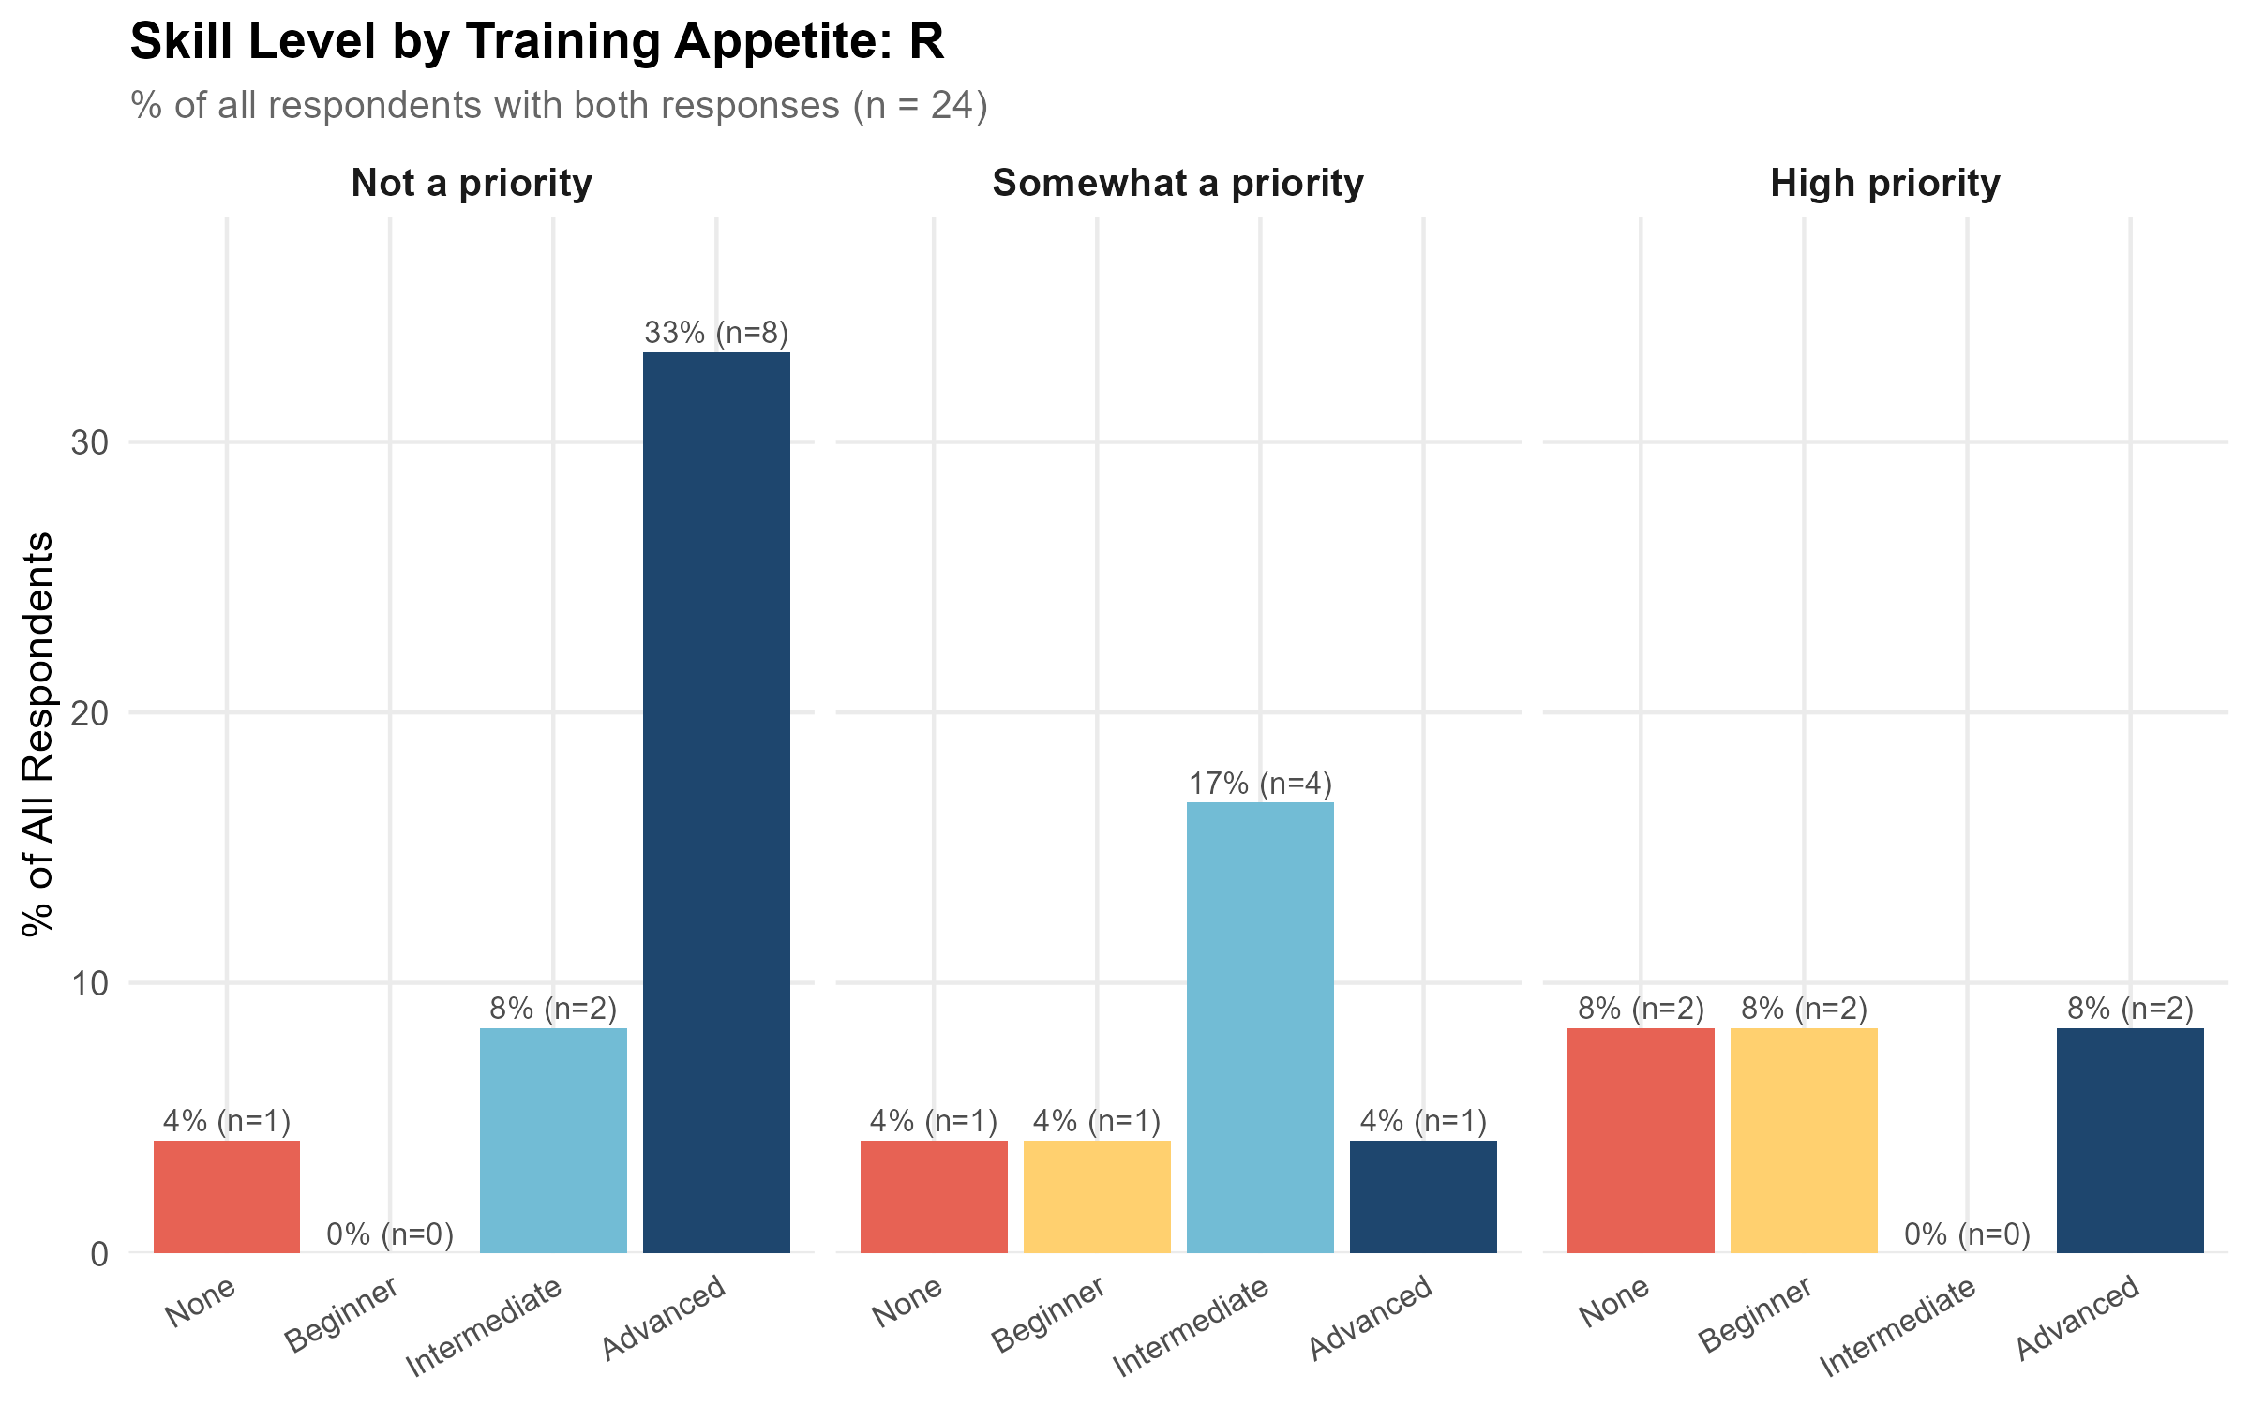
R: training demand and skill levels
See Appendix 2 for summary plots.

Findings
Training opportunities for R exist at all levels, from beginner to advanced, both internationally and in Australia. As noted earlier in this report, training opportunities offered through Australian research institutions, research conferences and the Carpentries workshops may not have been fully captured by this search; the database developed here is therefore likely to under-represent the full range of available training. However, the search will have captured the majority of training opportunities available on-demand and online, which are highly valued by the Australian research community (see Preferred Learning Approaches above for survey results on training format and time commitment preferences).
Geographic coverage
Of the 143 selected resources, 35 (24%) were Australian and 108 (76%) were international.
Delivery and format
The large majority of resources, 129 (90%), were delivered online, with 13 blended and one in-person. Format was fairly evenly split across MOOCs (49), short courses (48) and workshops (42), with a small number of specialisations and one full course.
Coverage by level
Intermediate training was the best represented level (71 resources), followed by beginner (55), with comparatively few resources at advanced (13) or expert (4) level, a combined 17 resources (12%) at the higher end. Among the Australian resources specifically, the level split was eight beginner, 20 intermediate, three advanced and four expert, indicating proportionally similar coverage at the advanced/expert end to the overall sample.
Cost
Pricing varied considerably. Of resources with a stated price, costs ranged from $0 to $4,000 USD, though the median listed price was $0, largely reflecting free-to-audit MOOCs. Cost models split across free to audit (45), paid (41), institutional access (22), free (18) and subscription (14).
Providers
The most frequent providers were Harvard Online and HarvardX (23 resources combined), followed by Australian providers Intersect Australia (10) and QCIF (8), and international platforms DataCamp and Udemy (8 each). Among Australian providers, Intersect Australia, QCIF, Instats and ACSPRI accounted for the majority of local offerings.
Of the 143 selected resources, 58.0% (83 resources) had no health domain relevance.

Recommendations
Given the volume and diversity of training already available online, the development of new resources for teaching R programming is not recommended as a high priority. It is clear that basic training for R is not needed in the current landscape.

Training Resources
It was not practical to list all identified training resources here. Please see Appendix for a reduced list of R training courses with a health research context.

Causal Analysis

7 training resources were identified for Causal Analysis, of which 1 were Australian and 6 were international. Coverage by level: 0 beginner, 4 intermediate, 2 advanced.

Community Skill Level and Training Demand
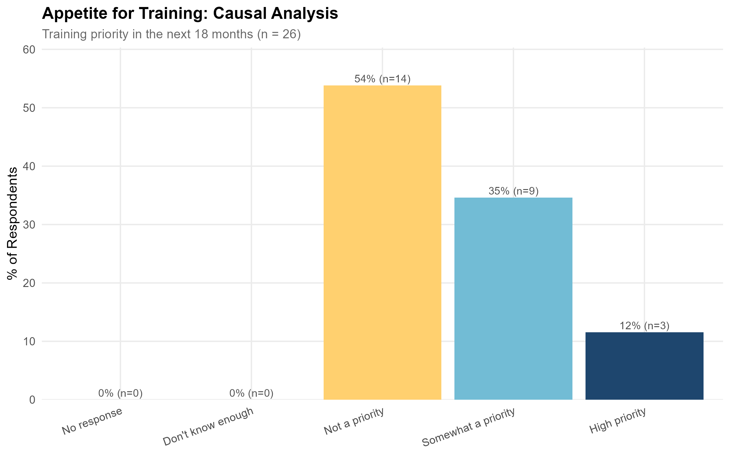  Causal Analysis: training demand and skill levels | 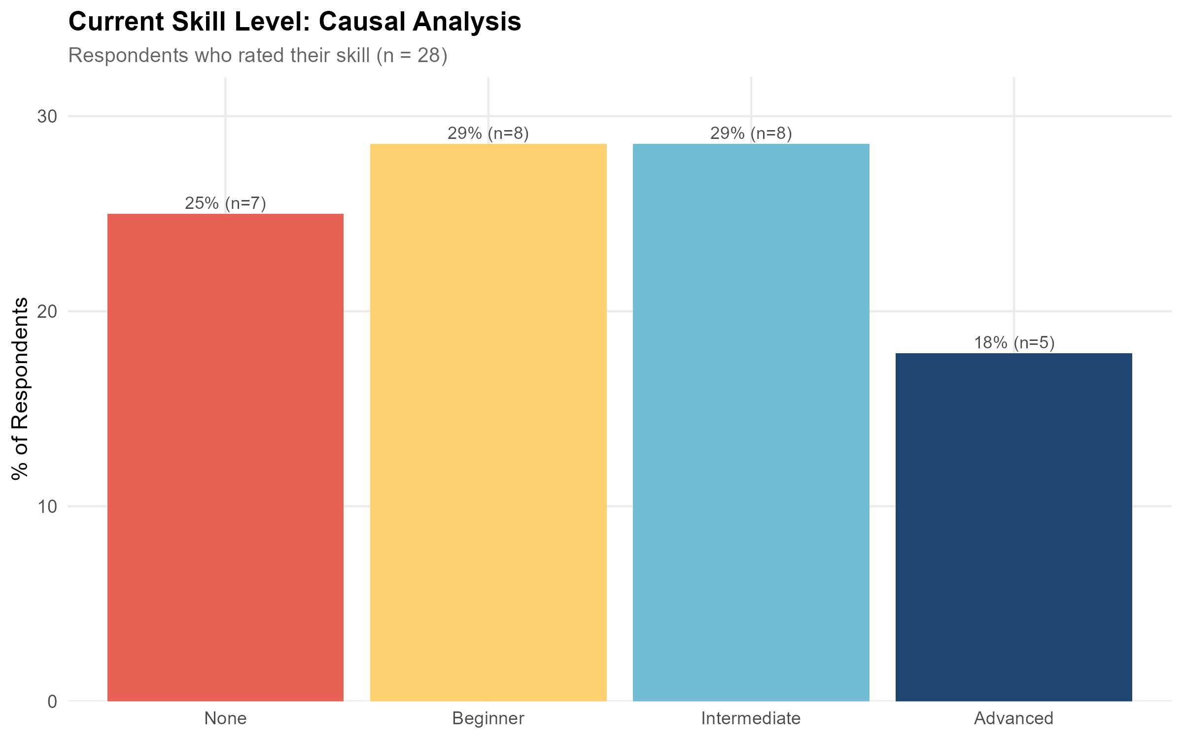  Causal Analysis: training demand and skill levels
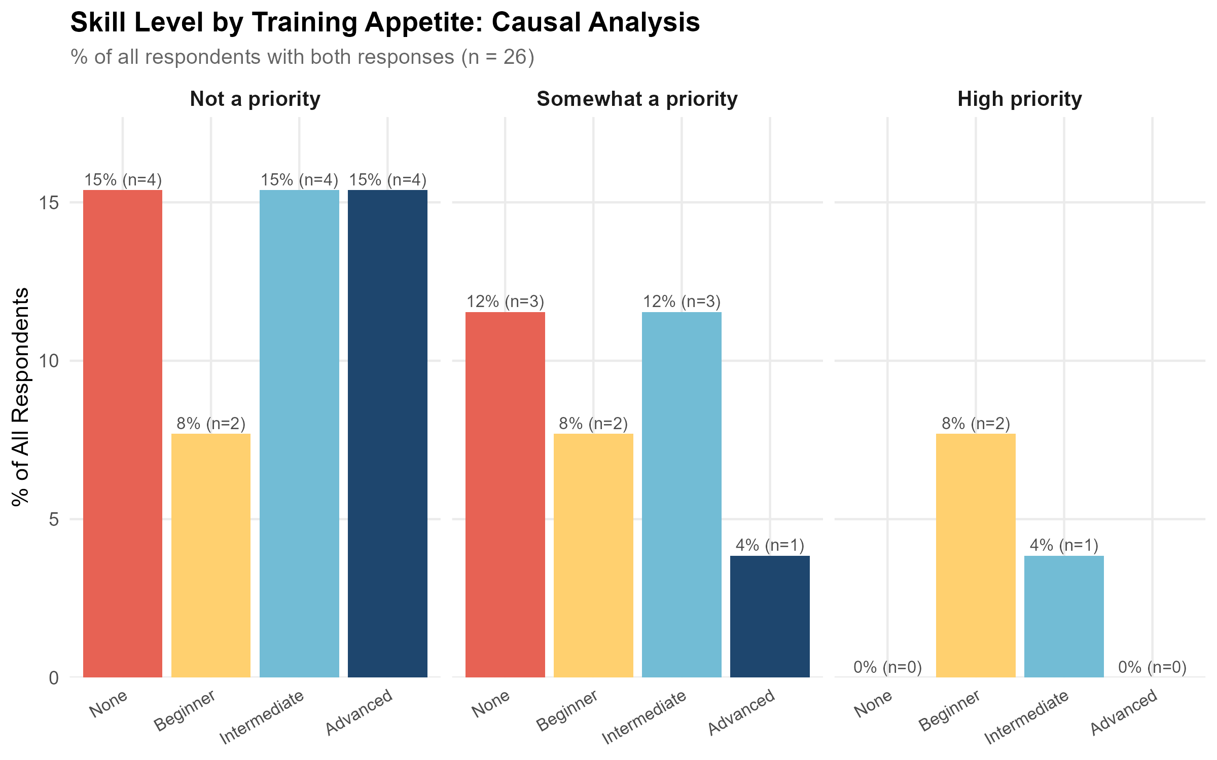
Causal Analysis: training demand and skill levels
See Appendix 2 for summary plots.

Findings
Geographic coverage
Of the seven selected resources, one (Instats) was Australian; the remaining six were international (five from the USA, one listed as Global).
Delivery and format
All seven resources were delivered online. Format was split across short courses (4), MOOCs (2) and one workshop.
Coverage by level
Intermediate training accounted for four of the seven resources, with two at advanced level and one at expert level. No beginner-level training was identified.
Cost
Cost models were mixed across the sample: free to audit (3), free (1), paid (1), subscription (1) and institutional access (1). Where a price was stated, it was $0 in all cases; no resources had a stated certificate price.
Providers
Columbia University was the only provider with more than one resource (2). The remaining five resources were each from a different provider: Microsoft Learn, Harvard Online, Instats, DeepLearning.AI and the University of Pennsylvania.
Two of the seven resources (29%) had health domain relevance, both rated “Yes - high” (DeepLearning.AI’s AI For Medical Treatment and the University of Pennsylvania’s A Crash Course in Causality).

Recommendations
We don’t consider causal inference to be a strong candidate for future training development currently. It is not often taught as a stand along course but is often embedded within other training, therefore we believe that the courses here are an under-representation of training opportunities. However, we believe this is an area to watch and consider developing training material if demand grows in the future.

Training Resources
Course / Programme | Provider | Level
Causal Inference | Columbia University | Advanced
Causal Inference 2 | Columbia University | Advanced
Machine Learning for Prediction and Causal Inference | Instats | Expert
Manage and Review Models in Azure Machine Learning | Microsoft Learn | Intermediate
Causal Diagrams: Draw Your Assumptions Before Your Conclusions | Harvard Online | Intermediate
AI For Medical Treatment | DeepLearning.AI | Intermediate
A Crash Course in Causality: Inferring Causal Effects from Observational Data | University of Pennsylvania | Intermediate

Regression

111 training resources were identified for Regression, of which 18 were Australian and 93 were international. Coverage by level: 36 beginner, 64 intermediate, 8 advanced.

Community Skill Level and Training Demand
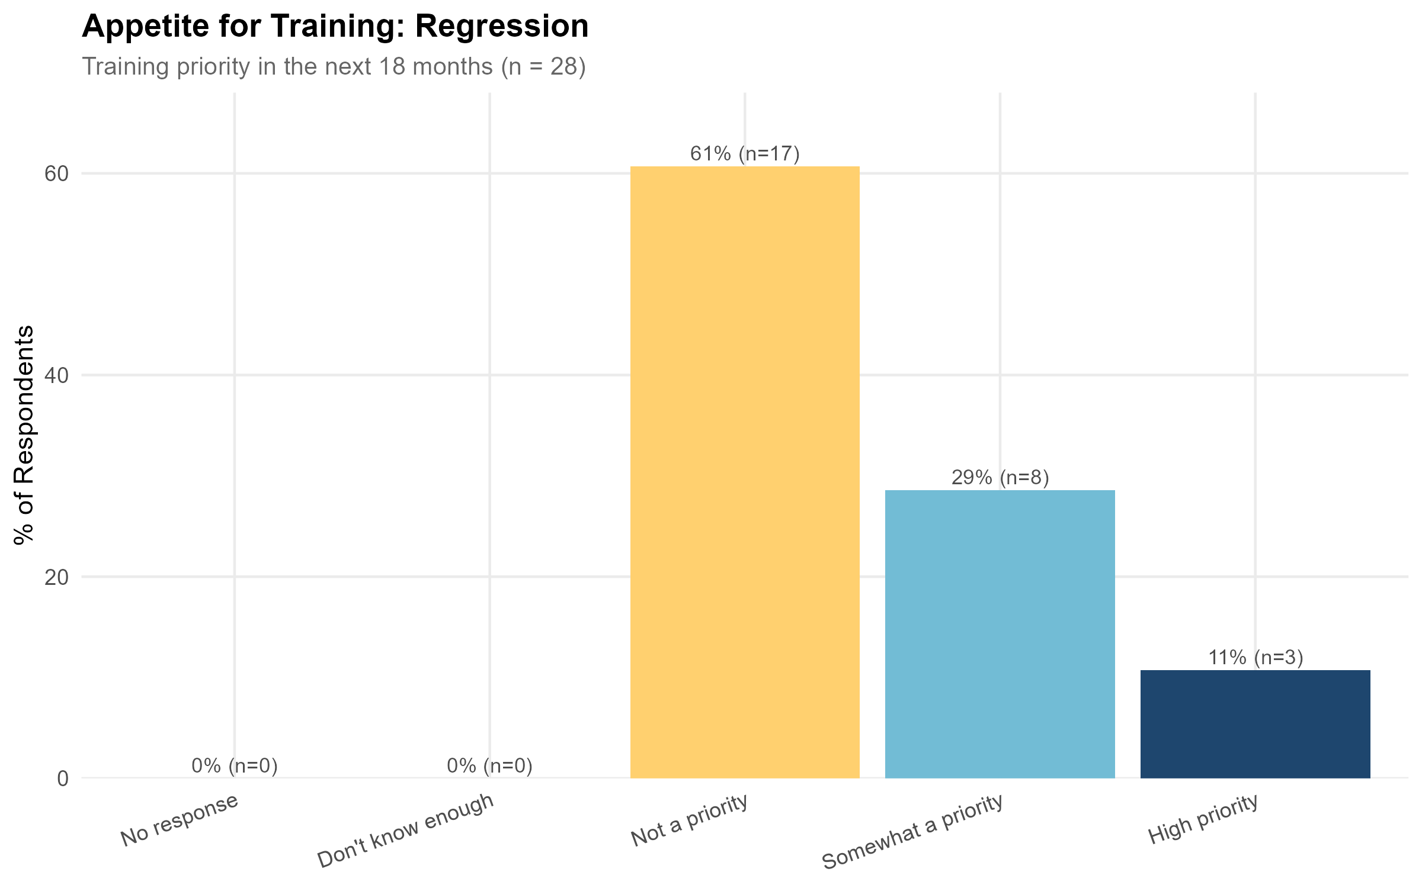  Regression: training demand and skill levels | 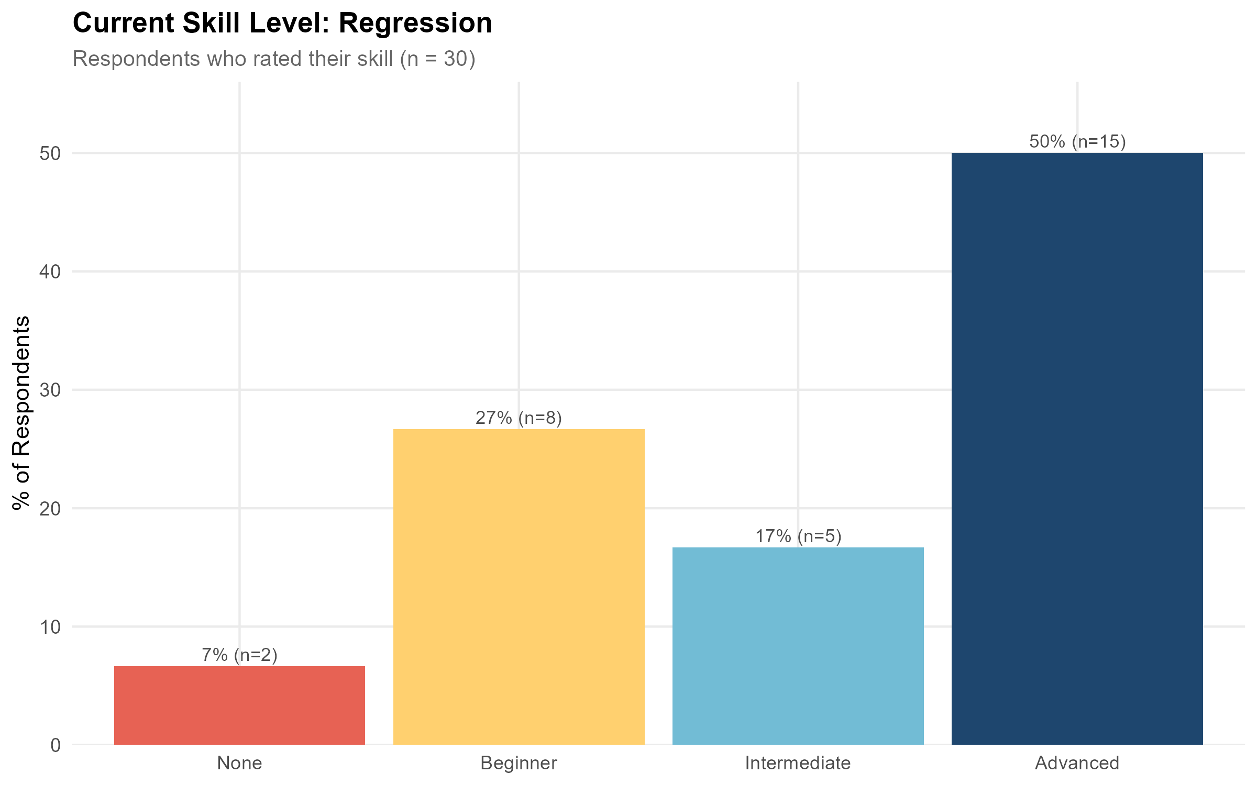  Regression: training demand and skill levels
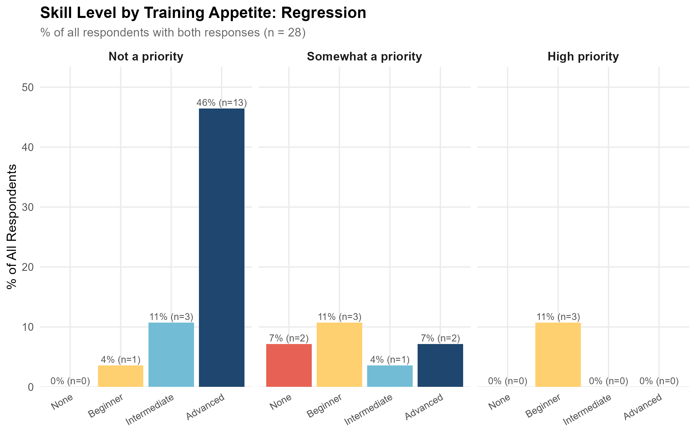
Regression: training demand and skill levels
See Appendix 2 for summary plots.

Findings
Geographic coverage
Of the 118 selected resources, 22 (19%) were Australian and 96 (81%) were international.
Delivery and format
The substantial majority of resources, 109 (92%), were delivered fully online, with the remaining nine blended. Format was led by short courses (51) and MOOCs (42), with workshops (20) making up most of the remainder.
Coverage by level
Intermediate training was the dominant level (70 resources), followed by beginner (37), with relatively few resources at advanced (8) or expert (3) level, a combined 11 resources (9%) at the higher end. Among the Australian resources, the level split was two beginner, 15 intermediate, two advanced and three expert, again skewed toward intermediate content and broadly consistent with the overall pattern.
Cost
Cost models were fairly evenly spread: paid (36), subscription (30), free to audit (29), institutional access (17) and free (5). Where a price was stated, costs ranged from $0 to $4,000 USD, with a median of $0 reflecting the substantial number of free-to-audit and institutional-access resources.
Providers
QCIF (9) and Udemy (8) were the most frequent providers, followed by Intersect Australia, Johns Hopkins University, Harvard Online and CloudSwyft Global Systems (5 each). Among Australian providers, QCIF, Intersect Australia, ACSPRI and Instats accounted for the majority of local offerings.
Of the 118 selected resources, 71% (84 resources) had no health domain relevance.

Recommendations
Regression is a foundational analytical technique that researchers would typically be expected to have encountered during their university training, and the volume and maturity of existing regression training available online, much of it free or low-cost, and spanning beginner through to expert level, supports treating regression as a well-served area rather than a priority for new training development. With this in mind it is worth noting that courses delivered as part of a degree programme at undergraduate or postgraduate level were excluded from the overall database. See Appendix 1 for the full rejection/selection criteria.
However, the presence of regression among the top priority tools points to the skills gap score. Many of the respondents who indicated training in regression was a priority were self-rated at beginner, indicating that training in this tool would have a strong impact on the community’s analytic capabilities. Most respondents who indicated training is not a priority already rate their skill as advanced.
This is also possibly a reflection of the health research community, where a substantial number of health researchers bring strong domain expertise (clinical, public health, epidemiological) and are increasingly expected to apply or extend their technical analytics capability as part of their research practice, rather than coming from a background where regression and applied statistics were a dominant part of formal training. For these researchers, demand for regression training may represent a genuine skill gap rather than a refresher need, and points toward training that is framed around applied, domain-specific use of regression (for example, in clinical or epidemiological contexts) rather than the introductory statistical theory typically covered at undergraduate level. For this reason, regression may be a good contender for the development of specific health-research-targeted training within the VRE.
As regression is a surprising tool to be ranked highly in Work Package 6.1, further community consultation should be conducted to understand the specific learning needs around this tool.

Training Resources
Please see Appendix 3 for a list of training resources for Regression.

SQL and Database Management

48 training resources were identified for SQL and Database Management, of which 0 were Australian and 48 were international. Coverage by level: 37 beginner, 7 intermediate, 4 advanced.

Community Skill Level and Training Demand
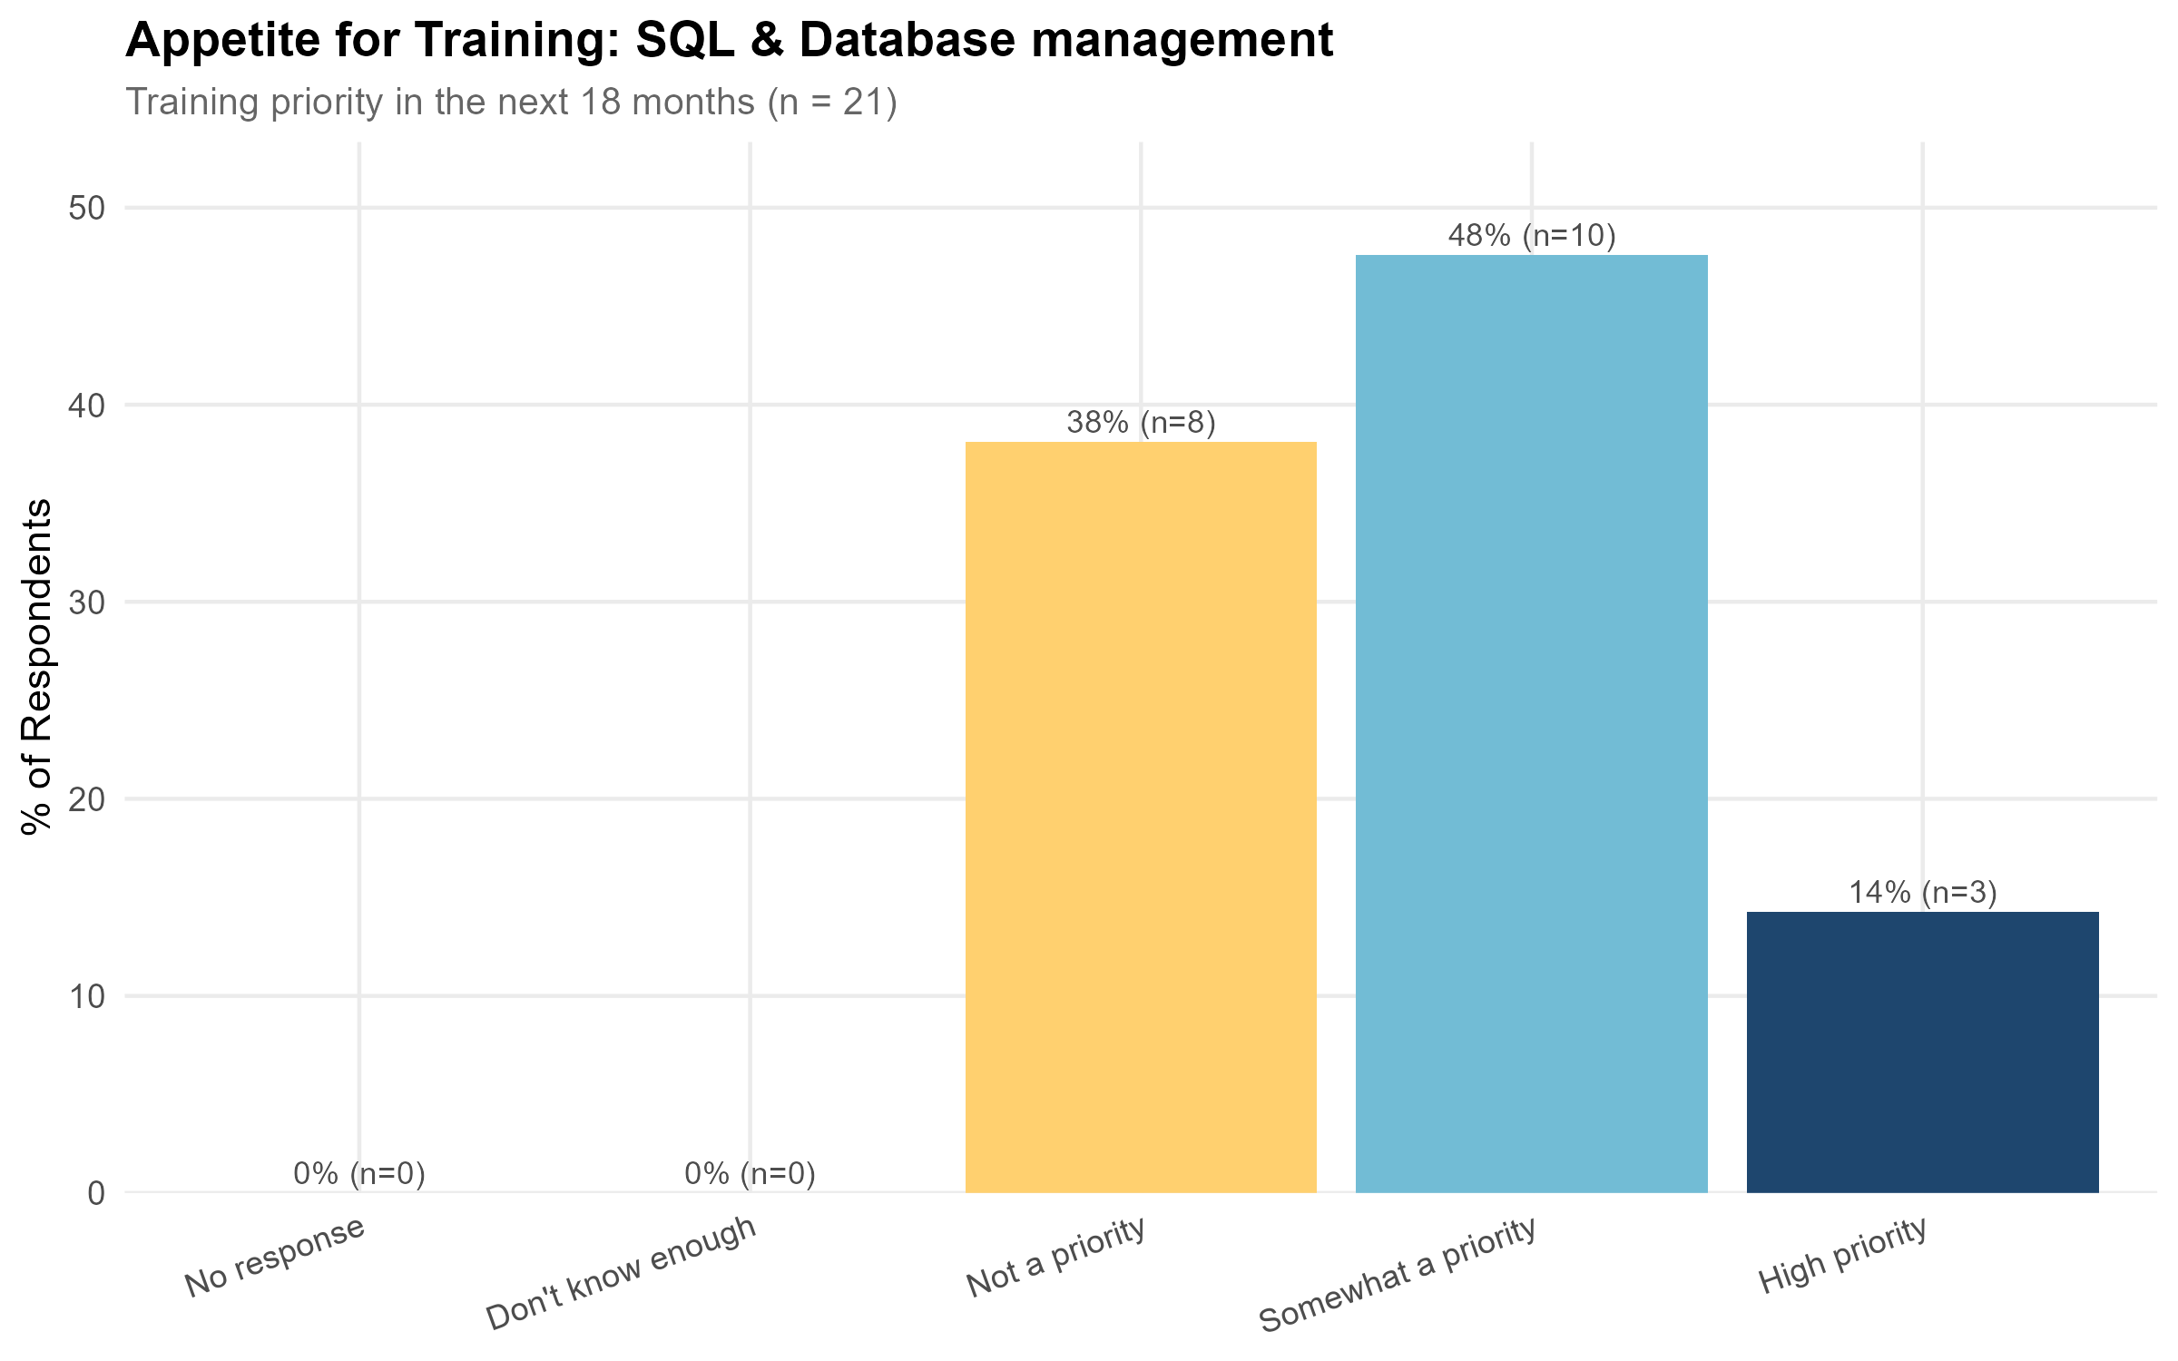  SQL and Database Management: training demand and skill levels | 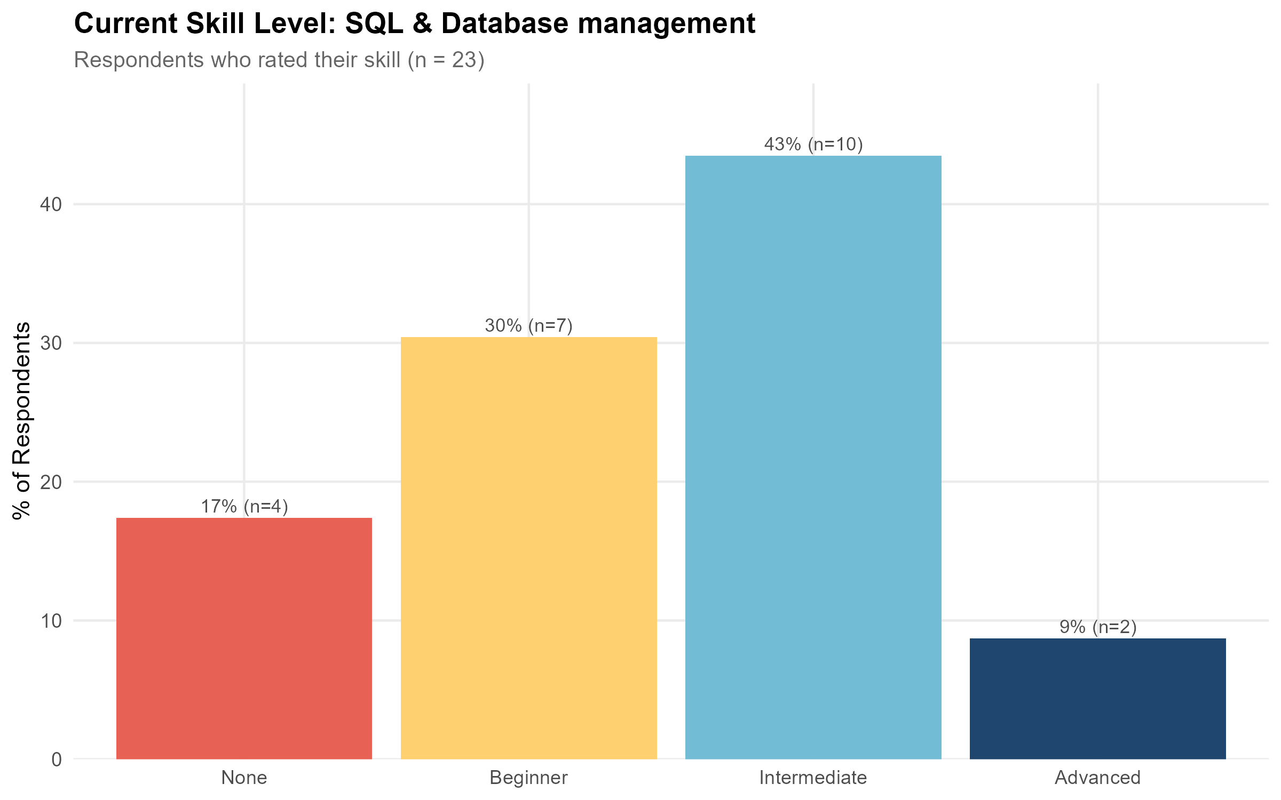  SQL and Database Management: training demand and skill levels
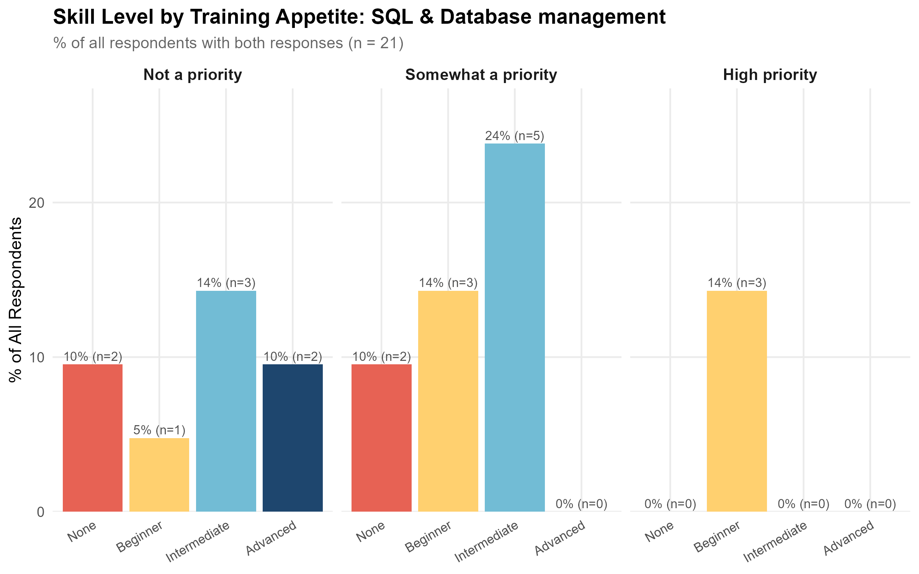
SQL and Database Management: training demand and skill levels
It is worth noting that every respondent who rated training in SQL and database management as a high priority self-identified as a beginner, suggesting that demand for this tool is concentrated at the introductory end rather than reflecting a need to deepen existing skills.
See Appendix 2 for summary plots.

Findings
Geographic coverage
Of the 52 selected resources, only one was Australian (Intersect Australia); the remaining 51 (98%) were international.
Delivery and format
Most resources, 47 (90%), were delivered fully online, with four blended and one in-person. Format was led by short courses (21) and MOOCs (20), with a smaller number of workshops (7).
Coverage by level
Beginner training dominated the available resources (41 of 52, 79%), with only seven intermediate and four advanced resources identified. The single Australian resource was also at beginner level.
Cost
Cost models were spread across subscription (16), free (12), paid (11) and free to audit (11), with only one resource requiring institutional access. Where a price was stated, costs ranged from \$0 to \$4,000 USD, with a median of \$0.
Providers
Udacity (8) and Udemy (5) were the most frequent providers, followed by DeepLearning.AI (4). No single provider accounted for a substantial share of the database, and providers were almost entirely international; Intersect Australia was the only Australian provider represented.
Of the 52 selected resources, 90% (47 resources) had no health domain relevance, with only five resources rated low or high.

Recommendations
The combination of strong beginner-level demand, a near-total absence of Australian-delivered training, and a database skewed heavily toward introductory, general-purpose (non-health-specific) content suggests that SQL and database management training is a candidate for development, particularly at the intermediate and beginner level and with content situated in a health research context.

Training Resources
See Appendix 3 for a list of training resources for SQL and Database Management.

Clinical Trial Design and Analysis

10 training resources were identified for Clinical Trial Design and Analysis, of which 0 were Australian and 10 were international. Coverage by level: 4 beginner, 5 intermediate, 1 advanced.

Community Skill Level and Training Demand
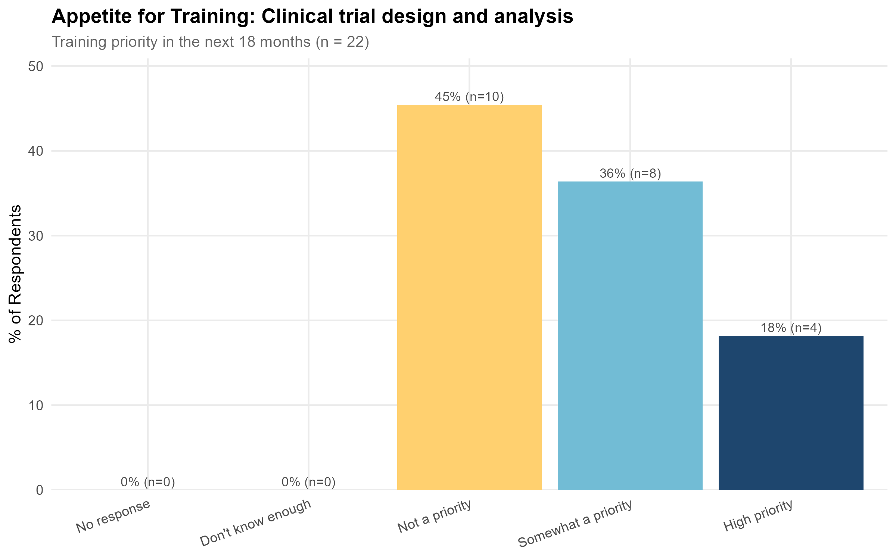  Clinical Trial Design and Analysis: training demand and skill levels | 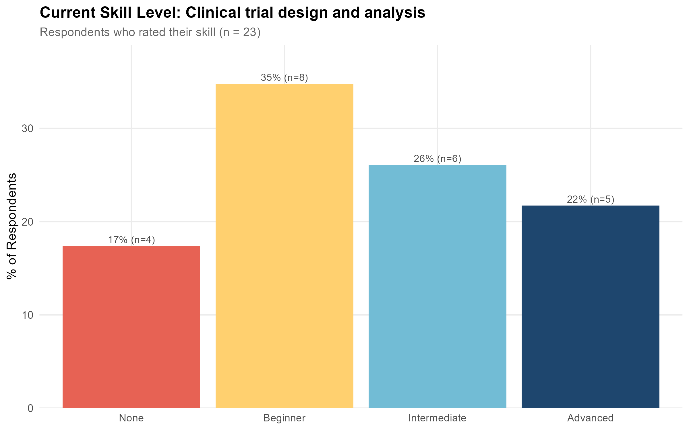  Clinical Trial Design and Analysis: training demand and skill levels
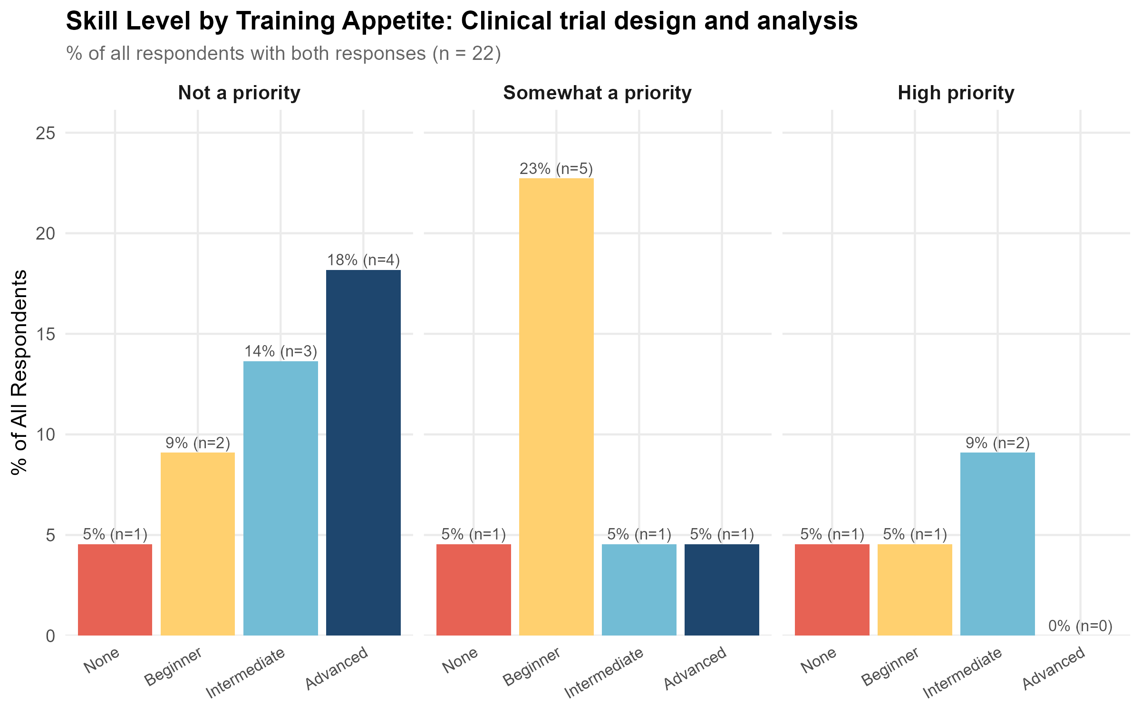
Clinical Trial Design and Analysis: training demand and skill levels
It is worth noting that the high proportion of beginner-level courses available (4 of the 10 selected resources) is a good outcome, as it meets the high proportion of training demand coming from beginners shown in the survey results above (see skill level by training appetite plots).
See Appendix 2 for summary plots.

Findings
Geographic coverage
All 10 selected resources were international; no Australian-delivered training was identified.
Delivery and format
All 10 resources were delivered fully online, split across short courses (6) and MOOCs (4).
Coverage by level
Four of 10 resources (40%) were beginner level, five intermediate, and one advanced.
Cost
Cost models were split between paid (6) and free to audit (4). Of the resources with a stated price, all were $0.
Providers
Udemy was the most frequently represented provider (3 resources, plus 2 more listed as “Udemy / BioStat”). The remaining resources were each from a different provider: Imperial College London, the University of Cape Town, Johns Hopkins University, and MD Anderson Cancer Center.

Recommendations
It is worth noting that no Australian-delivered courses were identified for Clinical Trial Design and Analysis. This is unlikely to be the case in reality; it more likely reflects a limitation of the search protocol in surfacing Australian courses. This is an interesting finding in itself, as it potentially points to a broader discoverability issue for Australian training in this area. Further research should be undertaken to confirm whether Australian-delivered training in clinical trial design and analysis genuinely does not exist, or whether it exists but was not captured by this search.

Training Resources
Please Appendix for a list of training resources for Clinical Trial Design and Analysis.

GitHub

44 training resources were identified for GitHub, of which 2 were Australian and 42 were international. Coverage by level: 25 beginner, 14 intermediate, 5 advanced.

Community Skill Level and Training Demand
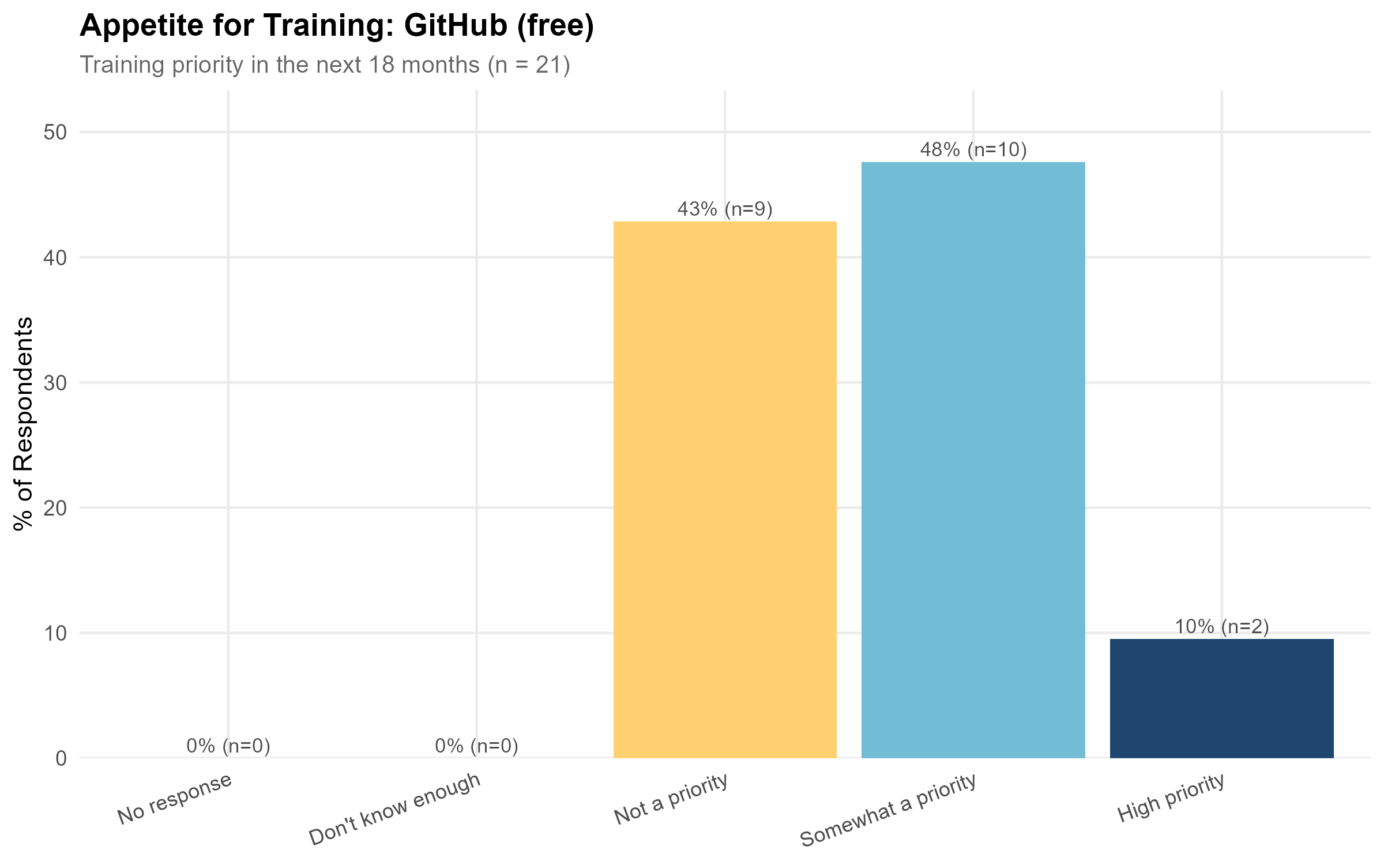  GitHub: training demand and skill levels | 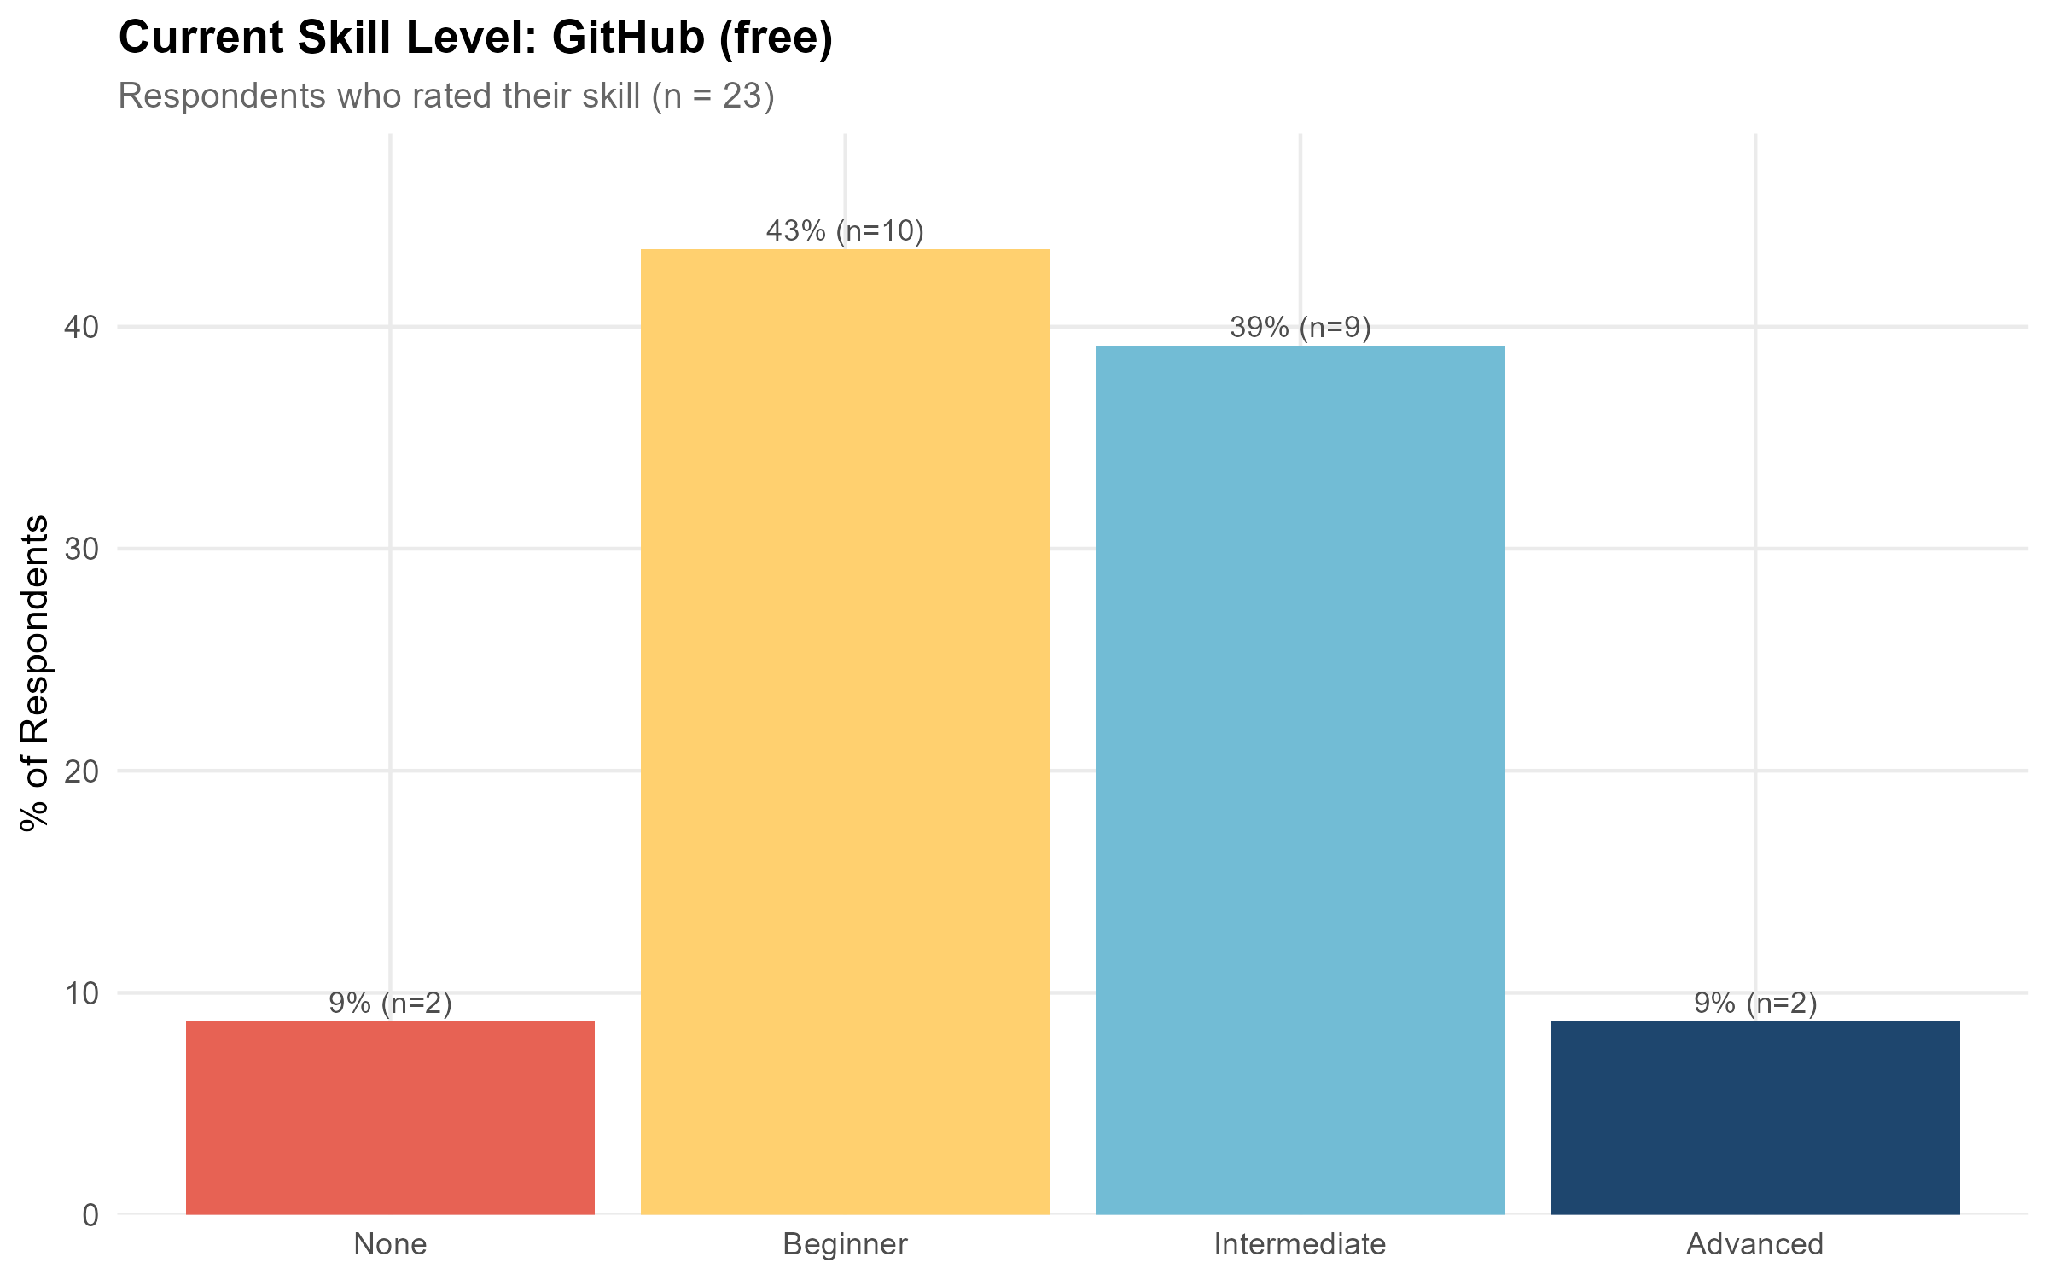  GitHub: training demand and skill levels
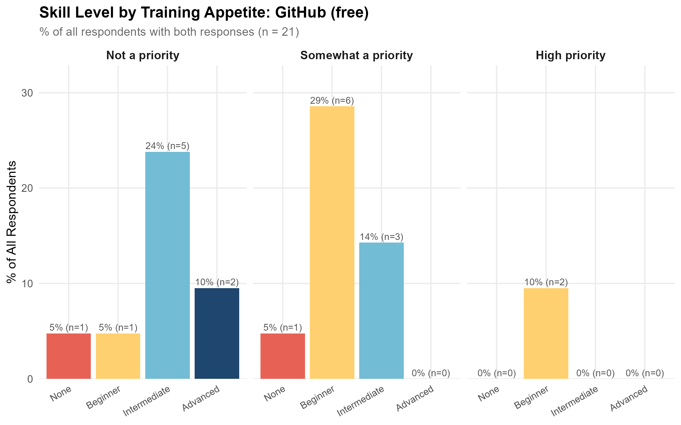
GitHub: training demand and skill levels
See Appendix 2 for summary plots.

Findings
Geographic coverage
Of the 47 selected resources, four (9%) were Australian and 43 (91%) were international.
Delivery and format
Almost all resources, 45 (96%), were delivered fully online, with two blended. Format was evenly split between short courses (20) and MOOCs (20), with a smaller number of workshops (6).
Coverage by level
Beginner training was the most common level (26 resources, 55%), followed by intermediate (16), with five advanced resources. Among the Australian resources, the split was three beginner and one intermediate, broadly in line with the overall beginner-skewed pattern.
Cost
Cost models leaned toward free access: free (16) and free to audit (12) together accounted for more than half the database, with subscription (12), paid (4) and institutional access (2) making up the remainder. Where a price was stated, costs ranged from $0 to $249 USD, with a median of $0.
Providers
Microsoft Learn (6) and Udacity (5) were the most frequent providers, followed by DataCamp (4). Australian providers were each represented once: ARDC, Intersect Australia, QCIF, and the Australian BioCommons / Sydney Informatics Hub.

Recommendations
GitHub training is well covered. There are many resources available that can teach this tool on-demand, online, through the carpentries and at the user’s preferred pace. This is not considered a priority tool for training development, and health-domain-specific training is unlikely to add significant value to GitHub training.

Training Resources
Please Appendix for a list of coursework resources for GitHub.

Clustering and Pattern Recognition

56 training resources were identified for Clustering and Pattern Recognition, of which 4 were Australian and 52 were international. Coverage by level: 15 beginner, 33 intermediate, 7 advanced.

Community Skill Level and Training Demand
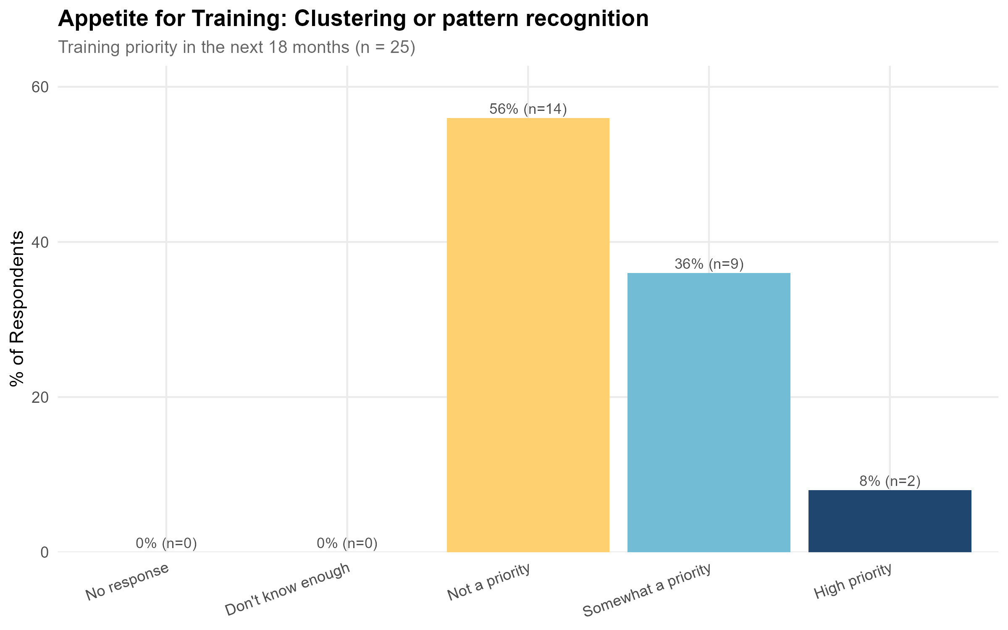  Clustering and Pattern Recognition: training demand and skill levels | 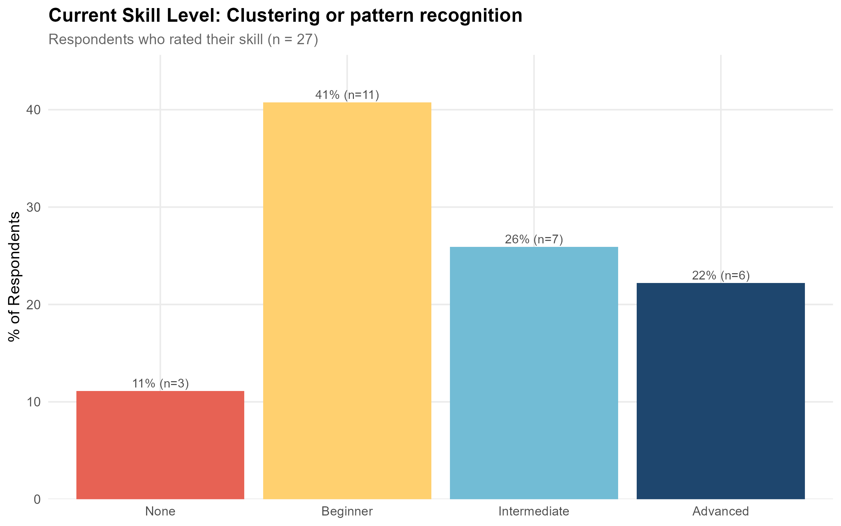  Clustering and Pattern Recognition: training demand and skill levels
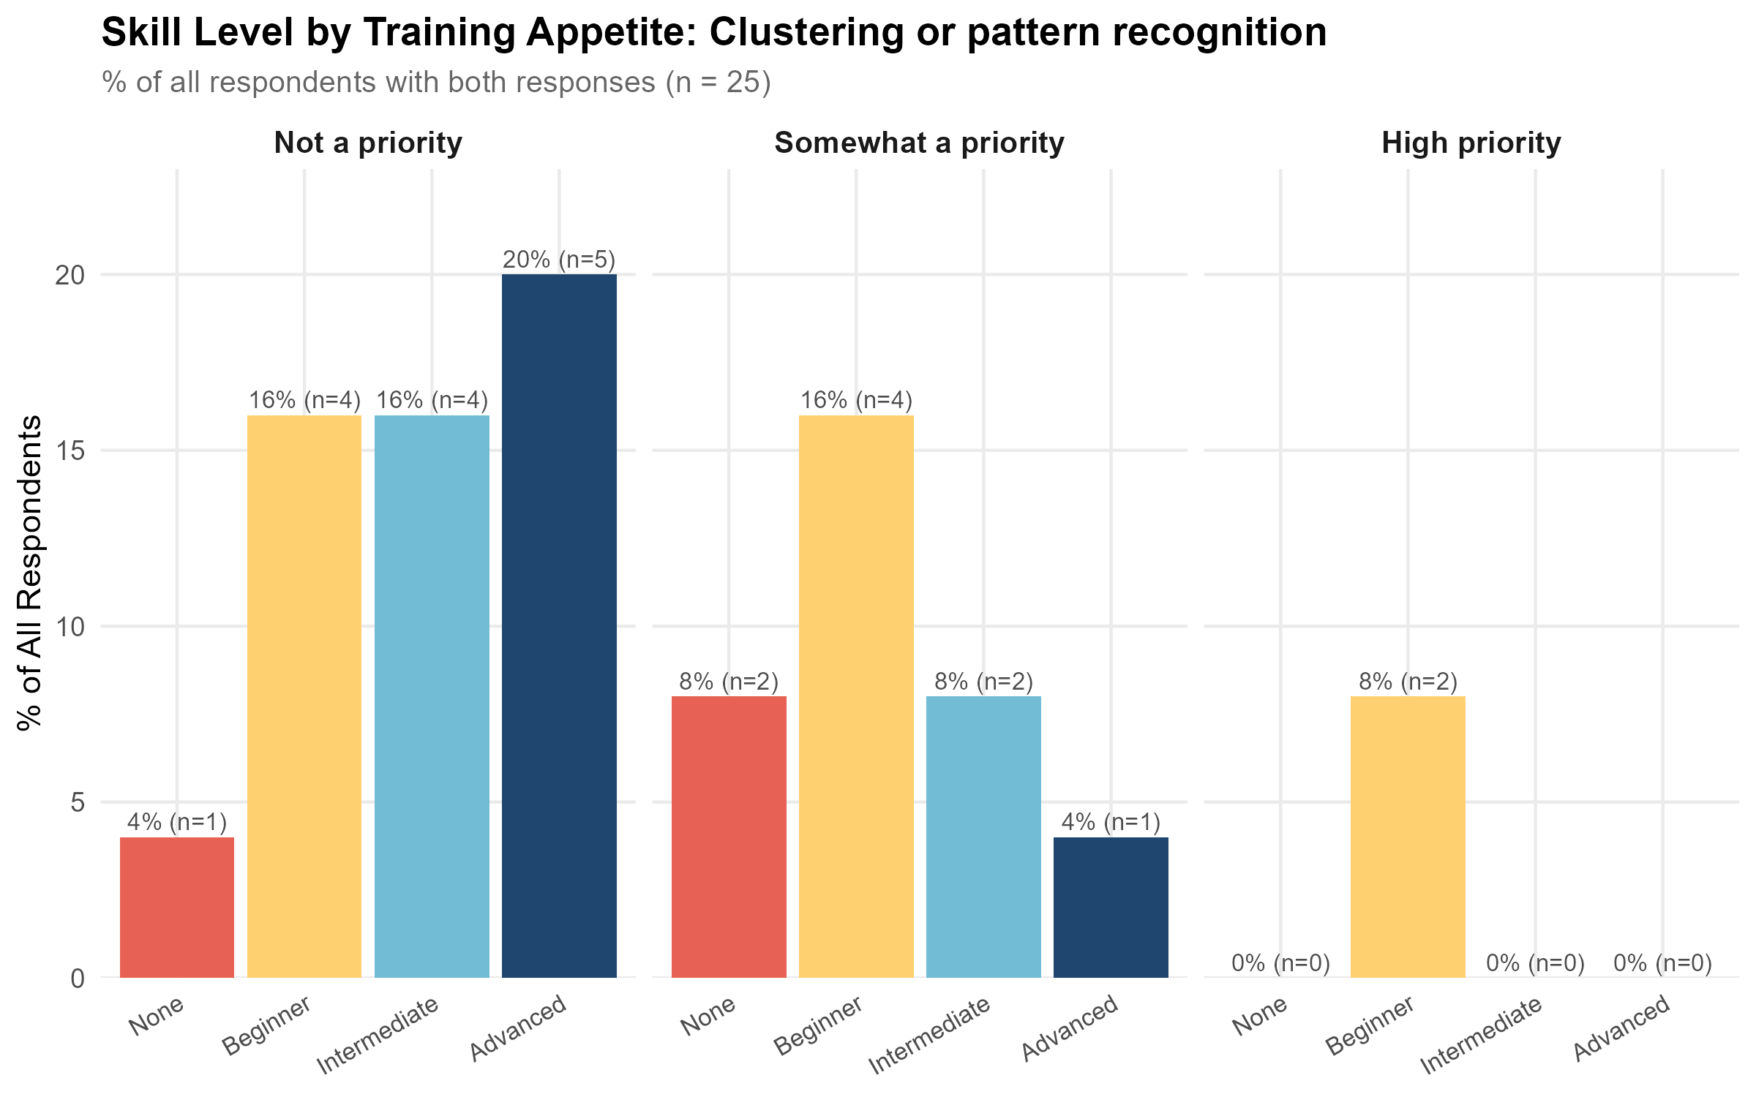
Clustering and Pattern Recognition: training demand and skill levels
See Appendix 2 for summary plots.

Findings
Geographic coverage
Of the 57 selected resources, five (9%) were Australian and 52 (91%) were international.
Delivery and format
Most resources, 54 (95%), were delivered fully online, with three blended. Format was led by short courses (28) and MOOCs (22), with a small number of workshops (5) and specialisations (2).
Coverage by level
Intermediate training was the dominant level (34 resources, 60%), followed by beginner (15), with comparatively few resources at advanced (7) or expert (1) level. Among the Australian resources, the split was four intermediate and one expert, with no beginner or advanced Australian resources identified.
Cost
Cost models were fairly evenly spread across paid (15), subscription (15), free to audit (14), free (9) and institutional access (4). Where a price was stated, costs ranged from $0 to $1,950 USD, with a median of $0.
Providers
No single provider dominated the database. Stanford Online and Udacity were the most frequent, with three resources each, followed by a long tail of providers with one or two resources. Australian providers (Intersect Australia, QCIF, Instats, and a joint BioCommons/QCIF/Sydney Informatics Hub/Monash Genomics listing) were each represented by one or two resources.
Of the 57 selected resources, 28% (16 resources) had some health domain relevance. The majority of health-relevant resources were rated low or medium (8 and 6 resources respectively), with only two resources rated high, suggesting that while clustering and pattern recognition training with a health context does exist, genuinely health-specific content remains limited.

Recommendations
Clustering and Pattern Recognition is reasonably well covered overall, with 57 resources spanning beginner through to expert level and a healthy mix of free and paid options. However, there is an Australian-specific gap and limited health-domain-relevant training options.

Training Resources
Please Appendix for a list of coursework resources for Clustering and Pattern Recognition.

NLP Models

71 training resources were identified for NLP Models, of which 2 were Australian and 69 were international. Coverage by level: 13 beginner, 42 intermediate, 16 advanced.

Community Skill Level and Training Demand
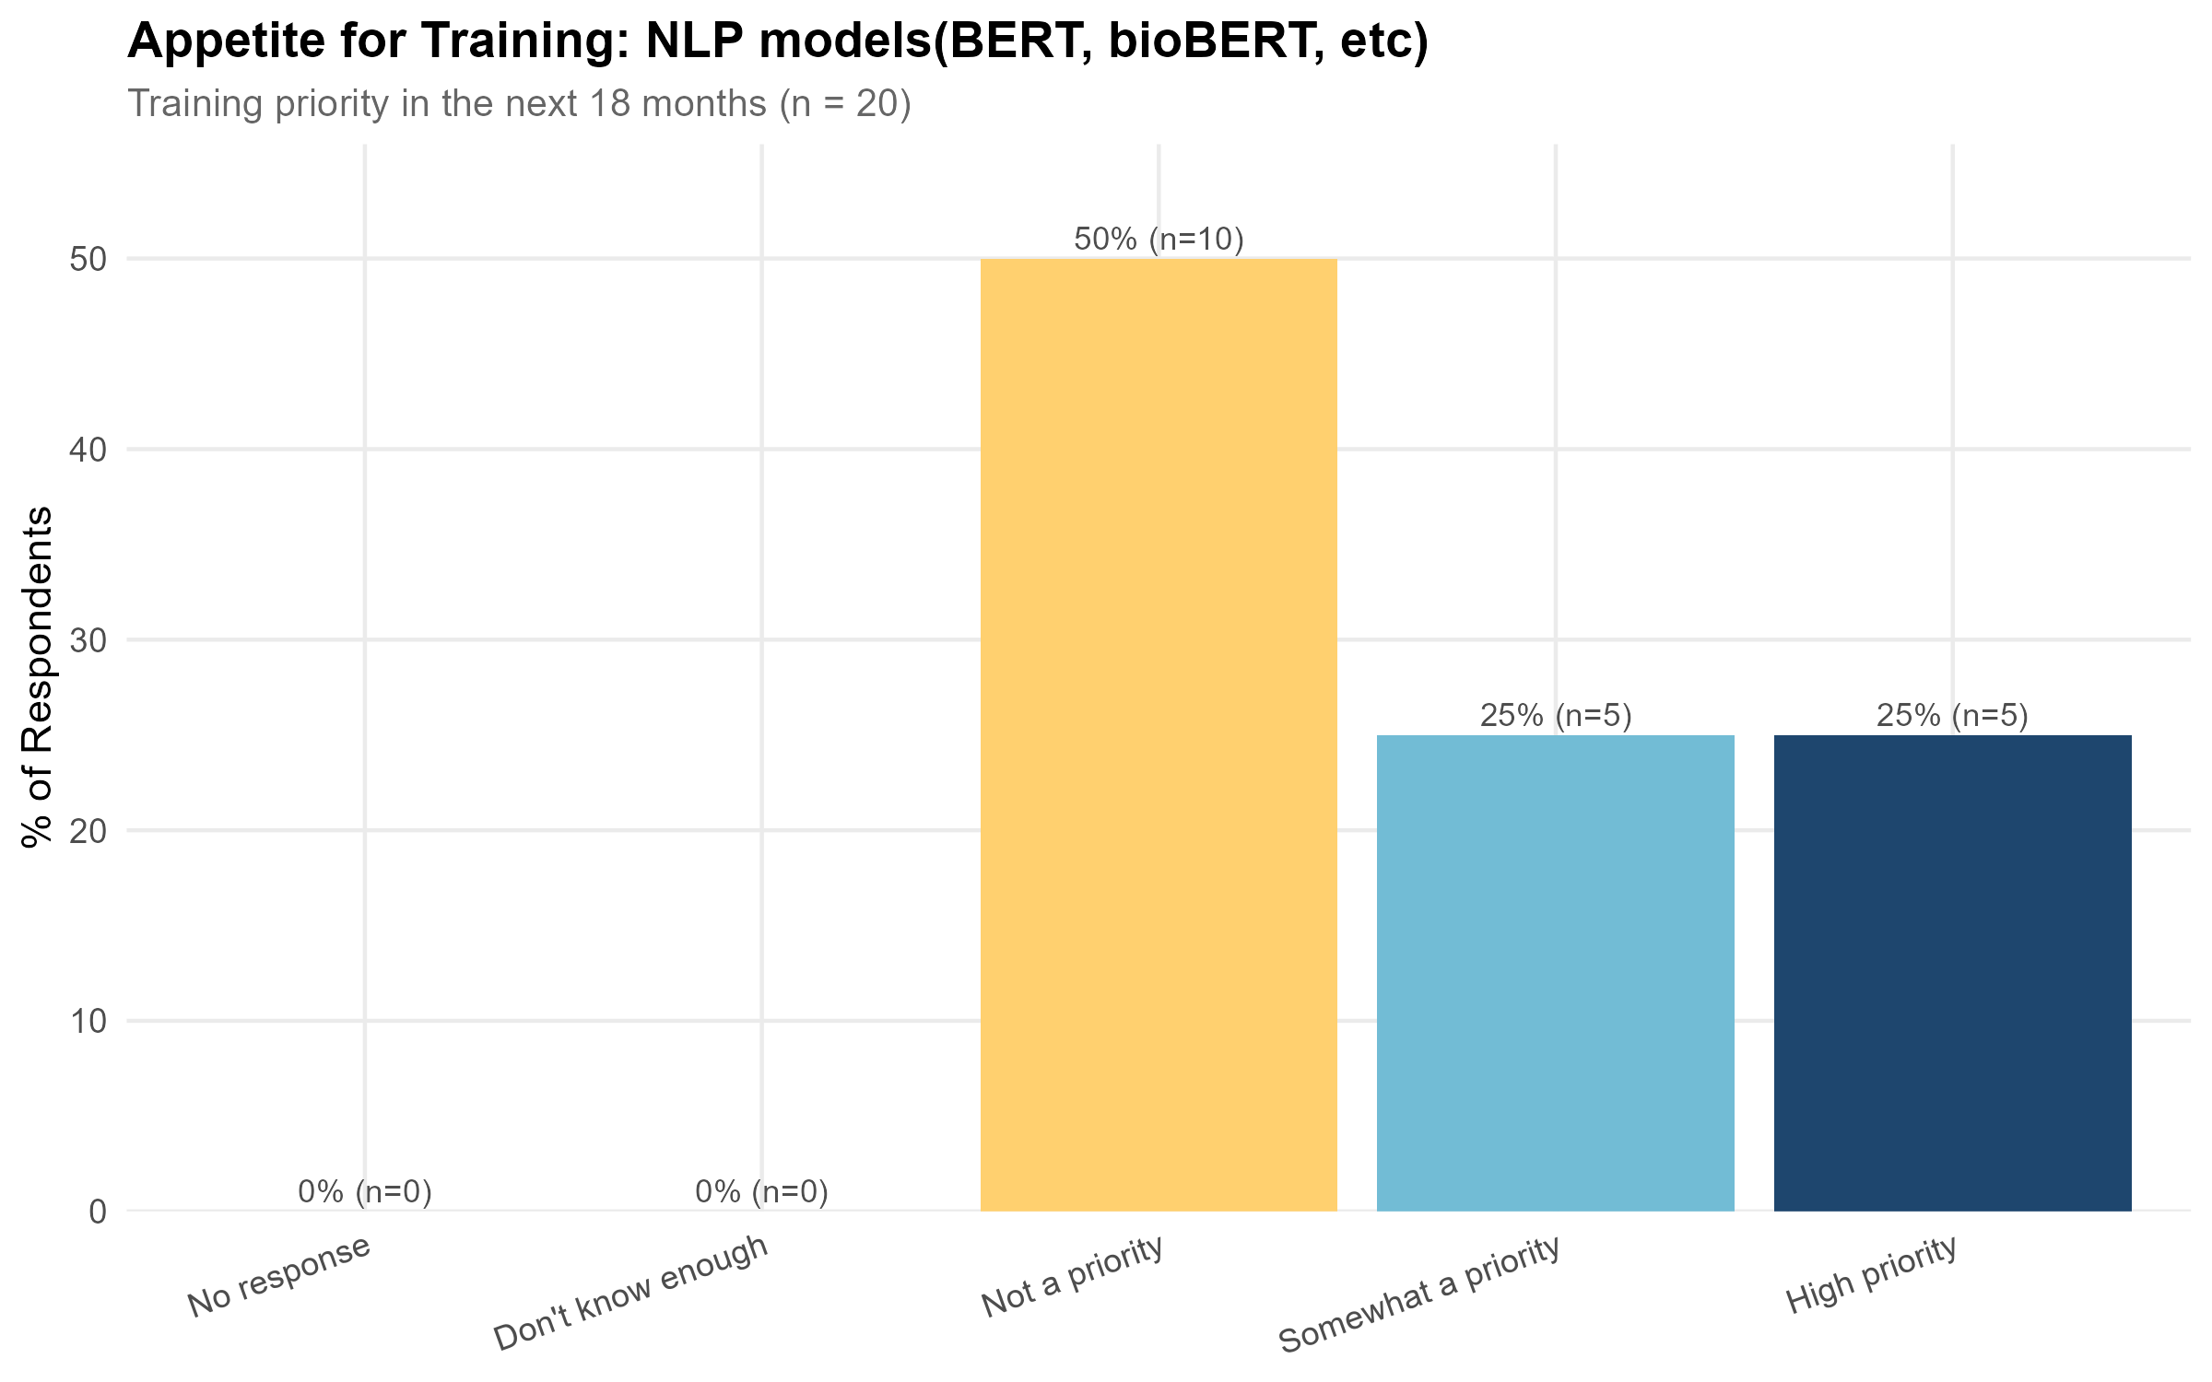  NLP Models: training demand and skill levels | 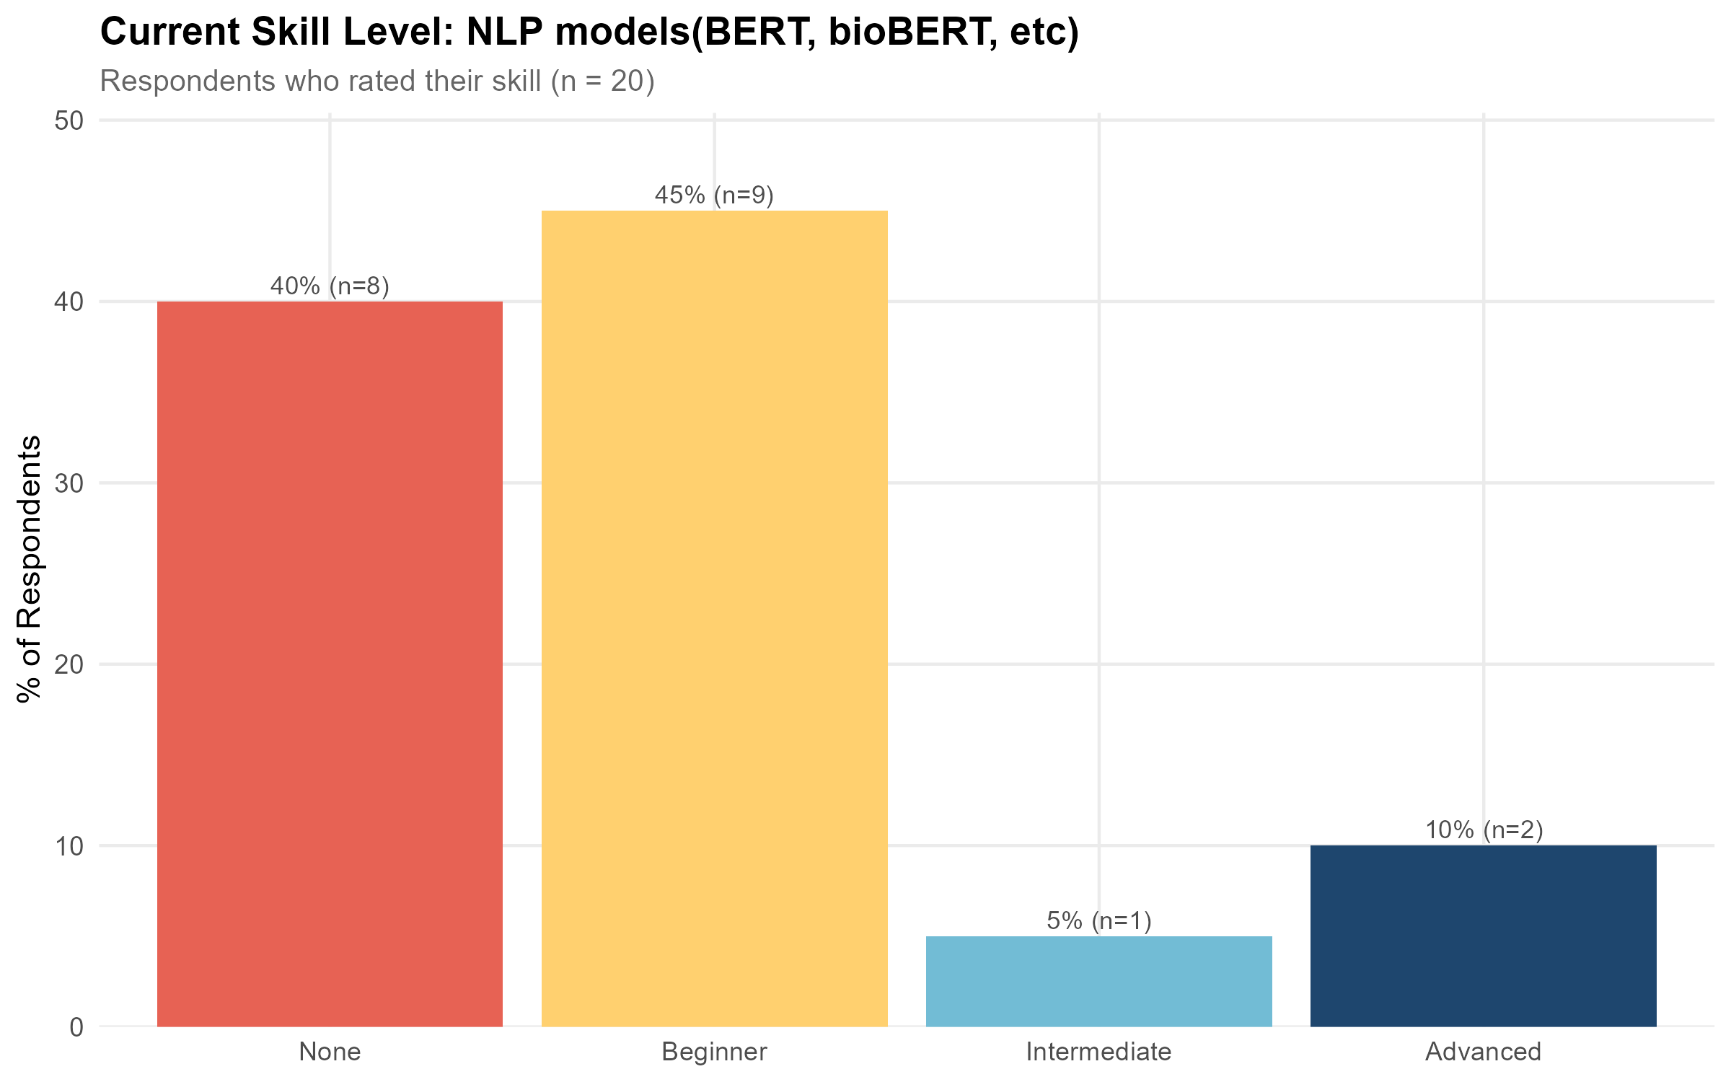  NLP Models: training demand and skill levels
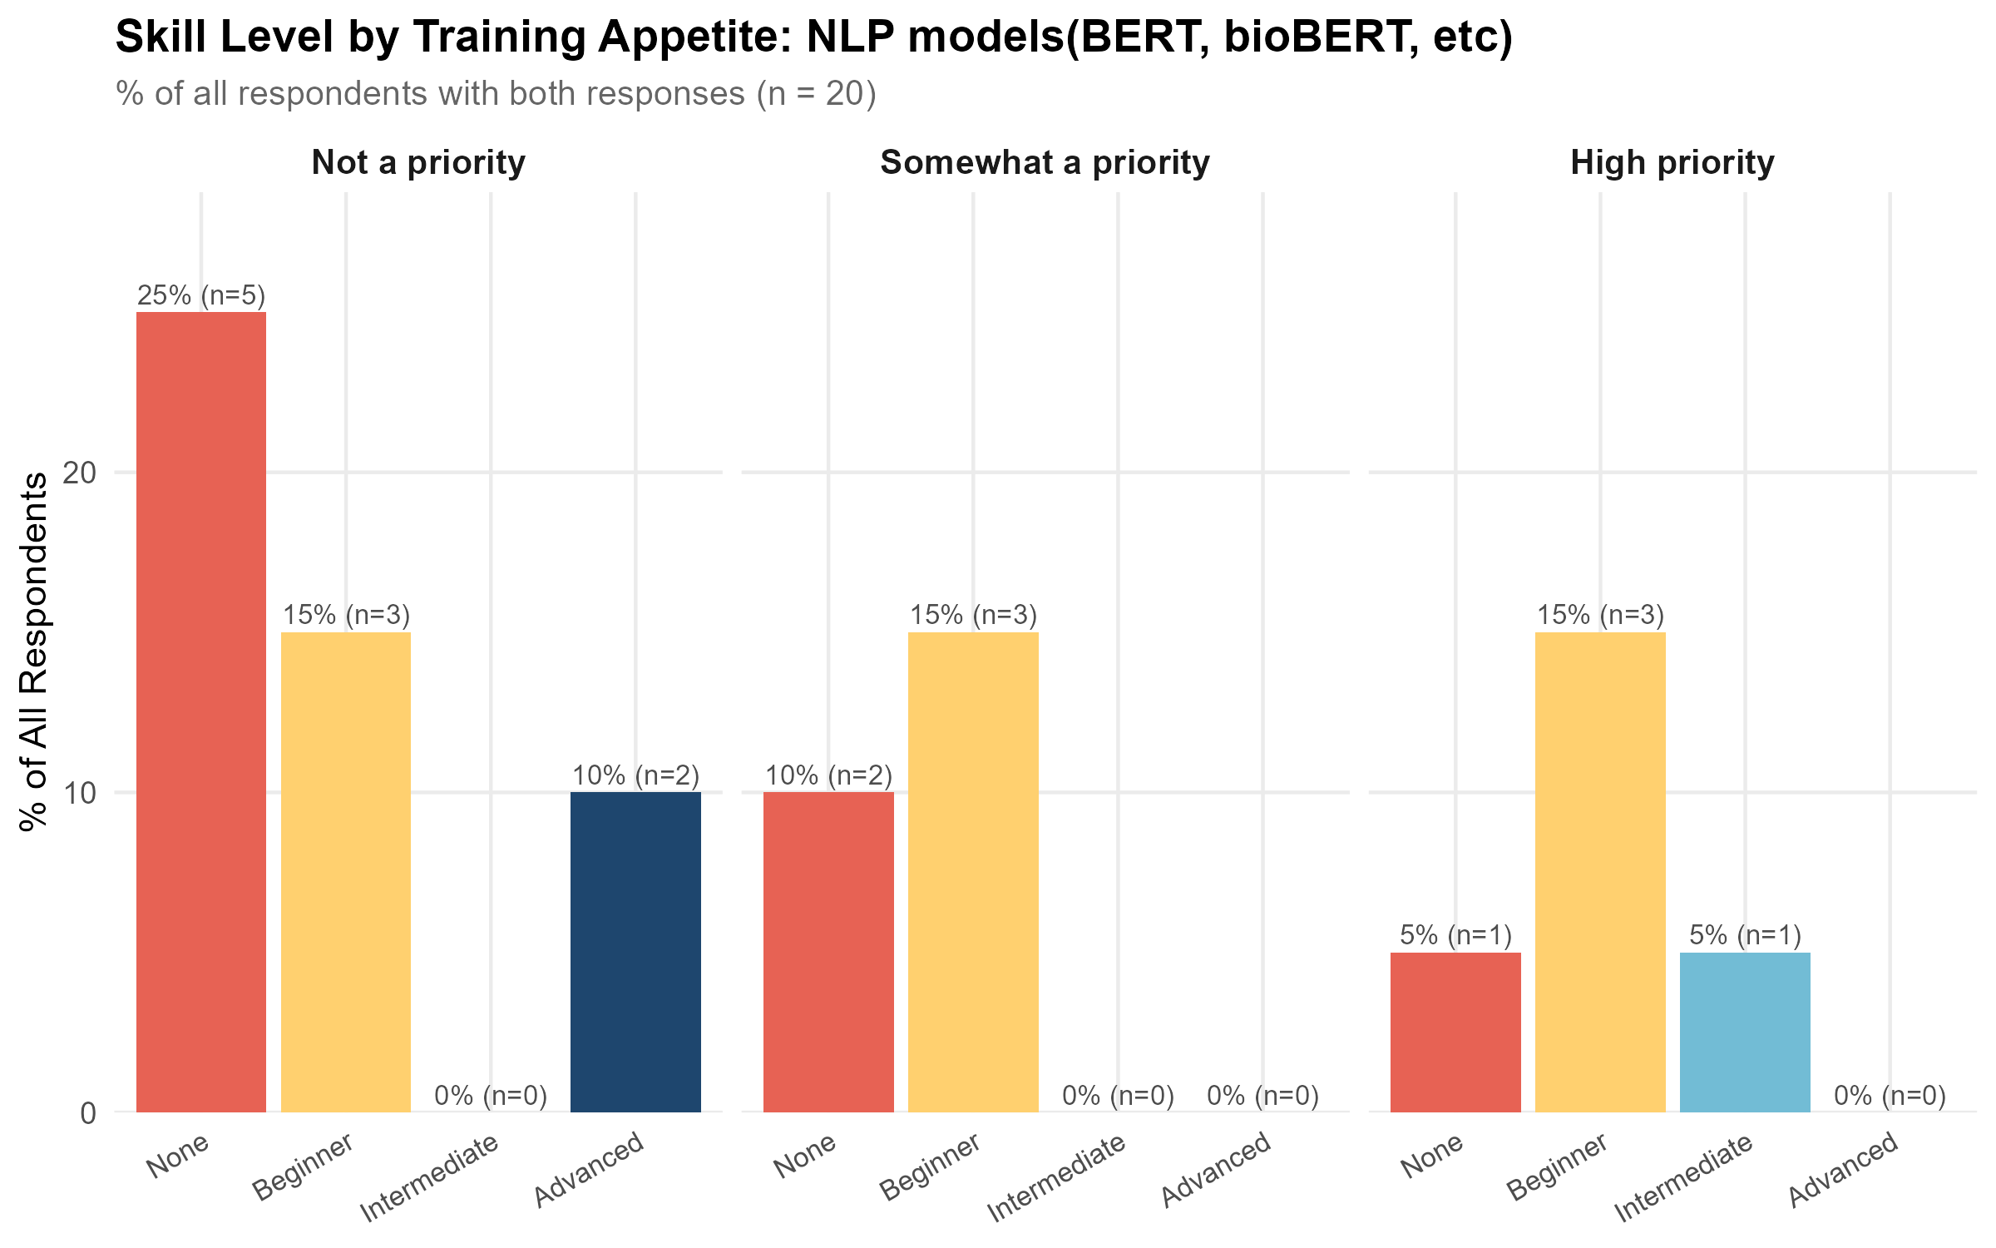
NLP Models: training demand and skill levels
See Appendix 2 for summary plots.

Findings
Geographic coverage
Of the 72 selected resources, only two (3%) were Australian; the remaining 70 (97%) were international.
Delivery and format
Almost all resources, 71 (99%), were delivered fully online, with one blended. Format was led by short courses (31) and MOOCs (30), with a smaller number of specialisations (4), professional certificates (4) and workshops (3).
Coverage by level
Intermediate training was the dominant level (43 resources, 60%), followed by advanced (16) and beginner (13). The two Australian resources were both beginner level.
Cost
Cost models were spread across subscription (25), paid (19), free (13) and free to audit (12), with a small number of freemium, institutional access and mixed-cost listings. Where a price was stated, costs ranged from $0 to $1,950 USD, with a median of $0.
Providers
DeepLearning.AI was the clear leading provider (11 resources), followed by DataCamp and Udacity (6 each) and Udemy (5). ACSPRI was the only Australian provider represented, with two resources, both beginner level.
Of the 72 selected resources, only 12.5% (9 resources) had any health domain relevance, split across low (5) and high (4) ratings, with no resources rated medium.

Recommendations
NLP Models is a strong candidate for training development. Australian coverage is minimal (2 of 72 resources, both beginner level, from a single provider), and the database is dominated by intermediate-level content despite Work Package 6.1 showing training demand for this tool is overwhelmingly introductory. Development of accessible, Australian-delivered, beginner-level training in NLP Models, ideally framed around health and biomedical applications (e.g. bioBERT-style use cases), would address both the geographic and skill-level gaps identified here. The very limited health-specific content available for NLP Models reinforces the case for developing Australian training that explicitly situates NLP techniques within a health and biomedical research context.

Training Resources
Please Appendix for a list of coursework resources for NLP Models.

Community Engagement Methods

Findings
No courses teaching community engagement methods were identified through the search protocol.

Recommendations
Community Engagement Methods is not considered a candidate for Advanced Analytics and AI training development. Although the survey results indicate demand for this type of training, it is considered outside the scope of the AAAIR project’s advanced analytics and AI remit.

Model Interpretability and Explainability

17 training resources were identified for Model Interpretability and Explainability, of which 0 were Australian and 17 were international. Coverage by level: 1 beginner, 10 intermediate, 6 advanced.

Community Skill Level and Training Demand
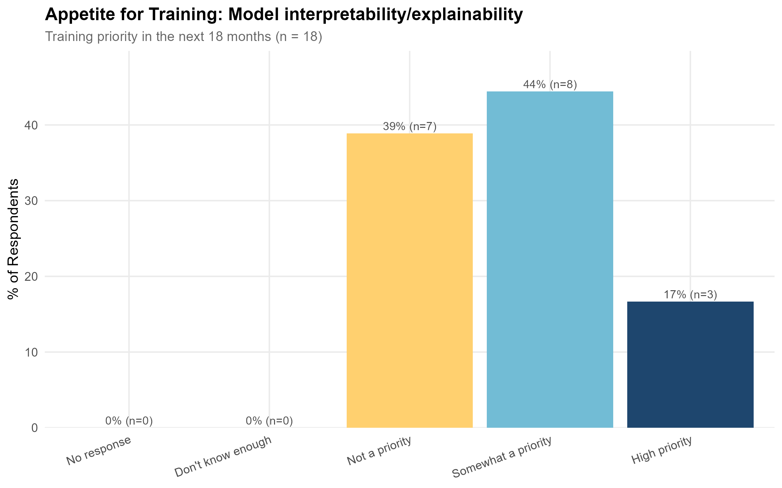  Model Interpretability and Explainability: training demand and skill levels | 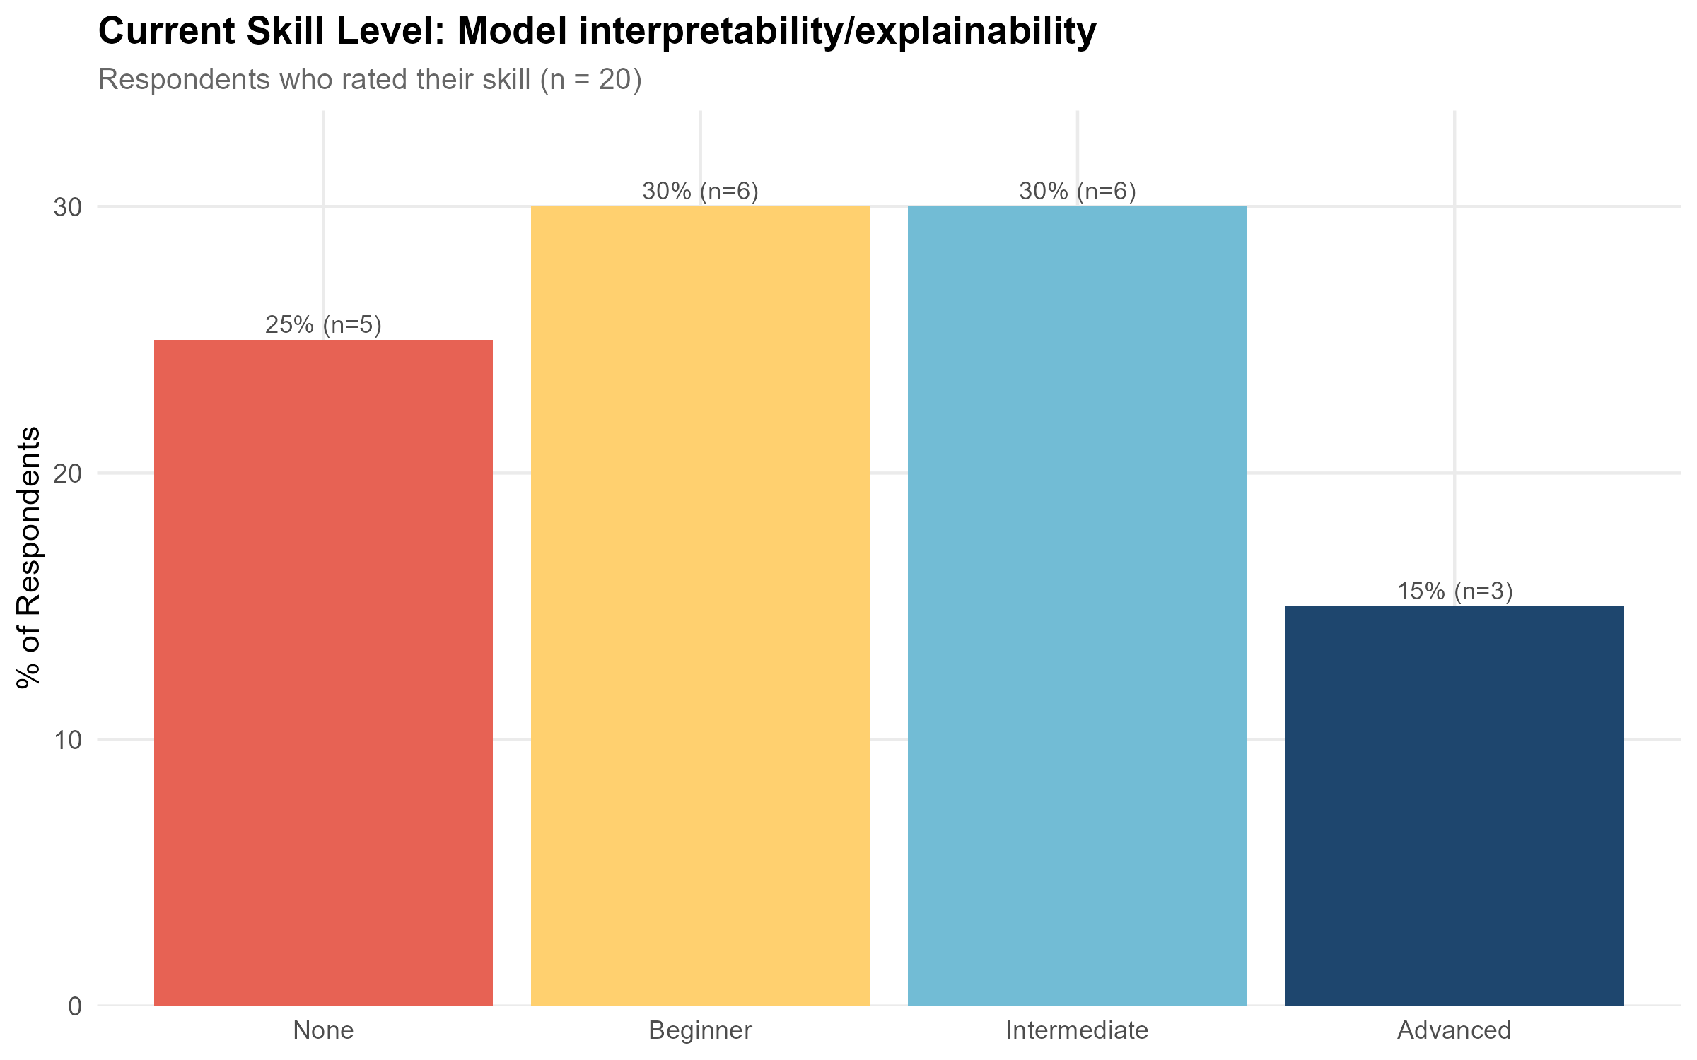  Model Interpretability and Explainability: training demand and skill levels
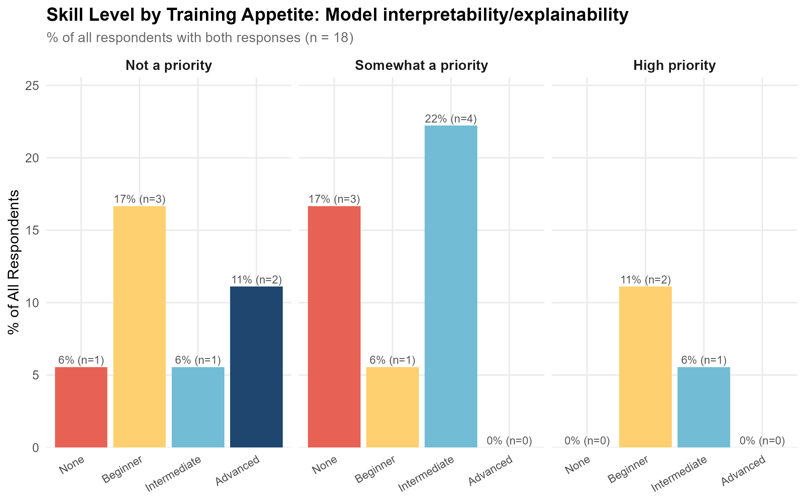
Model Interpretability and Explainability: training demand and skill levels
See Appendix 2 for summary plots.

Findings
Geographic coverage
All 17 selected resources were international; no Australian-delivered training was identified.
Delivery and format
Almost all resources, 16 of 17, were delivered fully online, with one blended. Format was led by short courses (10) and MOOCs (6), with one specialisation.
Coverage by level
Intermediate training was the dominant level (10 resources), followed by advanced (6), with only one beginner-level resource identified.
Cost
Cost models were split across paid (8), subscription (6), free (2) and free to audit (1). Where a price was stated, costs ranged from $0 to $249 USD.
Providers
DeepLearning.AI and Udemy were the most frequent providers (3 resources each); the remaining resources were each from a different provider.
Of the 17 selected resources, 29% (5 resources) had some health domain relevance. Given the small overall pool of resources identified for this tool, the limited health-specific content further strengthens the case for development of targeted training in model interpretability and explainability within a health research context.

Recommendations
The near-total absence of Australian-delivered training, combined with very limited beginner-level content (1 of 17 resources) and limited resources with health domain relevance, suggests Model Interpretability and Explainability is a reasonable candidate for training development, particularly introductory material that situates interpretability and explainability concepts within a health research context. This appears to be an emerging area of interest rather than a long-established training need, and demand may continue to grow as AI and LLM tools become more embedded in research workflows (see the Special Note Regarding AI Tools section).

Training Resources
Course / Programme | Provider | Level
Amazon SageMaker Studio for Data Scientists | AWS Training | Advanced
Advanced Machine Learning with Databricks | Databricks Academy | Advanced
Advanced Machine Learning Using SAS Viya | SAS Training | Advanced
TensorFlow: Advanced Techniques Specialization | DeepLearning.AI | Advanced
Advanced Computer Vision with TensorFlow | DeepLearning.AI | Advanced
AI for Healthcare Nanodegree | Udacity | Advanced
Explainable AI (XAI) with Python | Udemy | Beginner
Manage and Review Models in Azure Machine Learning | Microsoft Learn | Intermediate
IBM Machine Learning Professional Certificate | IBM (via Coursera) | Intermediate
Predictive Artificial Intelligence | MIT xPRO | Intermediate
Applied Machine Learning and AI Certificate | Cornell University | Intermediate
AI For Medical Treatment | DeepLearning.AI | Intermediate
Explainable AI in Python | DataCamp | Intermediate
Machine Learning Explainability | Kaggle | Intermediate
Explainable and Interpretable Artificial Intelligence: 1 | Udemy | Intermediate
Explainable and Interpretable AI: Techniques and Application | Udemy | Intermediate
Deep Learning with PyTorch for Medical Image Analysis | Udemy / Pierian Training (Jose Portilla et al.) | Intermediate

Overall Recommendations

Training Development Priorities
Based on the gap analysis conducted across the 11 priority tools, four tools are identified as strong candidates for the development of new training resources. In each case, the recommendation is driven by some combination of high training demand, limited Australian-delivered content, a mismatch between available training levels and the skill level at which demand is concentrated, and limited health-domain-specific content.
Electronic Health Records (EHR) Analytics and Data Linkage is the highest-priority candidate for training development. It ranked first overall in the Work Package 6.1 survey on Training Impact Score, reflecting both strong demand and a substantial existing skill gap. Only three Australian resources were identified, two of which were from providers with no current training available at the time of this report. No advanced Australian training specific to EHR data was identified. Locally produced training is particularly important for this tool, as Australian EHR and linked data have specific structural, terminological and legislative characteristics that international courses are unlikely to address adequately.
SQL and Database Management is also recommended as a priority for development. All respondents who rated training as a high priority for this tool self-identified as beginners, and the database was heavily weighted toward international content with no health domain relevance (90% with no health domain relevance, only one Australian resource). The development of introductory, health-research-focused, Australian-delivered training is recommended.
NLP Models (BERT, bioBERT, etc.) is a strong candidate for development, particularly introductory training framed around health and biomedical applications. Training demand in this area was overwhelmingly introductory (90% of demand from None/Beginner respondents in the Work Package 6.1 survey), yet the available training was dominated by intermediate-level content. Only two of 72 NLP Model resources were Australian, and only 12.5% of resources had any health domain relevance.
Model Interpretability and Explainability is an emerging priority. Only 17 resources were identified, none of them Australian, and only one at beginner level. As AI and LLM tools see increasing uptake in health research, demand for training in this area is expected to grow. Introductory, health-research-focused training is recommended.
Clinical Trial Design and Analysis warrants further investigation before being formally recommended for development. No Australian courses were identified, which is more likely a limitation of the search protocol than a genuine absence. If further investigation confirms that Australian training in this area is genuinely limited, it should be treated as a development priority.
Regression is an interesting case. It ranked highly on the skills gap score despite being a technique researchers would typically encounter during university training. This likely reflects the composition of the health research workforce, with many researchers entering analytics from a clinical or domain-expertise background rather than a quantitative one. If training is developed for this tool, it should be framed around applied, domain-specific regression in health research contexts rather than introductory statistical theory.

Tools Not Recommended as Development Priorities
The following tools are considered adequately served by existing online training and are not recommended as development priorities at this time. In each case, a sufficient volume of on-demand, online training is available across a range of skill levels that meets the current demand profile identified in the Work Package 6.1 survey.
- R Programming: well covered across all levels, with a high volume of on-demand, online resources available free or at low cost. Basic training for R is not a gap in the current landscape.
- GitHub: well covered, with many on-demand, online resources available, the majority free of charge.
- Causal Analysis: only seven resources were identified, but demand in the survey was also relatively low. Existing resources span intermediate through to expert level, which broadly matches the skill profile of respondents expressing training interest.
- Clustering and Pattern Recognition: reasonably well covered across most levels, with 57 resources identified. However, Australian coverage at beginner and advanced levels is limited; this may warrant targeted development if demand grows. This should be re-evaluated in the future, as health domain coverage was present but not extensive.

Learning Preferences and Implications for Training Design
Survey respondents expressed a strong preference for self-paced, on-demand learning, with self-paced online courses, video tutorials, reading research papers and documentation, and tutorials all highly preferred formats. One-on-one mentoring was the most preferred format overall, though it is difficult to scale and was not well represented in the database. Conference workshops and hands-on project-based learning showed high rates of “not preferred at all”, suggesting these formats may not be well suited to the broader community, though this finding should be interpreted cautiously given the survey sample size.
These preferences have direct implications for training design: new resources developed for priority tools should, where possible, be self-paced and available on demand. Given that learning format preferences likely differ across tool types and skill levels, future survey rounds should consider asking domain-specific questions about preferred learning formats rather than applying a single set of preferences across all tools.

Appendices

Search Protocol Selection / Rejection Protocol
Selection Criteria
# | Criterion
S1 | Health data and health research specific analytics courses.
S2 | LLM and generative AI training specifically designed for or framed around research.
S3 | Any course delivered by a key Australian research stakeholder, including: ARDC, QCIF, PAWSEY, Instats, Intersect Australia, DReSA, Australian BioCommons, Australian Statistical Society, Nectar, Australian Consortium for Social and Political Research (ACSPRI), and Australian Bioinformatics and Computational Biology Society (ABACBS), Sax Institute.
S4 | Teaches to the top 10 training needs identified in 6.1
S5 | Contains health data adjacent examples and data
S6 | Training provider – 1 line per provider retained in the database. Users are directed to check these providers as one-of training is constantly being offered.
S7 | New AI, LLM or ML technology that requires further review in order to exclude.
Rejection Criteria
# | Criterion
R1 | The course is delivered in-person only, outside of Australia.
R2 | Postgraduate coursework that requires enrolment in a PhD or Masters programme.
R3 | Degree programmes.
R4 | Grant writing coursework.
R5 | Basic programming or methods courses with no health research focus. Except for any methods or tools listed in the top 10 learning needs in WP 6.1. Researchers are directed instead to Research Bazaar, the Carpentries, their university and other providers listed in the project disclaimer.
R6 | Past workshops or courses where the course material is not available for on-demand access.
R7 | Coursework targeting business analytics, including: Google Analytics, PwC training, and IBM Professional training. These tools are typically available at enterprise level only — organisations with access to them are assumed to have access to vendor-provided training.
R8 | Training targeting business analytics tools, including: Tableau, Excel, and Power BI.
R9 | All TAFE courses.
R10 | Khan Academy. Content is assumed to be undergraduate statistics level and not relevant to the research audience.
R11 | General LLM training, for example OpenAI training, ChatGPT training, which does not have a focus on the use of chat based LLM tools for research.
R12 | AI agent training.
R13 | Too basic for health researchers. No analytics only introductory concepts, or Healthcare professional focused not health research focused.

Summary Plots by Tool

Summary Plots — Electronic Health Records (EHR) Analytics and Data Linkage
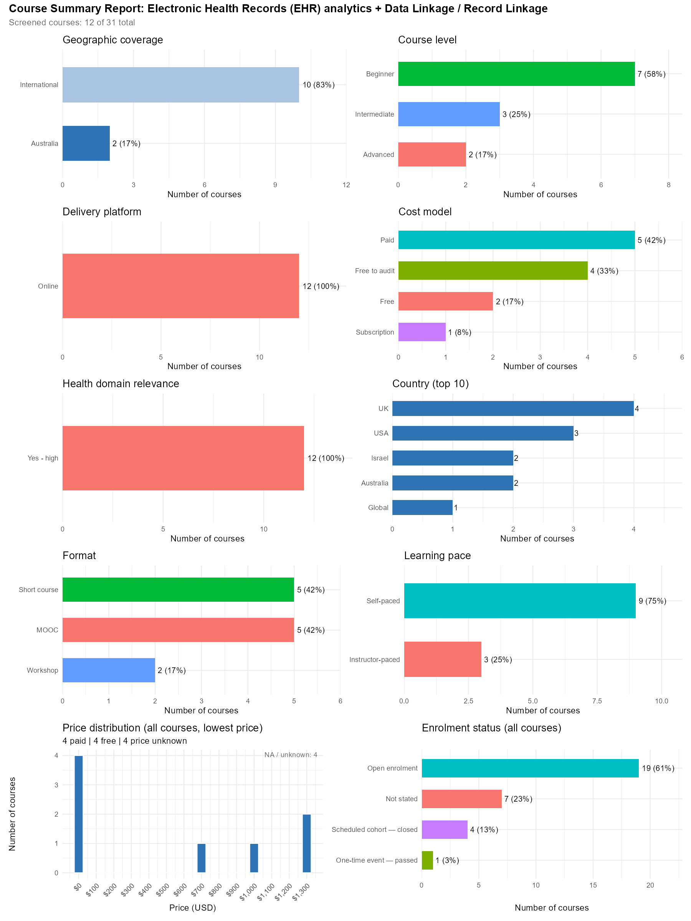

Summary Plots — R Programming
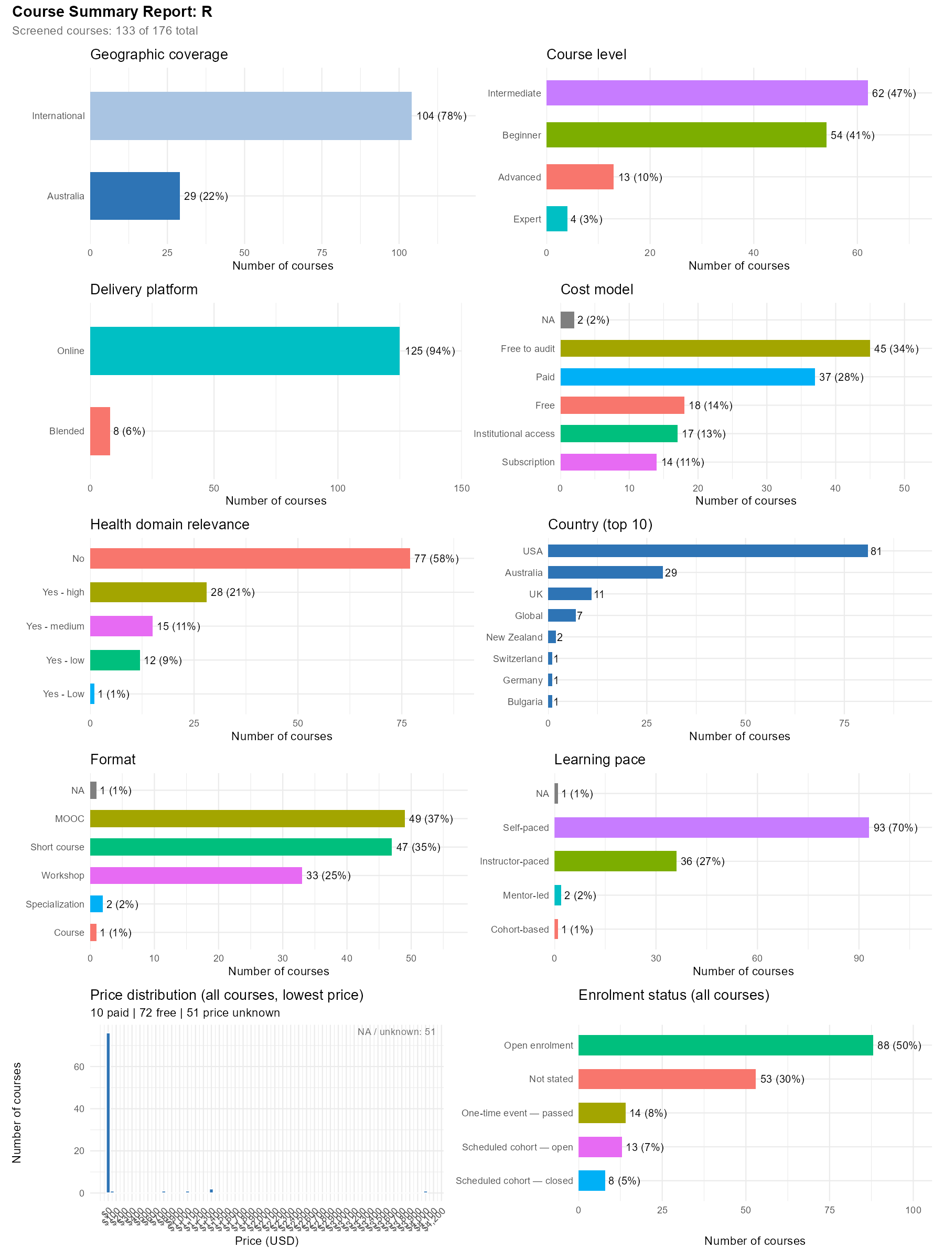
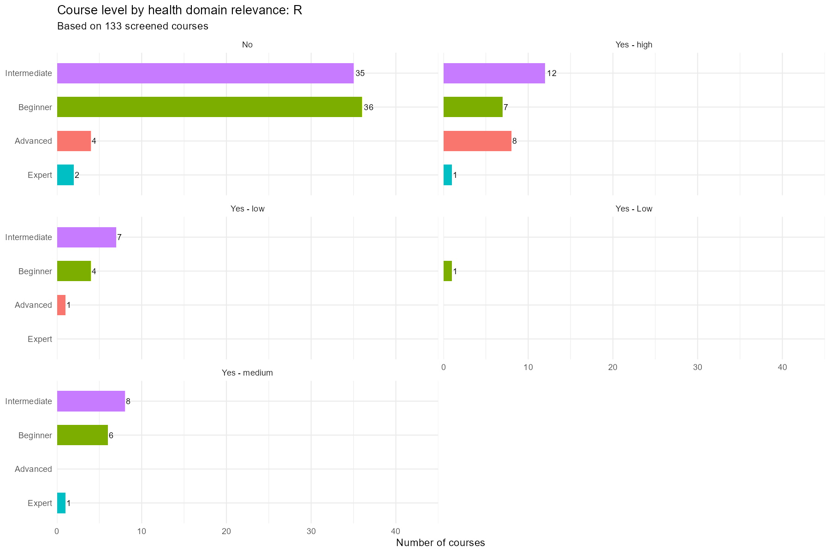

Summary Plots — Causal Analysis
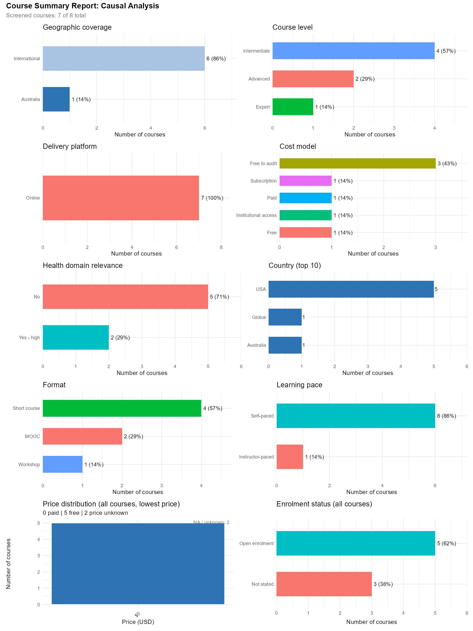
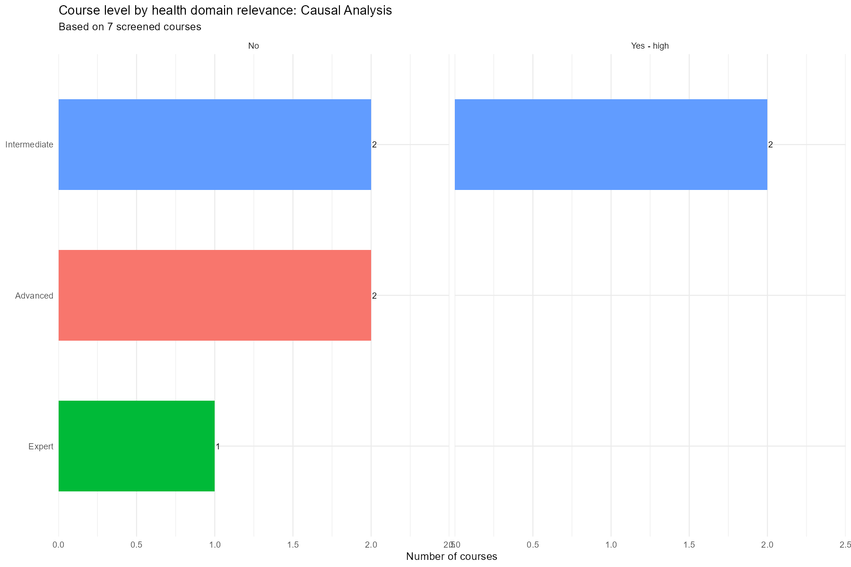

Summary Plots — Regression
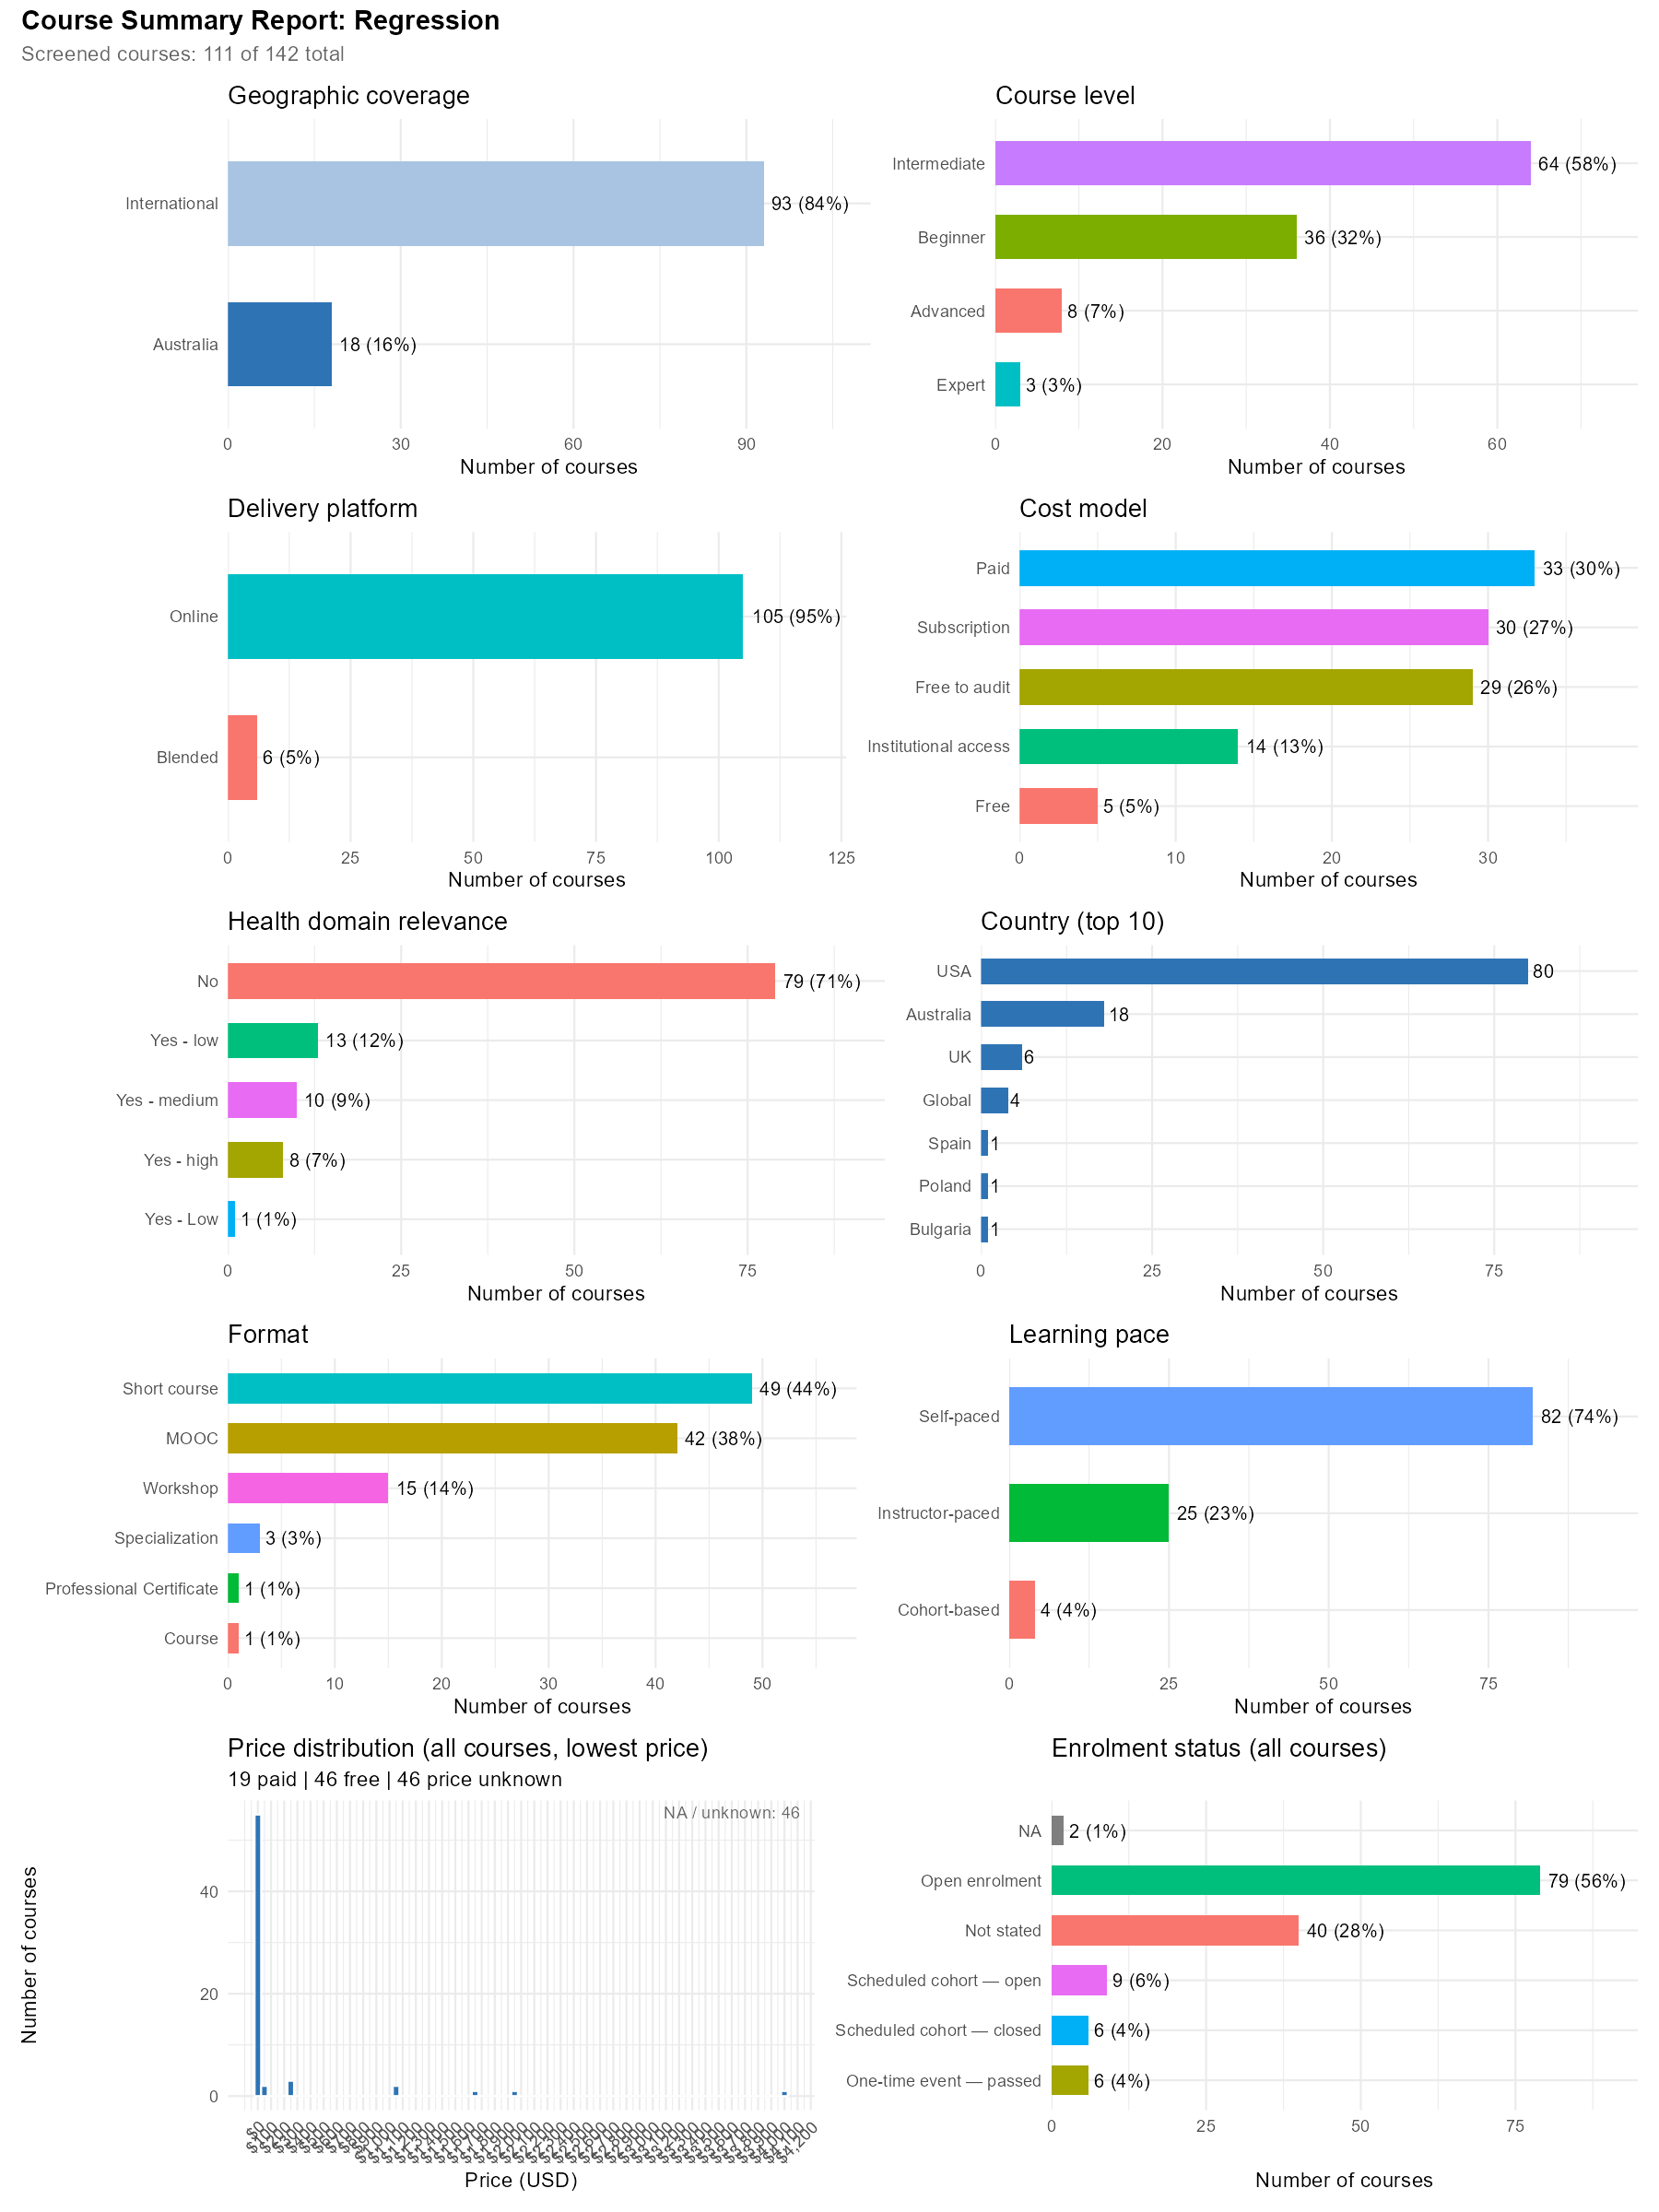
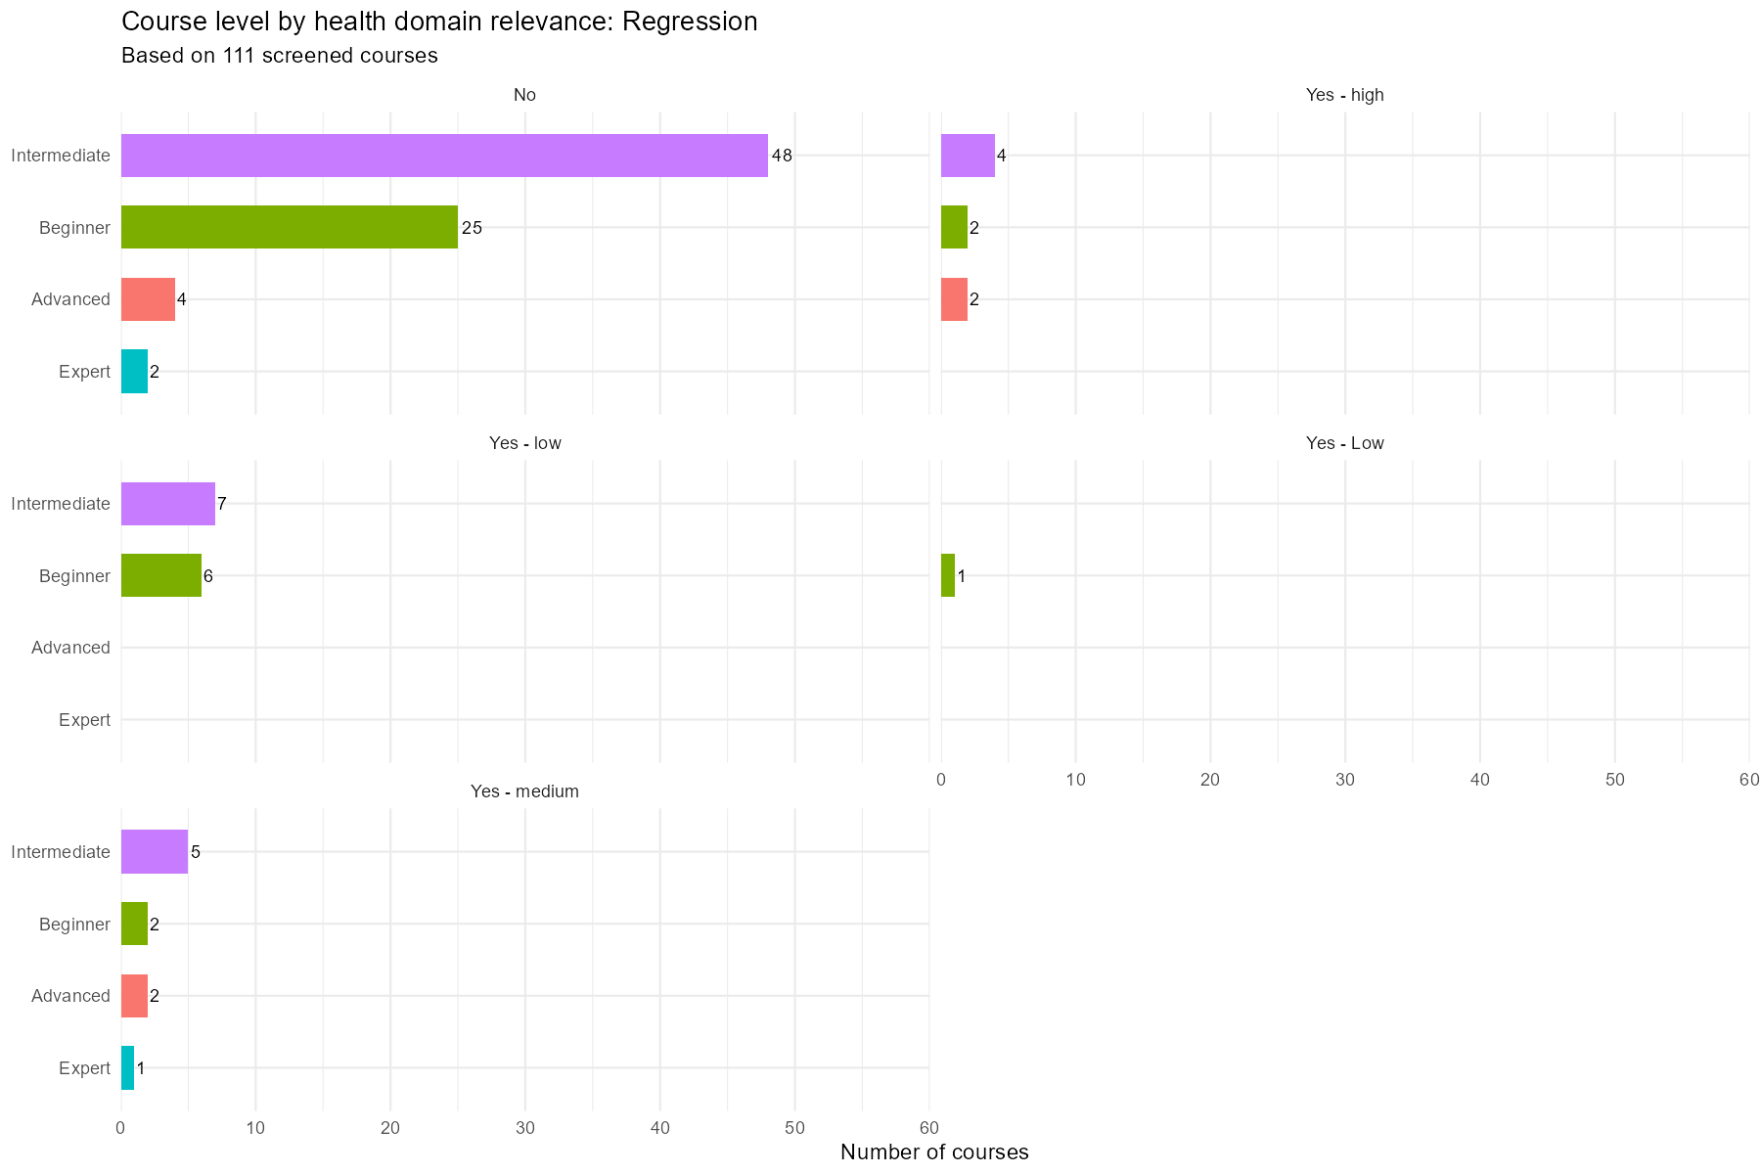

Summary Plots — SQL and Database Management
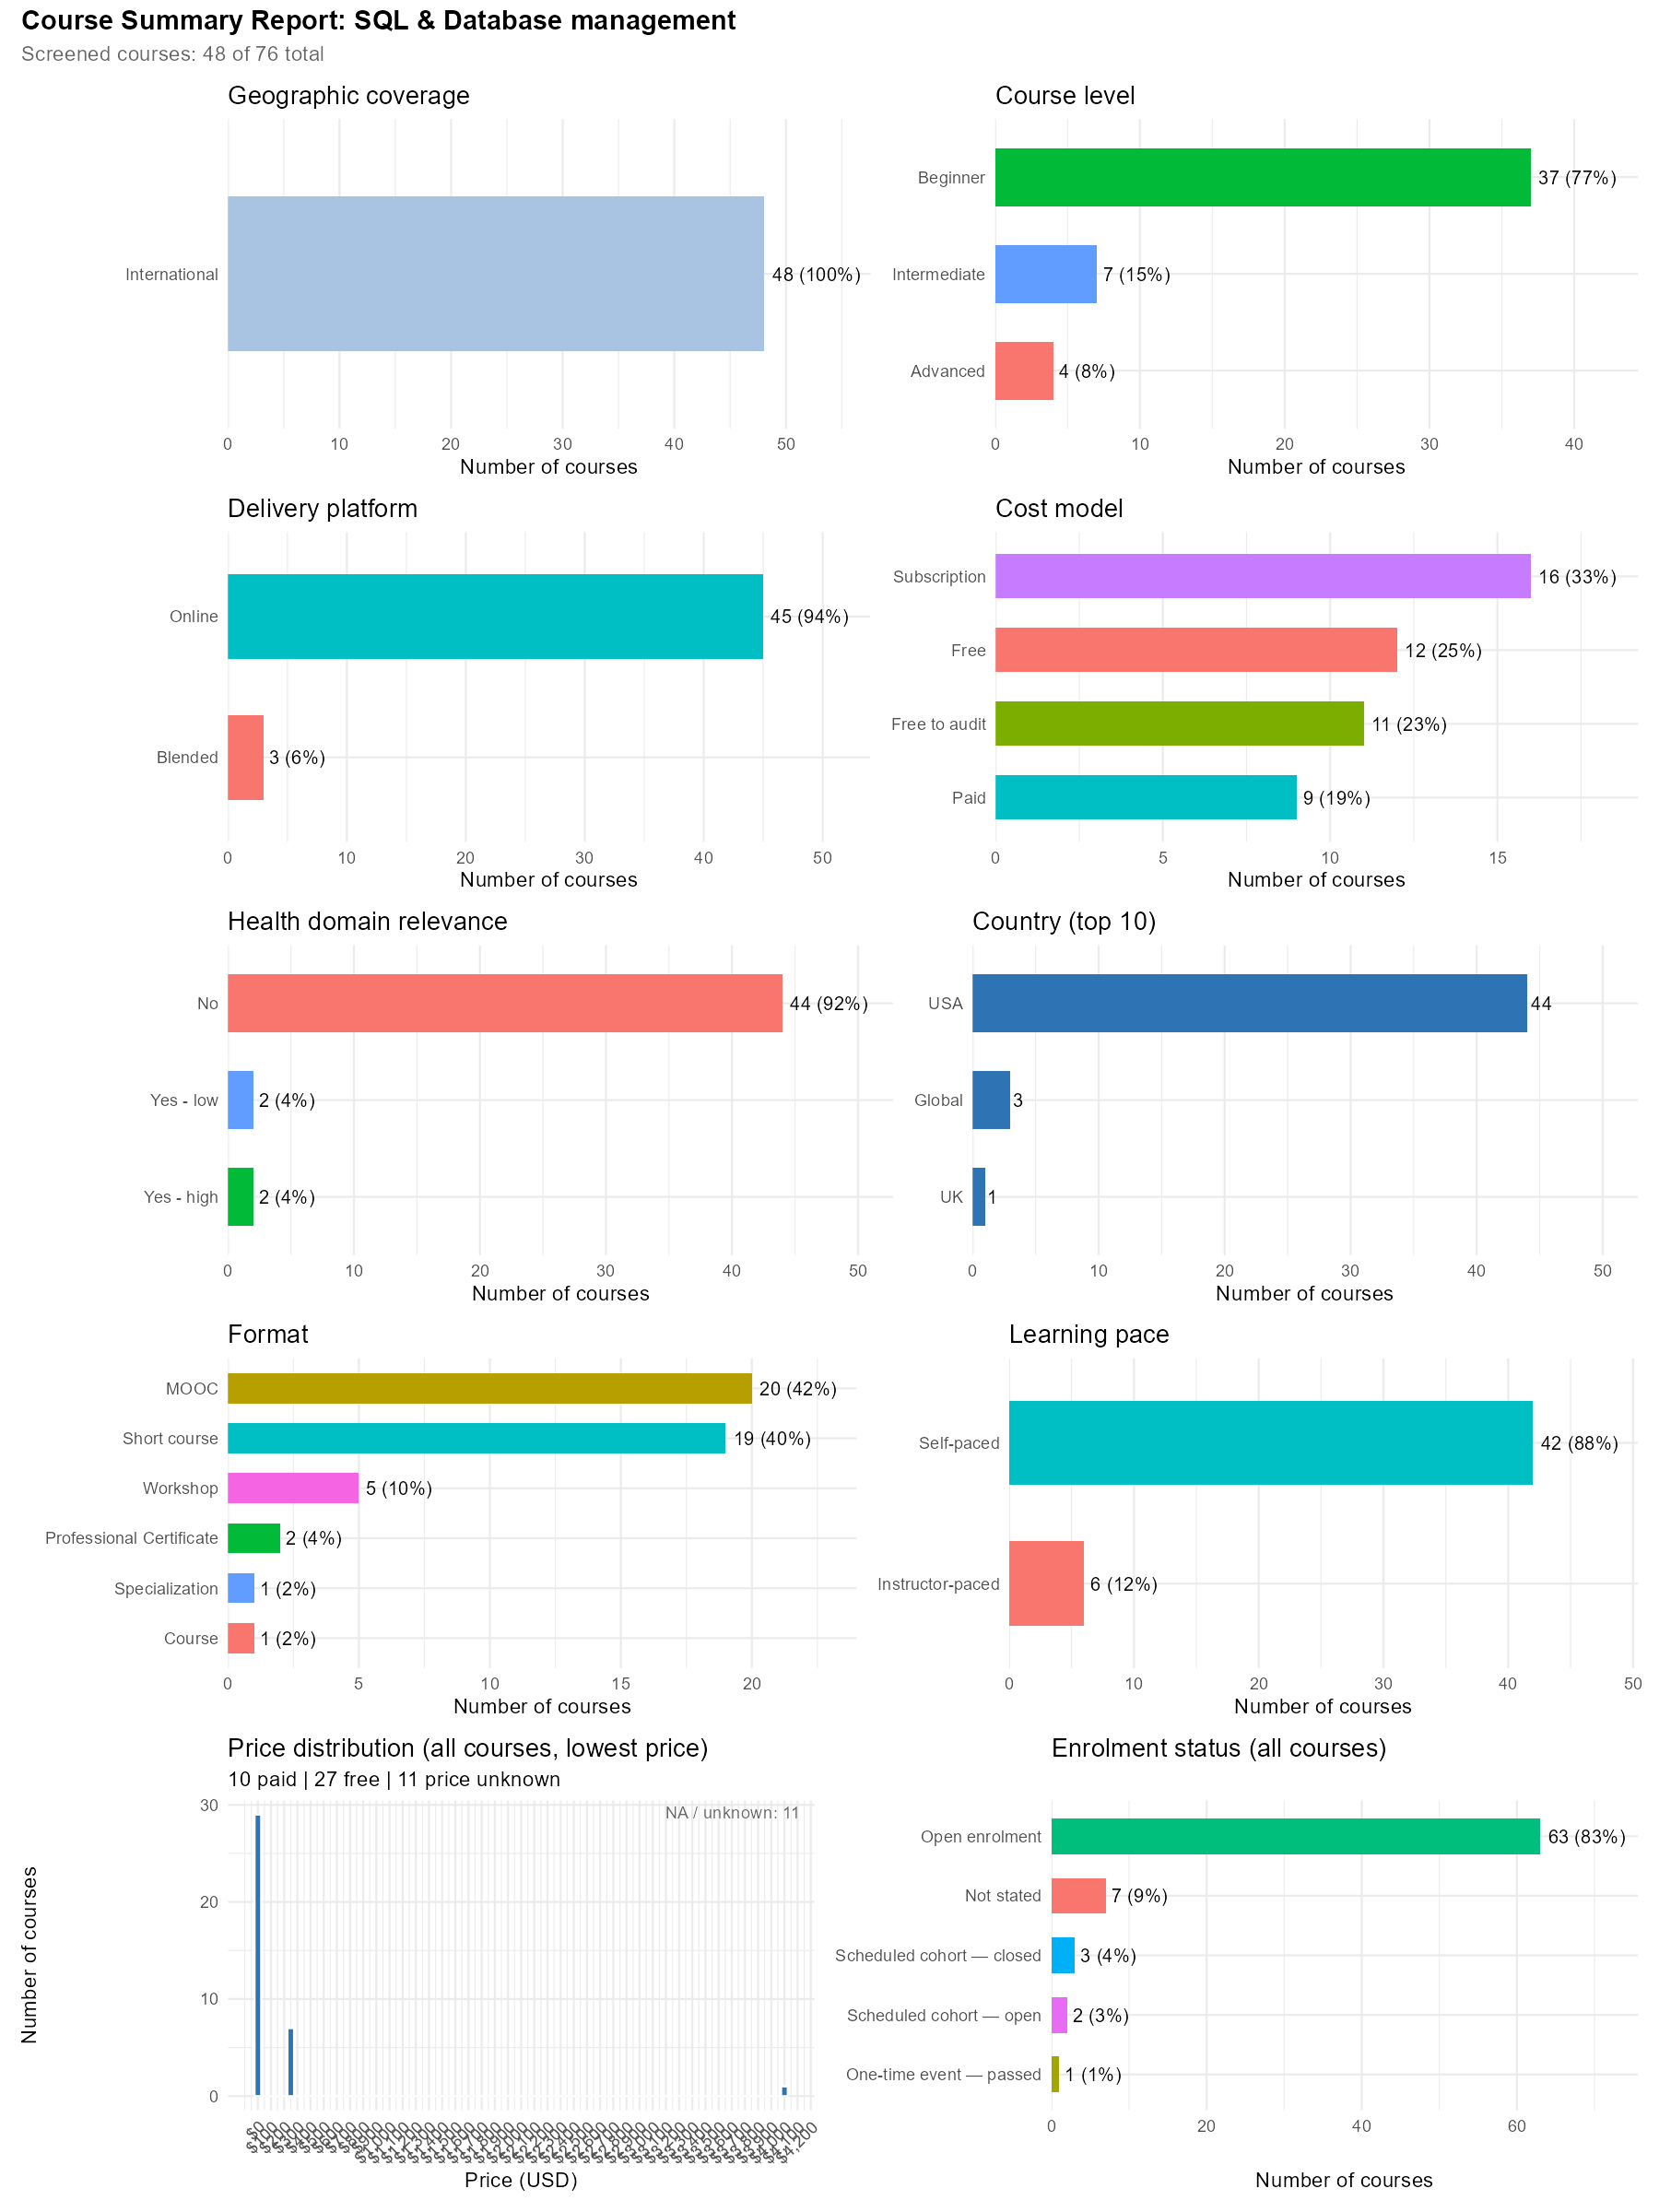
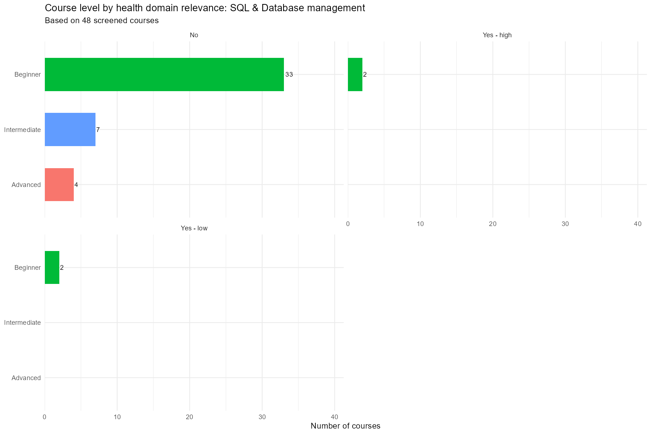

Summary Plots — Clinical Trial Design and Analysis
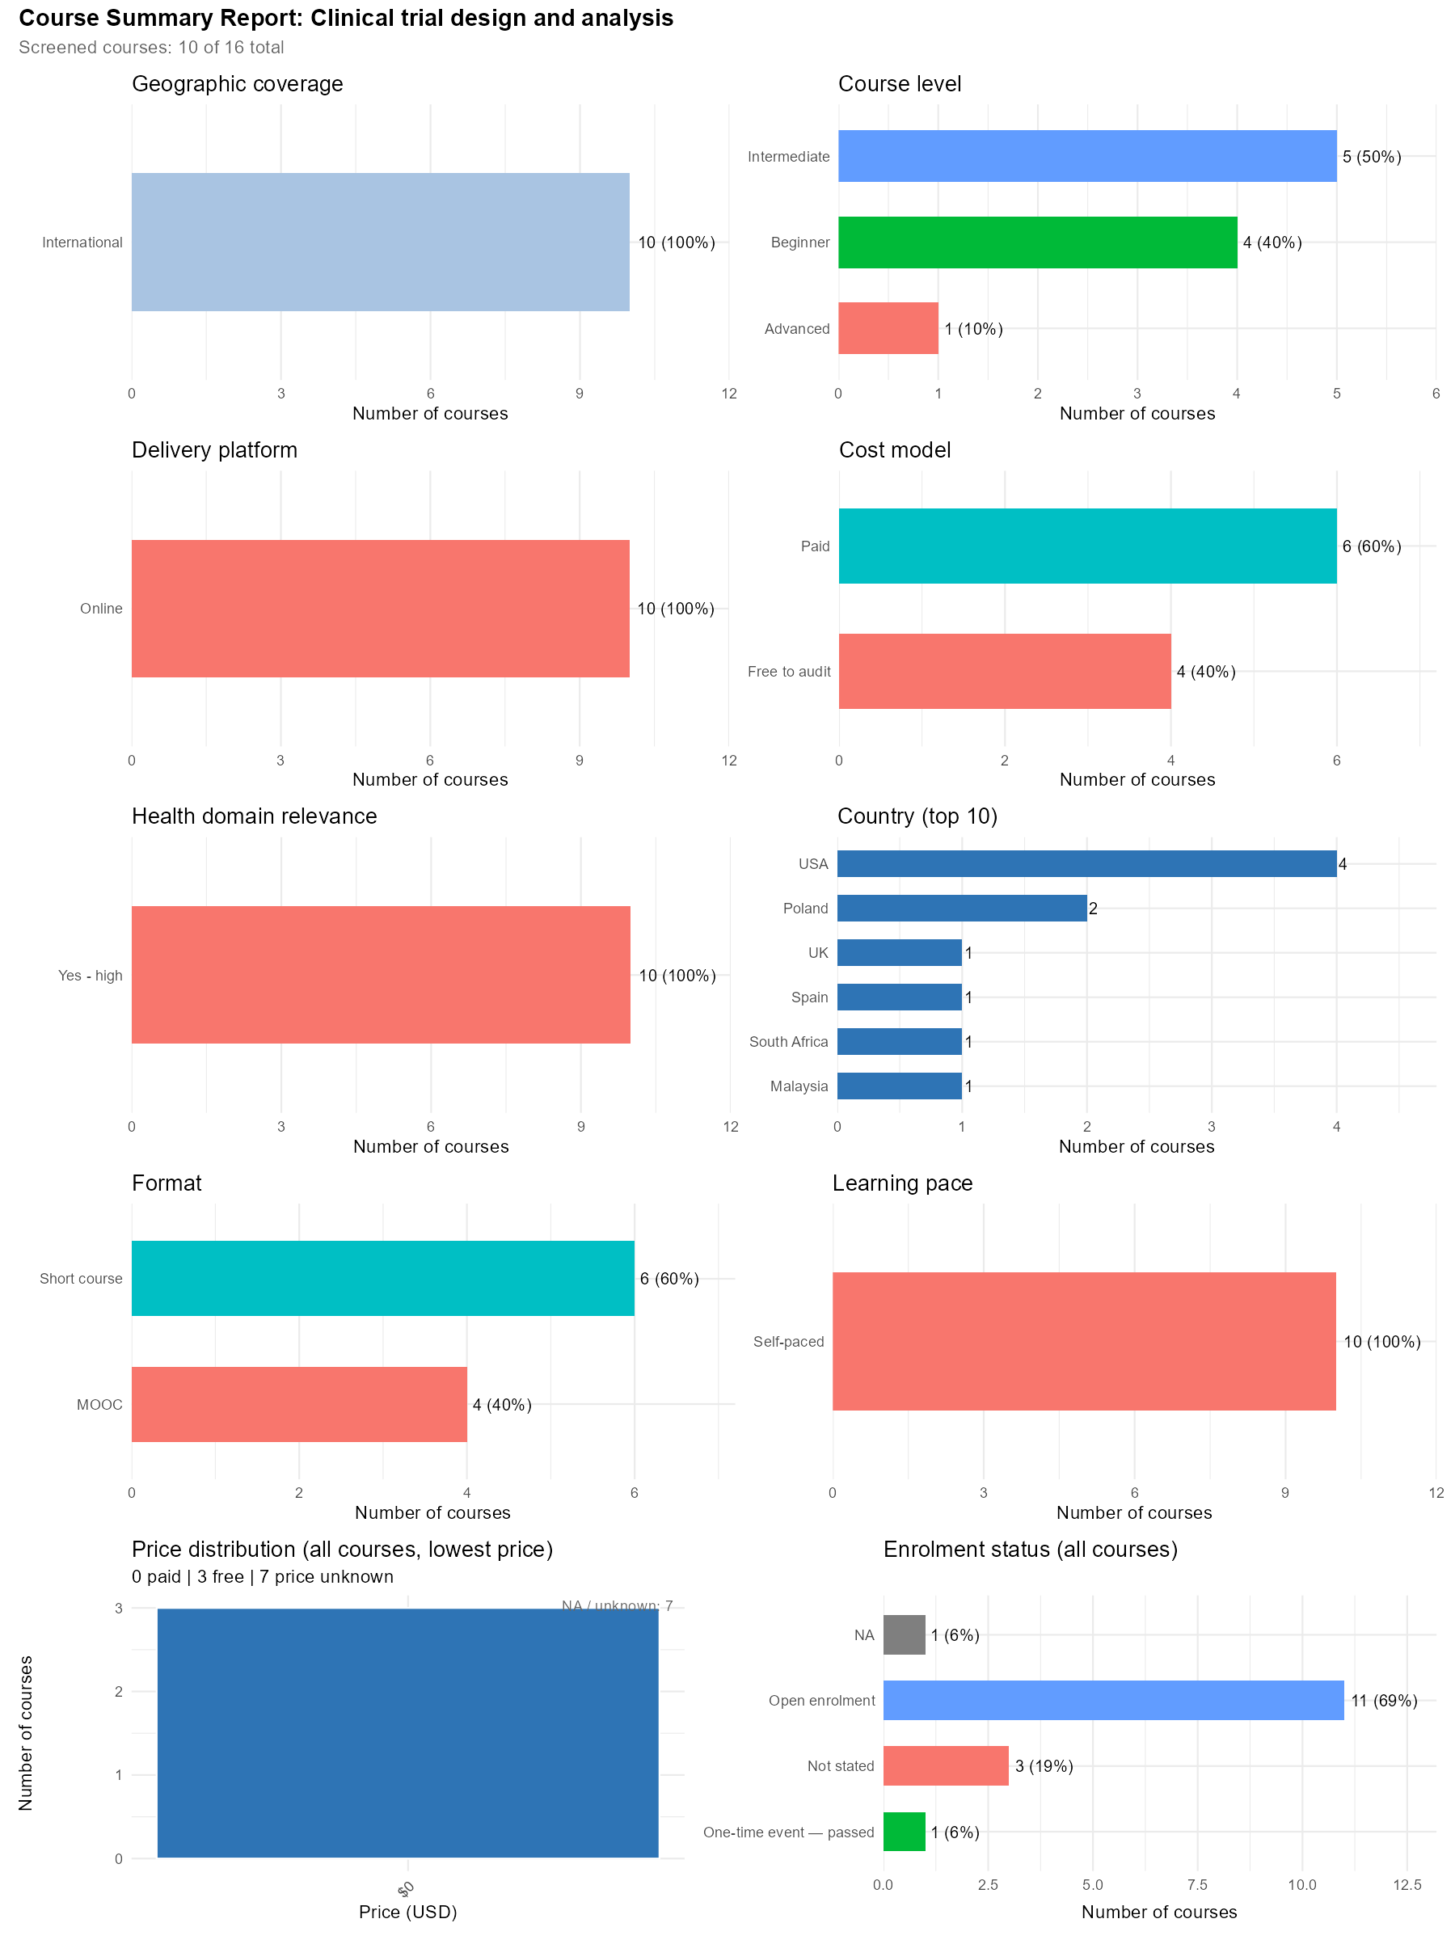
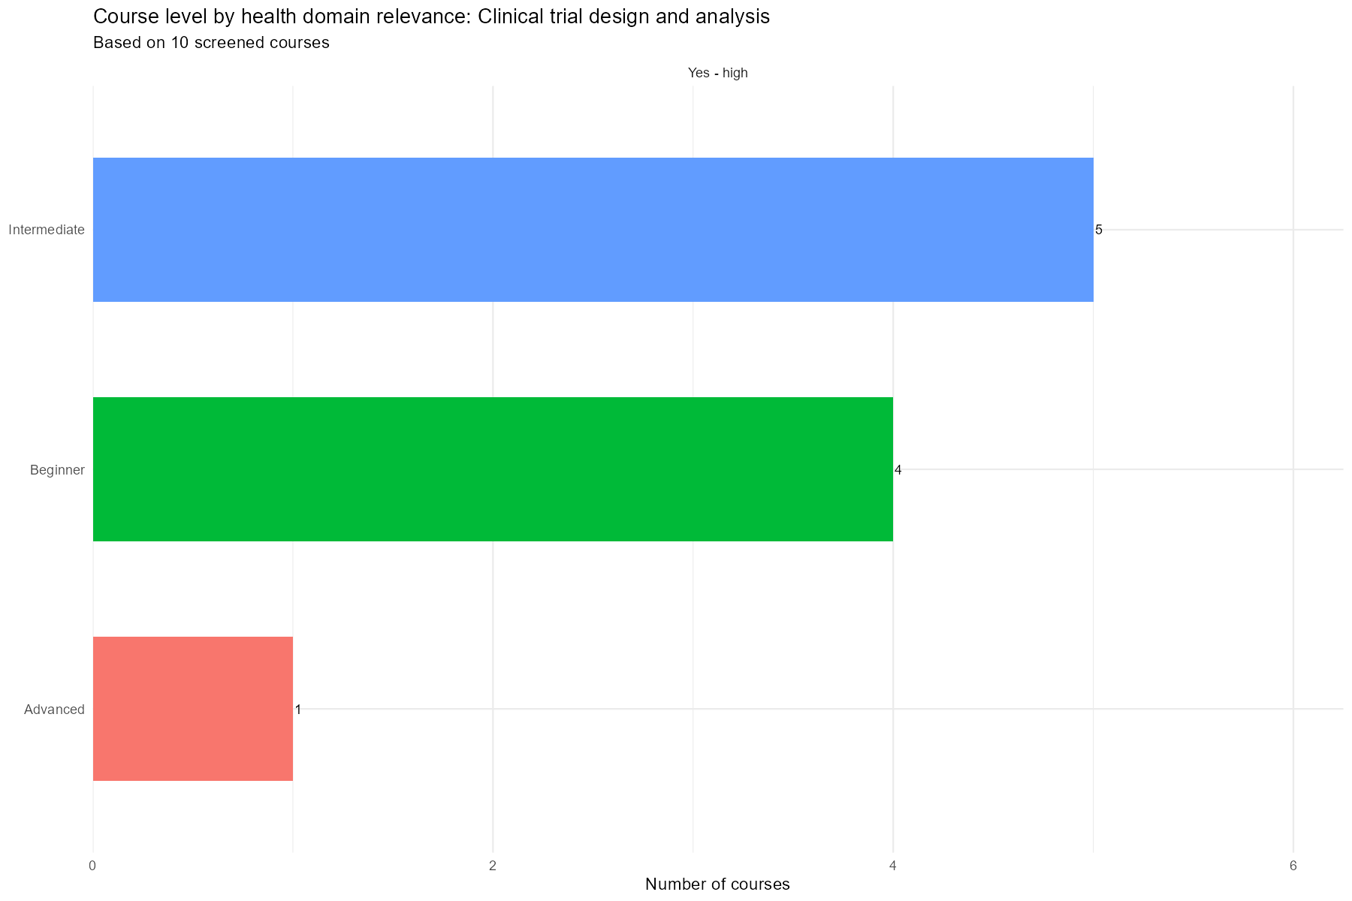

Summary Plots — GitHub
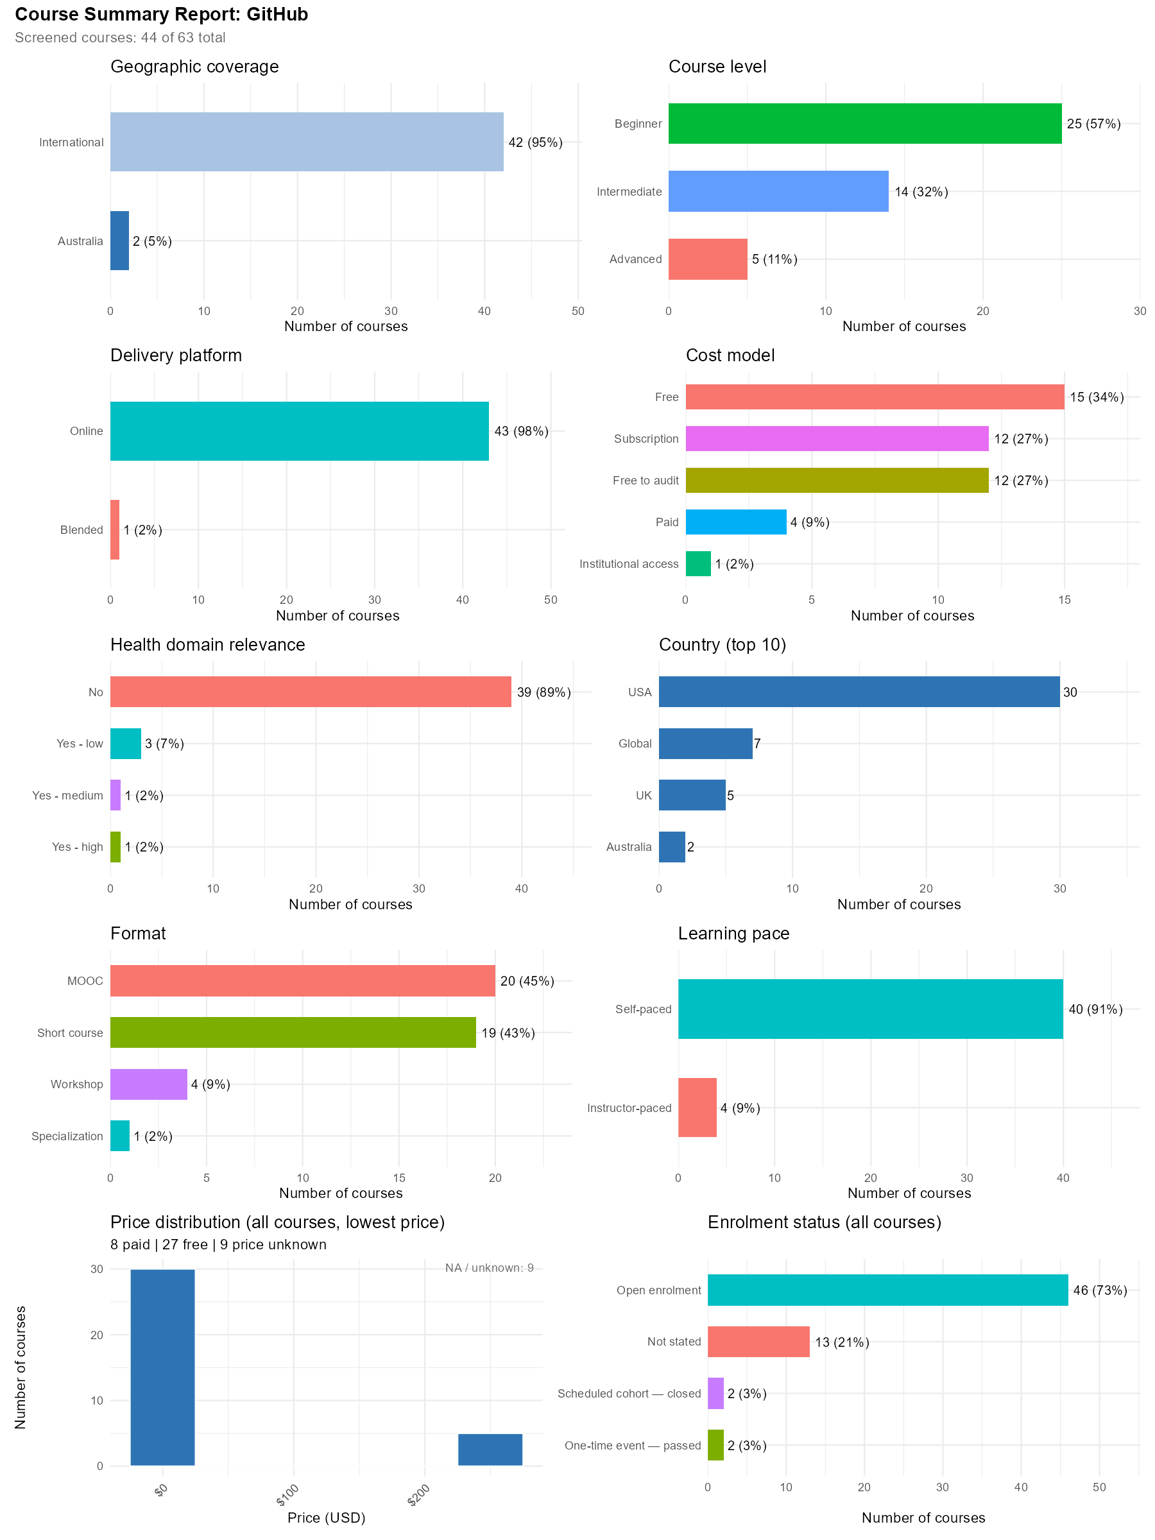
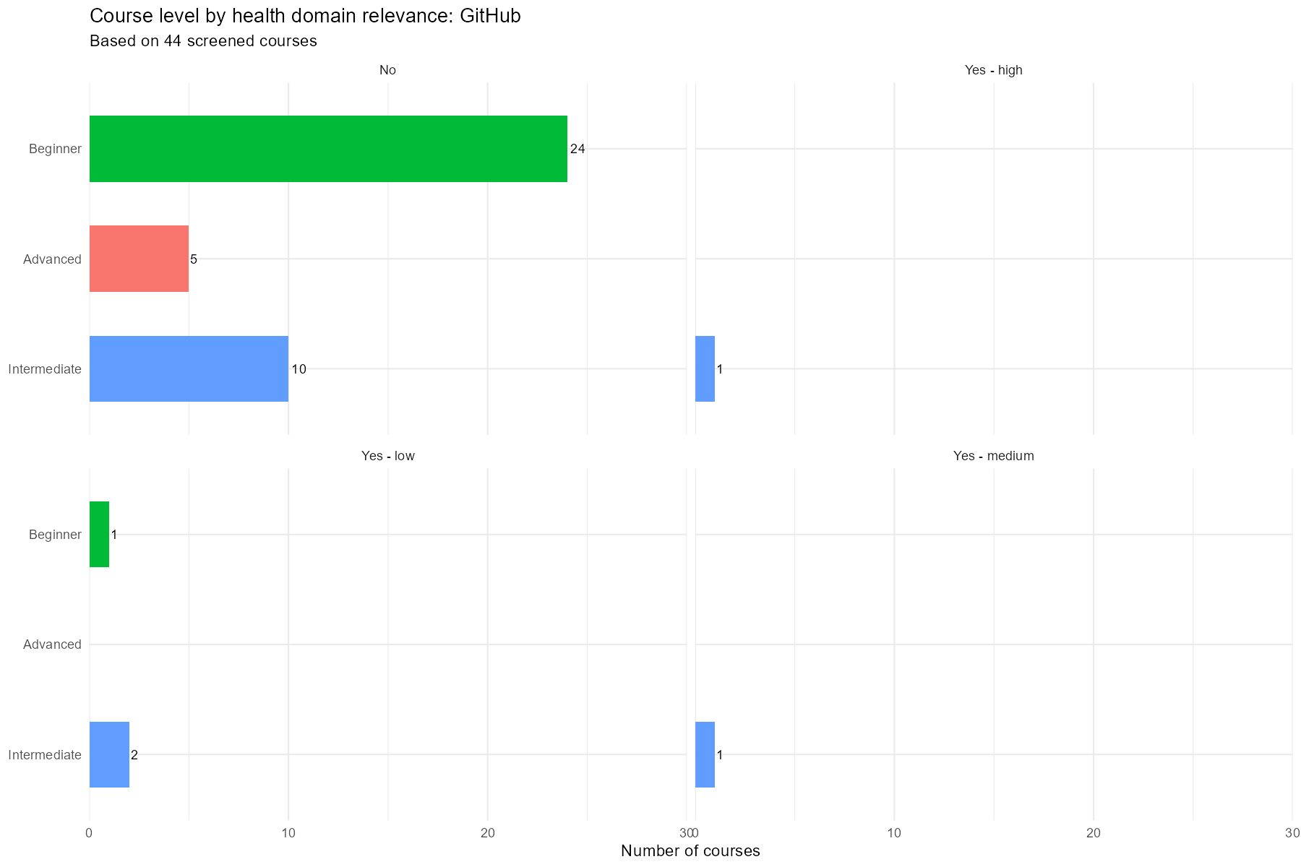

Summary Plots — Clustering and Pattern Recognition
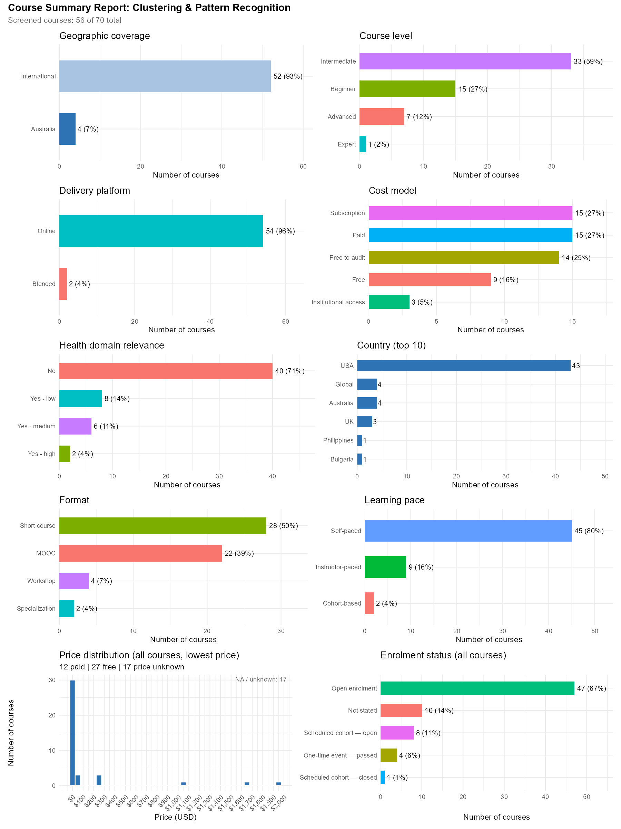
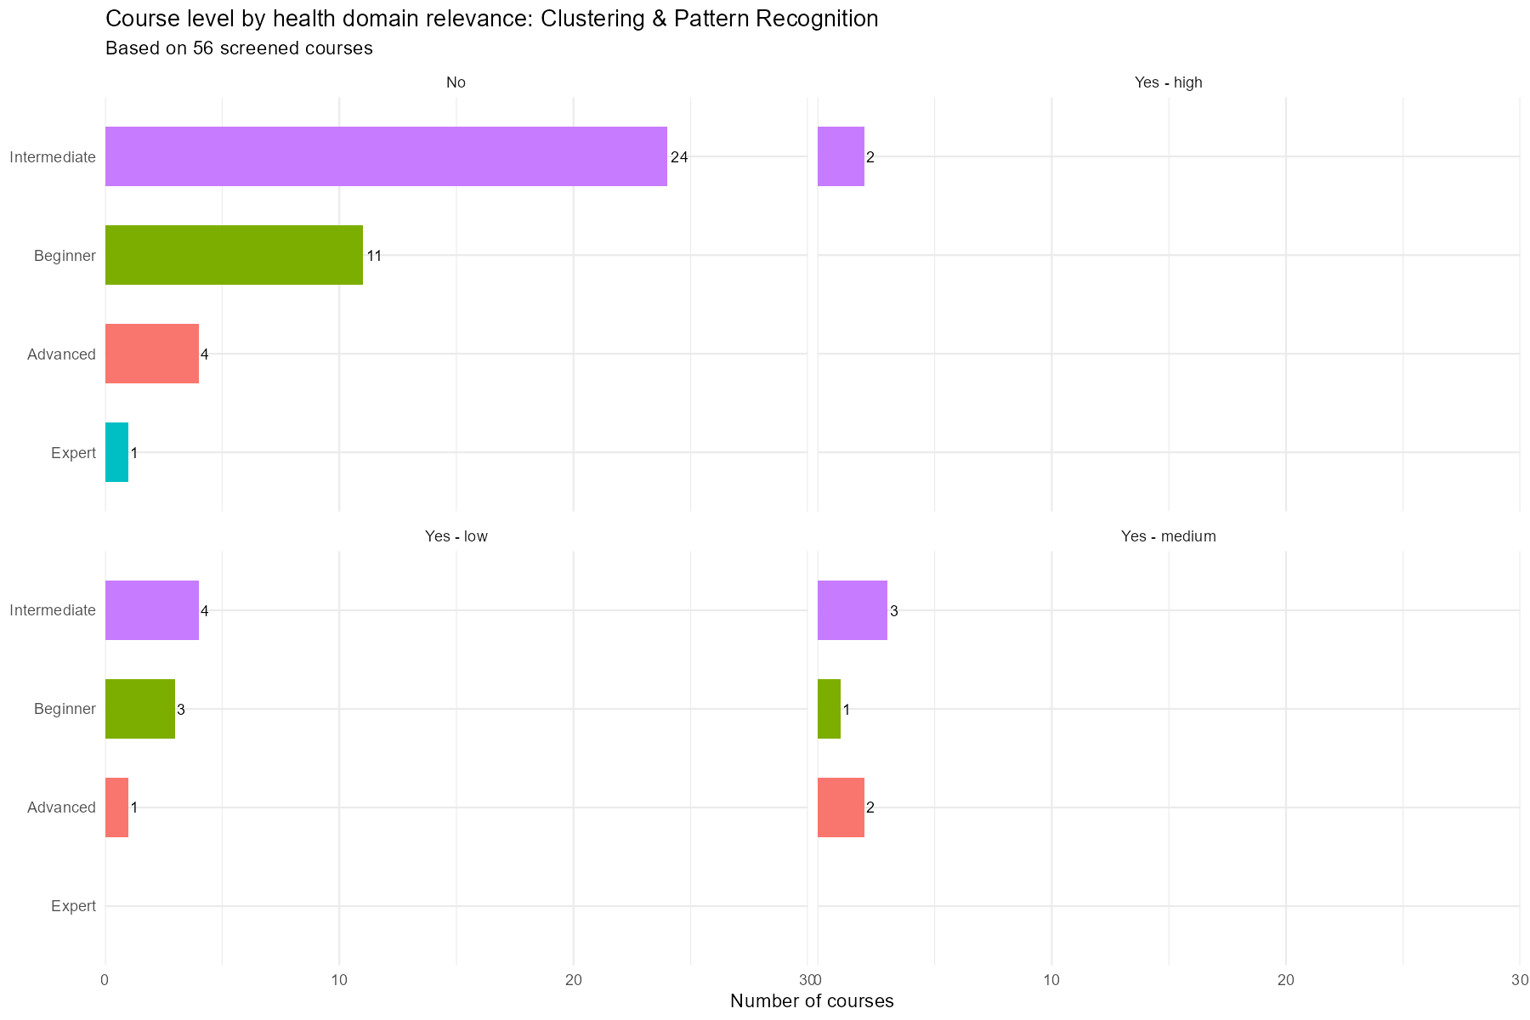

Summary Plots — NLP Models
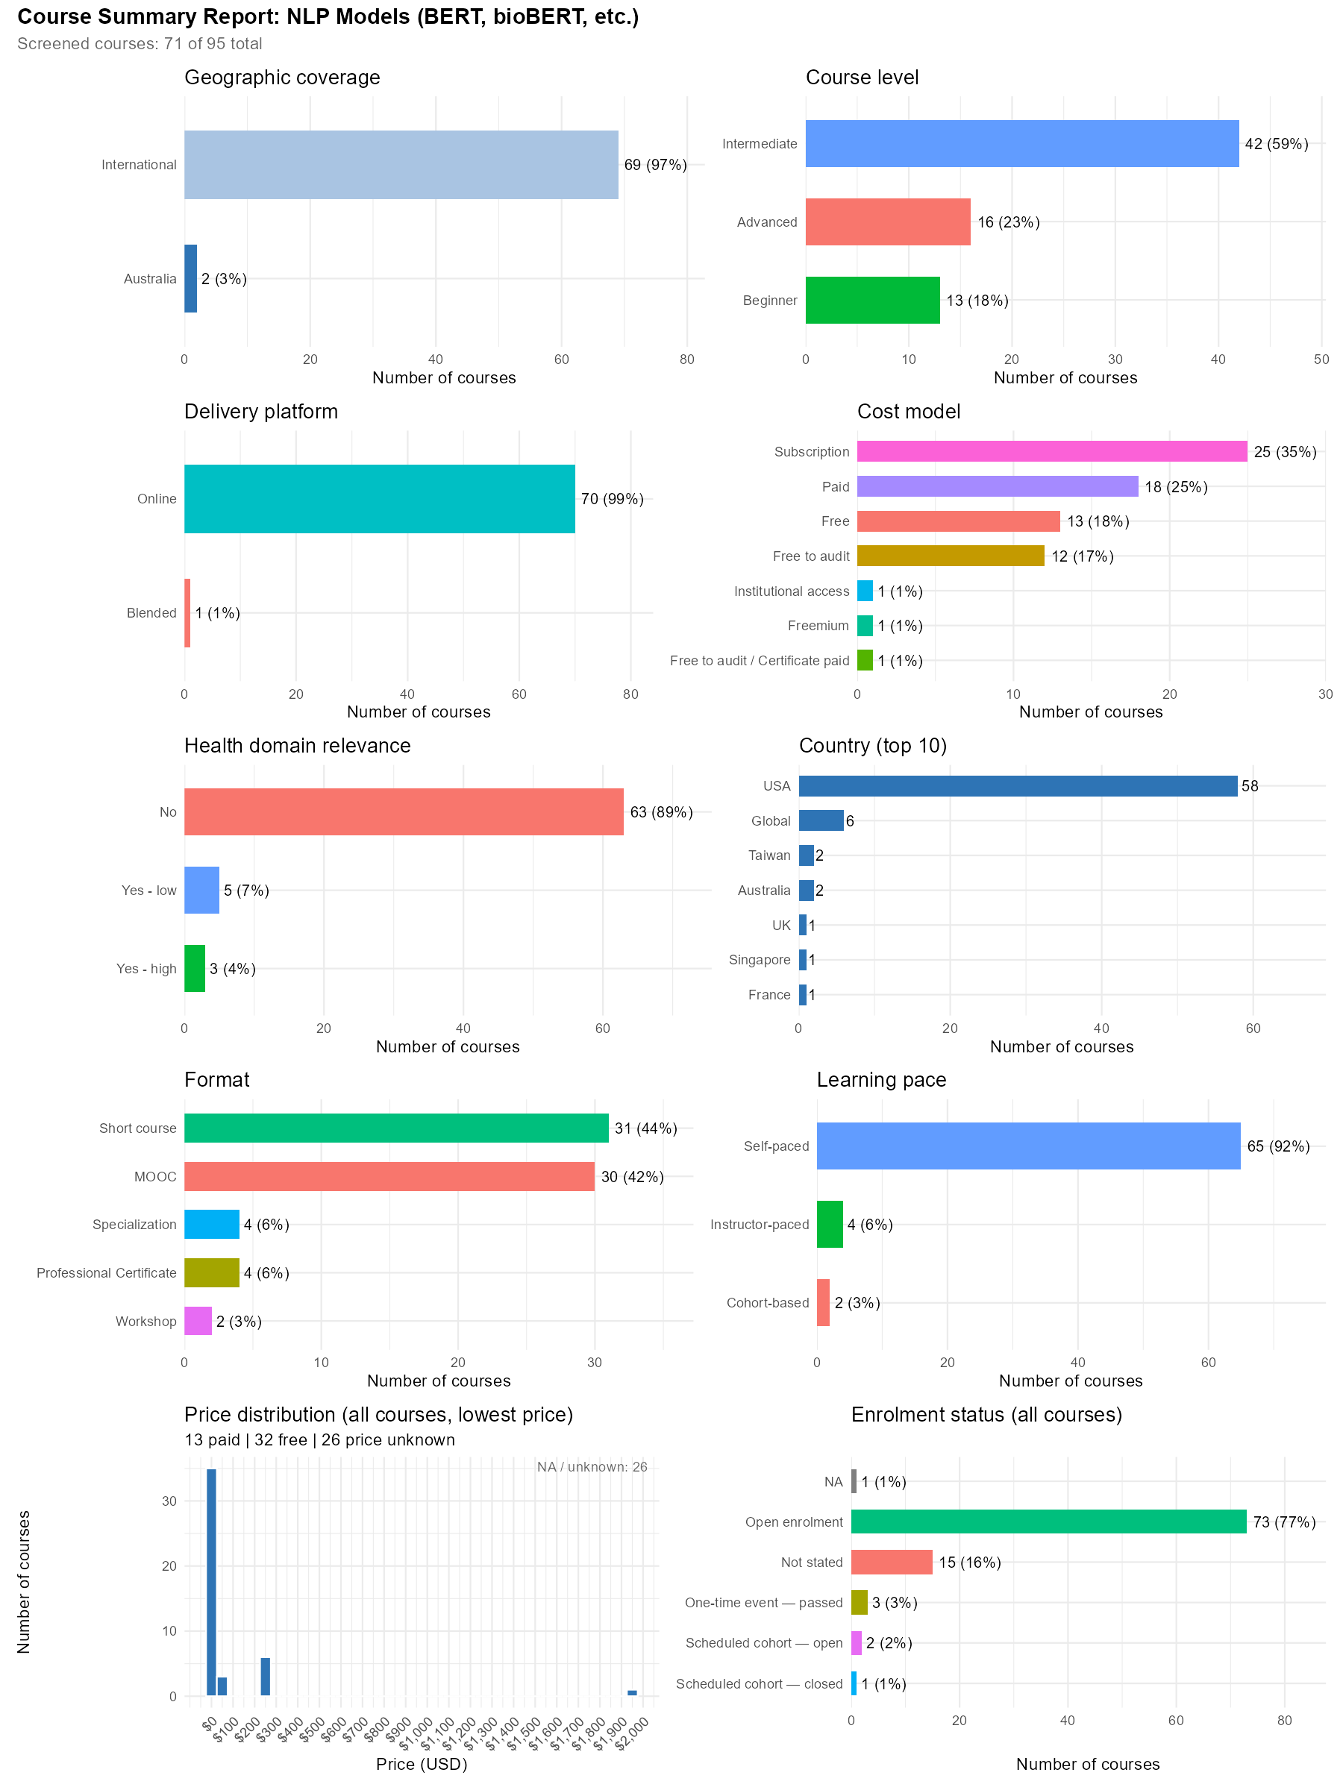
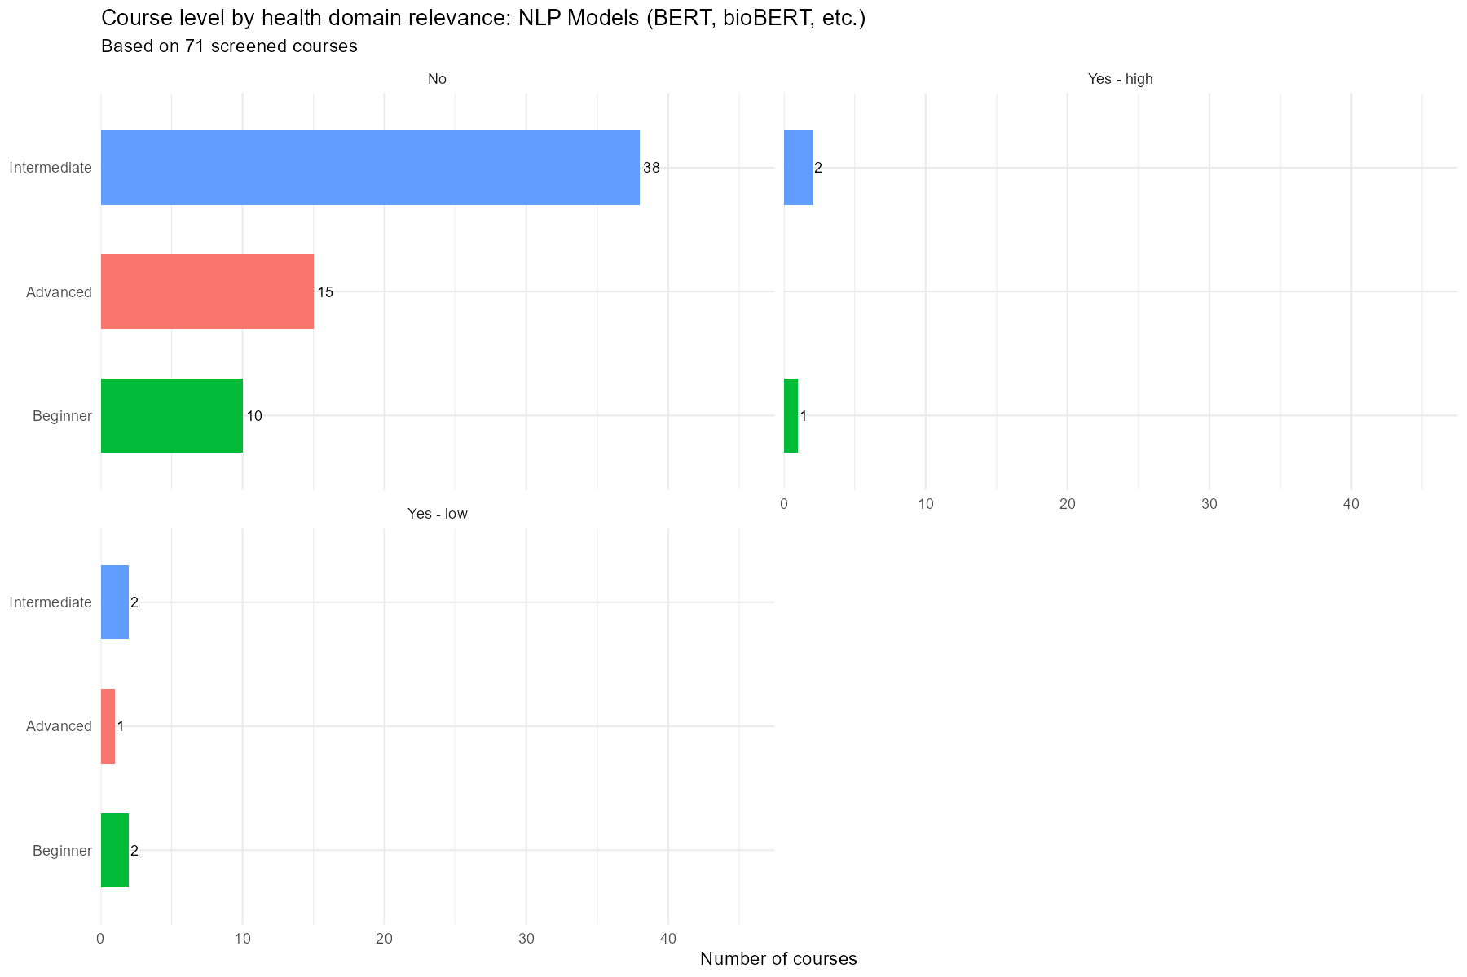

Summary Plots — Model Interpretability and Explainability
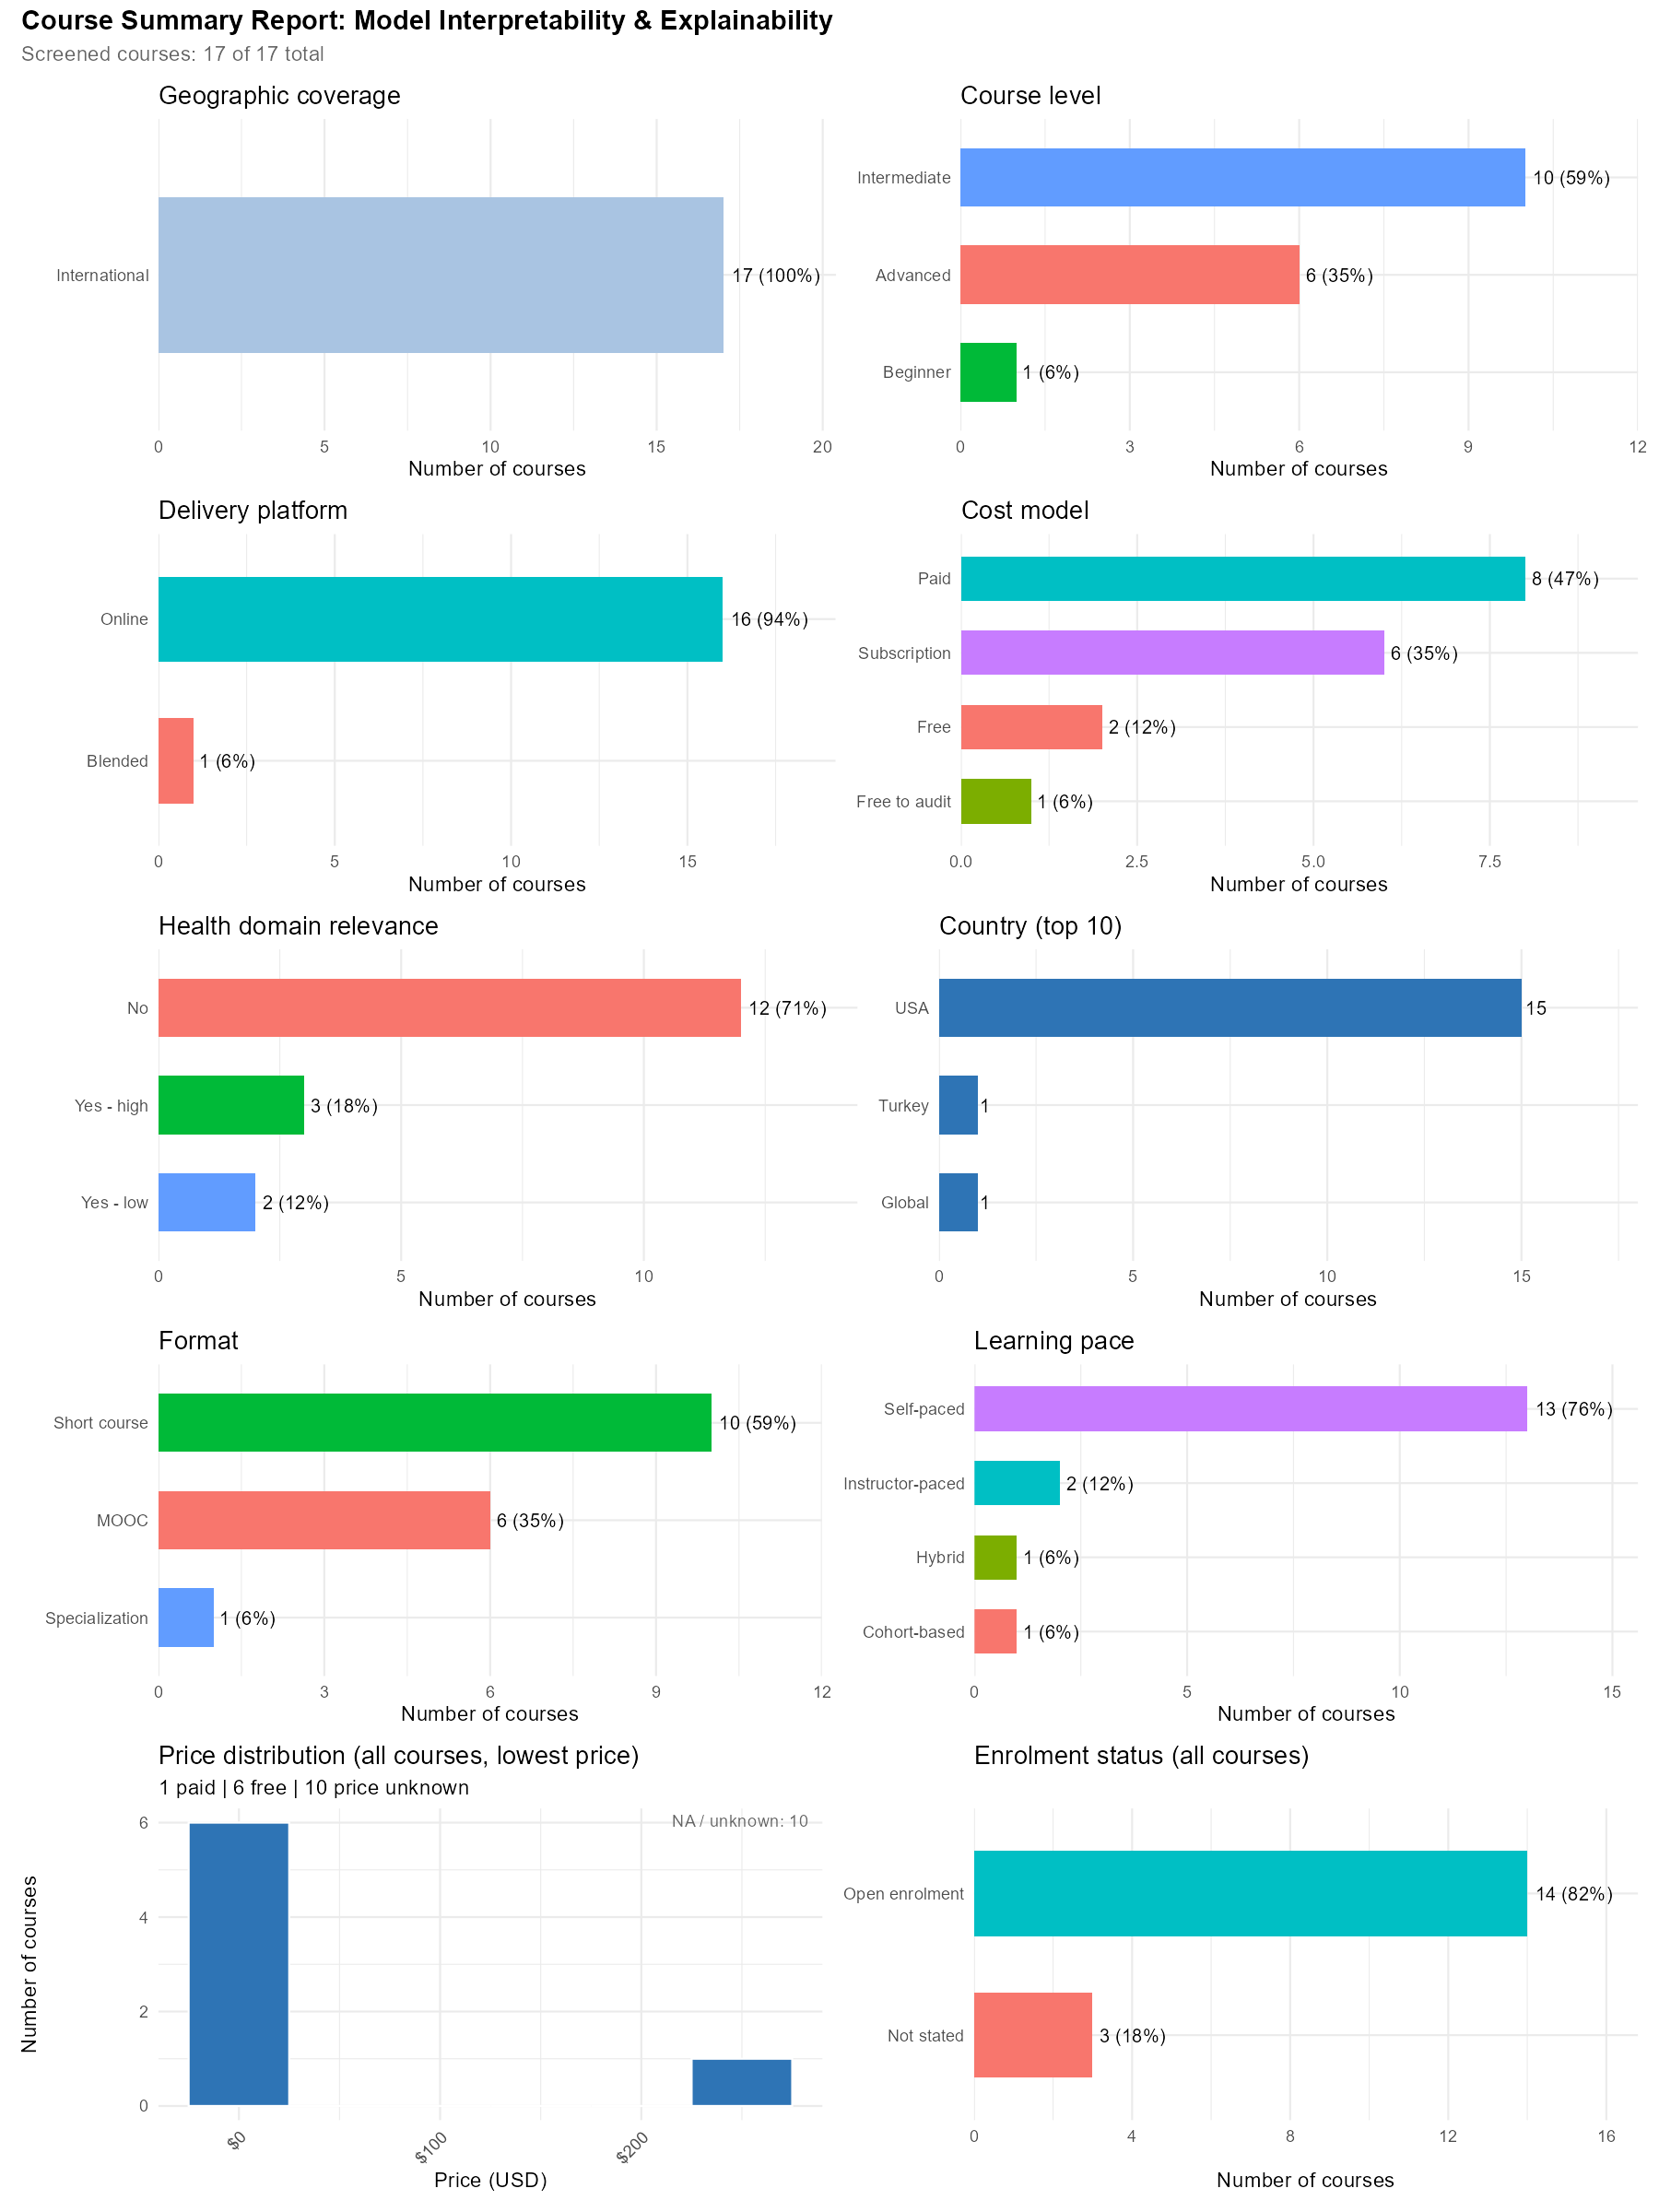
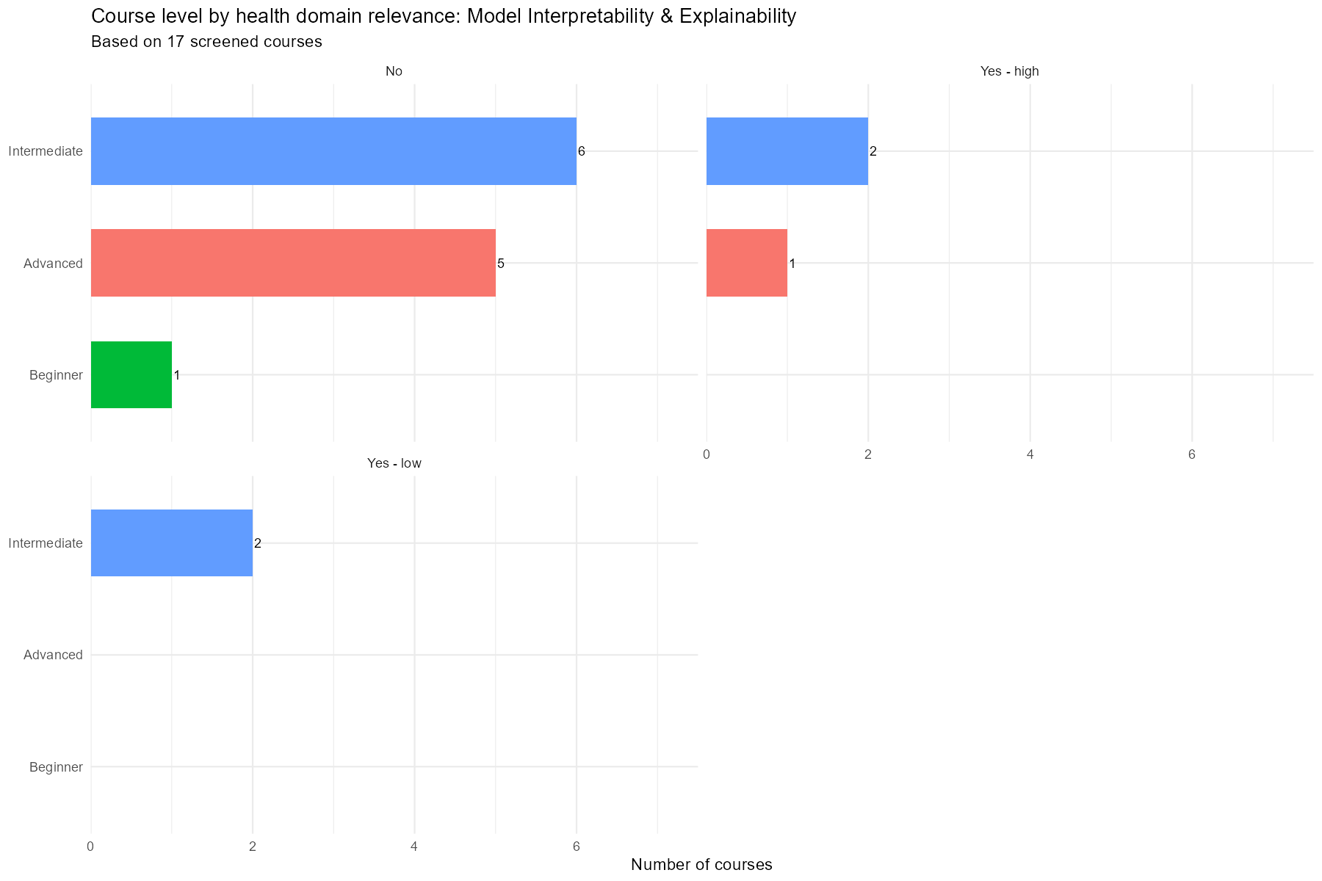

Training Resources by Tool

Training Resources (R)
It was not possible to list all 133 training resources identified that teach R programming, therefor the table below has been limited to only those resources that contained some health research context.
Course / Programme | Provider | Level
Advanced Statistics for Data Science Specialization | Johns Hopkins University (via Coursera) | Advanced
Case Studies in Functional Genomics | Harvard Online | Advanced
Advanced Bioconductor | Harvard Online | Advanced
Advanced Bayesian Statistics Using R | UCx (University of Canterbury) | Advanced
Advanced Bioconductor | HarvardX (Harvard University) | Advanced
Case Studies in Functional Genomics | HarvardX (Harvard University) | Advanced
Data Analysis for Genomics Professional Certificate | HarvardX (Harvard University) | Advanced
Advanced Analysis of Linked Data (Theory) | Datacise Open Learning (ADR Wales / Swansea University) | Advanced
Advanced Analysis of Linked Data (Practical) | Datacise Open Learning (ADR Wales / Swansea University) | Advanced
Programming in R (Posit Academy) | Posit (RStudio) | Beginner
Intro to R and RStudio for Genomics | The Carpentries (Data Carpentry) | Beginner
Cancer Data Science Course | NIH NCI (CBIIT) | Beginner
Data Science Specialization | Johns Hopkins University (via Coursera) | Beginner
Tidyverse Skills for Data Science in R Specialization | Johns Hopkins University (via Coursera) | Beginner
Data Visualization & Dashboarding with R Specialization | Johns Hopkins University (via Coursera) | Beginner
Data Science: Building Machine Learning Models | Harvard Online | Beginner
Data Science: R Basics | Harvard Online | Beginner
Data Science: Linear Regression | Harvard Online | Beginner
Clinical Data Science Specialization | University of Colorado (via Coursera) | Beginner
Introduction to Social Network Analysis (Free Seminar) | Instats | Beginner
Statistical Analysis with R for Public Health Specialization | Imperial College London | Beginner
Statistics and R | HarvardX (Harvard University) | Beginner
Learn Statistical Methods with R | University of Leeds | Beginner
Introduction to R for Epidemiological Analysis | London School of Hygiene & Tropical Medicine / UK Health Security Agency | Beginner
The Complete Survival Analysis Course in R | Udemy (Lam Nguyen) | Beginner
Bayesian Statistics for Data Science | Udemy | Beginner
NeurodeskEDU – Neurodesk Learning Resources | Neurodesk (University of Queensland / ARDC) | Beginner
Bayesian Statistics for Social and Health Scientists in R and Python | Instats | Expert
Machine Learning for Social and Health Sciences in R | Instats | Expert
Bulk RNA-seq Analysis with Bioconductor (bioc-rnaseq) | Bioconductor | Intermediate
Introduction to Machine Learning Using R | Galaxy Training Network | Intermediate
Genomic Data Science Specialization | Johns Hopkins University (via Coursera) | Intermediate
Data Science: Statistics and Machine Learning Specialization | Johns Hopkins University (via Coursera) | Intermediate
Statistical Learning with R | Stanford Online | Intermediate
Statistics and R | Harvard Online | Intermediate
Principles, Statistical and Computational Tools for Reproducible Data Science | Harvard Online | Intermediate
Introduction to Linear Models and Matrix Algebra | Harvard Online | Intermediate
Data Science Certificate | Cornell University | Intermediate
Statistics and Data Analysis with R | University of Colorado Boulder | Intermediate
Bayesian Statistics | Duke University | Intermediate
A Crash Course in Causality: Inferring Causal Effects from Observational Data | University of Pennsylvania | Intermediate
Survival Analysis in R for Public Health | Imperial College London | Intermediate
Survival Analysis in R | DataCamp | Intermediate
Introduction to Bioconductor | HarvardX (Harvard University) | Intermediate
Statistical Analysis in R (Professional Certificate) | UCx (University of Canterbury) | Intermediate
Data Analysis for Life Sciences Professional Certificate | HarvardX (Harvard University) | Intermediate
Principles, Statistical and Computational Tools for Reproducible Data Science | HarvardX (Harvard University) | Intermediate
Bioinformatics for Biologists: Analysing and Interpreting Genomics Datasets | Wellcome Connecting Science | Intermediate
Survival Analysis in R | Udemy / R-Tutorials Training | Intermediate
Data Analysis in R: Online | ACSPRI | Intermediate
Applied Longitudinal Data Analysis: Online | ACSPRI | Intermediate
WORKSHOP: Single cell RNAseq analysis in R | Australian BioCommons / QCIF / Sydney Informatics Hub / Monash Genomics and Bioinformatics Platform | Intermediate
Introductory Analysis of Linked Data (Theory) | Datacise Open Learning (ADR Wales / Swansea University) | Intermediate
Introductory Analysis of Linked Data (Practical) | Datacise Open Learning (ADR Wales / Swansea University) | Intermediate
Statistical Society of Australia (SSA) | Statistical Society of Australia (SSA) | Intermediate
rOpenSci | rOpenSci | Intermediate

Training Resources (Regression)
Course / Programme | Provider | Level
Longitudinal and Mixed Model Analysis Using R | QCIF | Advanced
Google Advanced Data Analytics Professional Certificate | Google (via Coursera) | Advanced
Advanced Statistics for Data Science Specialization | Johns Hopkins University (via Coursera) | Advanced
Machine Learning (XCS229) | Stanford Online | Advanced
Machine Learning, Modeling, and Simulation: Engineering Problem-Solving in the Age of AI | MIT xPRO | Advanced
Advanced Machine Learning | The Open University / Persontyle / Uppsala University | Advanced
Statistics in Clinical Trials. Part 3 | Udemy / BioStat | Advanced
Advanced Statistical Analysis Using R: Online | ACSPRI | Advanced
Introduction to SPSS | QCIF | Beginner
Create Machine Learning Models | Microsoft Learn | Beginner
Statistics 1: Introduction to ANOVA, Regression, and Logistic Regression | SAS Training | Beginner
Statistics You Need to Know for Machine Learning | SAS Training | Beginner
R for Data Science: Analysis and Visualization | LinkedIn Learning | Beginner
Artificial Intelligence Foundations: Machine Learning | LinkedIn Learning | Beginner
Data Science Specialization | Johns Hopkins University (via Coursera) | Beginner
Biostatistics in Public Health Specialization | Johns Hopkins University (via Coursera) | Beginner
Tidyverse Skills for Data Science in R Specialization | Johns Hopkins University (via Coursera) | Beginner
Data Science: Building Machine Learning Models | Harvard Online | Beginner
Data Science: Inference and Modeling | Harvard Online | Beginner
Data Science: Linear Regression | Harvard Online | Beginner
Introduction to Data Science | UC Berkeley Extension | Beginner
Python for Data Science Certificate | Cornell University | Beginner
Data Science Online Bootcamp | Imperial College London | Beginner
Data Science Foundations Specialization | University of London (via Coursera) | Beginner
Data Scientist: Machine Learning Specialist | Codecademy | Beginner
Data Scientist: Natural Language Processing Specialist | Codecademy | Beginner
Build a Machine Learning Model | Codecademy | Beginner
Machine Learning Specialization | DeepLearning.AI | Beginner
DeepLearning.AI Data Analytics Professional Certificate | DeepLearning.AI | Beginner
Data Analysis with R Specialization | Duke University | Beginner
Machine Learning Specialization | DeepLearning.AI / Stanford University | Beginner
Supervised Machine Learning: Regression and Classification | DeepLearning.AI / Stanford University | Beginner
Linear Regression and Modeling | Duke University | Beginner
Introduction to Statistics | Stanford University | Beginner
Statistical Analysis with R for Public Health Specialization | Imperial College London | Beginner
Statistics and R | HarvardX (Harvard University) | Beginner
Machine Learning with Python: A Practical Introduction | IBM | Beginner
PyTorch Basics for Machine Learning | IBM | Beginner
Python for Data Science and Machine Learning Bootcamp | Udemy (Jose Portilla) | Beginner
Machine Learning A-Z: AI, Python & R + ChatGPT Prize [2026] | Udemy / SuperDataScience (Kirill Eremenko, Hadelin de Ponteves) | Beginner
R Programming for Statistics and Data Science | Udemy | Beginner
Complete TensorFlow 2 and Keras Deep Learning Bootcamp | Udemy (Jose Portilla / Pierian Training) | Beginner
Implementing Machine Learning Workflow with RapidMiner | Pluralsight | Beginner
Data Science: Master Machine Learning Without Coding | Udemy | Beginner
Machine Learning and AI for Research in R and Python 2.0 | Instats | Expert
Machine Learning for Social and Health Sciences in R | Instats | Expert
Statistical Machine Learning for Researchers | Instats | Expert
Introduction to Machine Learning using Python: Introduction & Linear Regression (PYTHON205) | Intersect Australia | Intermediate
Exploring Chi-Square and Correlation in R (R210) | Intersect Australia | Intermediate
Statistical Comparisons Using R | QCIF | Intermediate
Exploring and Predicting Using Linear Regression in R | QCIF | Intermediate
Analysing Categorical Outcomes and Logistic Regression with R | QCIF | Intermediate
Fundamentals of Classification in Machine Learning | QCIF | Intermediate
Fundamentals of Regression in Machine Learning | QCIF | Intermediate
Exploring and Predicting Using Linear Regression in SPSS | QCIF | Intermediate
Statistical Comparisons Using SPSS | QCIF | Intermediate
Bulk RNA-seq Analysis with Bioconductor (bioc-rnaseq) | Bioconductor | Intermediate
IBM Machine Learning Professional Certificate | IBM (via Coursera) | Intermediate
Machine Learning with Databricks | Databricks Academy | Intermediate
Machine Learning Using SAS Viya | SAS Training | Intermediate
Survival Analysis Using the Proportional Hazards Model | SAS Training | Intermediate
Complete Guide to R: Wrangling, Visualizing, and Modeling Data | LinkedIn Learning | Intermediate
Introduction to Neural Networks and PyTorch | IBM (via Coursera) | Intermediate
Introduction to Machine Learning Using R | Galaxy Training Network | Intermediate
Data Science: Statistics and Machine Learning Specialization | Johns Hopkins University (via Coursera) | Intermediate
Statistical Learning with R | Stanford Online | Intermediate
Statistical Learning with Python | Stanford Online | Intermediate
Statistics and R | Harvard Online | Intermediate
Introduction to Linear Models and Matrix Algebra | Harvard Online | Intermediate
Statistical Learning for Data Science Specialization | University of Colorado (via Coursera) | Intermediate
Introduction to Machine Learning Using Python | UC Berkeley Extension | Intermediate
Professional Program in Data Analysis | UC Berkeley Extension | Intermediate
Data Science Certificate | Cornell University | Intermediate
Data Analysis: Hypothesis Testing | The Open University | Intermediate
Build Deep Learning Models with TensorFlow | Codecademy | Intermediate
Data Science with Python (Learning Path) | Pluralsight | Intermediate
Data Science with R | Pluralsight | Intermediate
Optimizing Machine Learning Models in Python | Dataquest | Intermediate
Machine Learning in Python | 365 Data Science | Intermediate
Regression Models | Johns Hopkins University | Intermediate
Modern Regression Analysis in R | University of Colorado Boulder | Intermediate
Introduction to Regression in R | DataCamp | Intermediate
Intermediate Regression in R | DataCamp | Intermediate
Supervised Learning in R: Regression | DataCamp | Intermediate
Generalized Linear Models in R | DataCamp | Intermediate
Statistical Learning with R | StanfordOnline (Stanford University) | Intermediate
Data Science: Inference and Modeling | HarvardX (Harvard University) | Intermediate
Statistical Analysis in R (Professional Certificate) | UCx (University of Canterbury) | Intermediate
Data Science Professional Certificate | HarvardX (Harvard University) | Intermediate
Data Analysis for Life Sciences Professional Certificate | HarvardX (Harvard University) | Intermediate
Machine Learning: Regression | IBM | Intermediate
Microsoft Future Ready: Data Science Research Methods Using Python Programming | CloudSwyft Global Systems, Inc. | Intermediate
Microsoft Future Ready: Data Science Research Methods Using Python Programming (Short Course) | CloudSwyft Global Systems, Inc. | Intermediate
Principles of Machine Learning with Python Programming (Advanced AI) | CloudSwyft Global Systems, Inc. | Intermediate
Principles of Machine Learning with Python (Ethics) | CloudSwyft Global Systems, Inc. | Intermediate
Principles of Machine Learning with Python (Short Course) | CloudSwyft Global Systems, Inc. | Intermediate
Time Series | Kaggle | Intermediate
Data Analyst Nanodegree | Udacity | Intermediate
Intro to Machine Learning with PyTorch Nanodegree | Udacity | Intermediate
Intro to Machine Learning with TensorFlow Nanodegree | Udacity | Intermediate
Python for Machine Learning & Data Science Masterclass | Udemy (Jose Portilla) | Intermediate
Machine Learning, Data Science & AI Engineering with Python | Udemy / Sundog Education (Frank Kane) | Intermediate
Applied Statistical Modeling for Data Analysis in R | Udemy | Intermediate
Statistics in Clinical Trials | Udemy | Intermediate
Master Statistics Using R: Coding, Concepts, Applications | Udemy | Intermediate
Machine Learning with Scikit-learn | Udemy | Intermediate
Data Analysis in R: Online | ACSPRI | Intermediate
Machine Learning for Data Science: Supervised Learning Techniques: Online (3 days) | ACSPRI | Intermediate
Applied Longitudinal Data Analysis: Online | ACSPRI | Intermediate
Julia Programming for Machine Learning | Udemy | Intermediate
Machine Learning Modelling with RapidMiner | Udemy | Intermediate

Training Resources (SQL and Database Management)
Course / Programme | Provider | Level
Google Business Intelligence Professional Certificate | Google (via Coursera) | Advanced
Advanced Machine Learning Operations | Databricks Academy | Advanced
Advanced SQL Querying | Maven Analytics | Advanced
Data Scientist Nanodegree | Udacity | Advanced
Introduction to Microsoft Azure Data (DP-900T00-A) | Microsoft Learn | Beginner
Google Cloud Data Analytics Professional Certificate | Google (via Coursera) | Beginner
Relational Databases Certification | freeCodeCamp | Beginner
Intro to SQL: Querying and Managing Data | Khan Academy | Beginner
Using Databases and SQL | The Carpentries (Software Carpentry) | Beginner
Data Management with SQL for Ecologists | The Carpentries (Data Carpentry) | Beginner
Data Management with SQL for Social Scientists | The Carpentries (Data Carpentry) | Beginner
Software Carpentry Workshop | The Carpentries (Software Carpentry) | Beginner
Data Carpentry: Ecology (with R) | The Carpentries (Data Carpentry) | Beginner
Data Science: Wrangling | Harvard Online | Beginner
Clinical Data Science Specialization | University of Colorado (via Coursera) | Beginner
Data Science Online Bootcamp | Imperial College London | Beginner
Data Scientist: Machine Learning Specialist | Codecademy | Beginner
Data Scientist: Natural Language Processing Specialist | Codecademy | Beginner
Learn SQL | Codecademy | Beginner
DeepLearning.AI Data Analytics Professional Certificate | DeepLearning.AI | Beginner
Data I/O and Preprocessing with Python and SQL | DeepLearning.AI | Beginner
Data Storage and Queries | DeepLearning.AI | Beginner
Tools for Data Science | IBM | Beginner
Data Science Fundamentals with Python and SQL Specialization | IBM | Beginner
Introduction to SQL | DataCamp | Beginner
SQL for Data Science | IBM | Beginner
CS50’s Introduction to Databases with SQL | HarvardX (Harvard University) | Beginner
Microsoft Future Ready: Data Query with Transact-SQL | CloudSwyft Global Systems, Inc. | Beginner
Data Query with T-SQL | CloudSwyft Global Systems (Microsoft) | Beginner
Intro to SQL | Kaggle | Beginner
Business Analytics Nanodegree | Udacity | Beginner
Programming for Data Science with Python Nanodegree | Udacity | Beginner
SQL for Data Analysis | Udacity | Beginner
SQL Fundamentals | Udacity | Beginner
Introduction to Databases and SQL Querying | Udemy | Beginner
Complete Database Course: SQL, MySQL, PostgreSQL & MongoDB | Udemy | Beginner
Complete SQL & MySQL Course 2026: From Beginner to Advanced | Udemy | Beginner
Data Analysis | SQL, Tableau, Power BI & Excel | Real Projects | Udemy | Beginner
Python Data Science: Data Prep & EDA with Python | Udemy (Maven Analytics) | Beginner
Complete SQL Course: Become an Expert in Database Management | Udemy | Beginner
The Data Science of Health Informatics | Johns Hopkins University via Coursera | Beginner
Machine Learning at Scale | Databricks Academy | Intermediate
Professional Program in Data Analysis | UC Berkeley Extension | Intermediate
DeepLearning.AI Data Engineering Professional Certificate | DeepLearning.AI | Intermediate
Advanced SQL | Kaggle | Intermediate
Data Analyst Nanodegree | Udacity | Intermediate
Agentic AI on Microsoft Azure Nanodegree | Udacity | Intermediate
Data Engineering Nanodegree | Udacity | Intermediate

Training Resources (Clinical Trial Design and Analysis)
Course / Programme | Provider | Level
Statistics in Clinical Trials. Part 3 | Udemy / BioStat | Advanced
Understanding Clinical Research: Behind the Statistics | University of Cape Town | Beginner
Statistics in Clinical Trials. Part 1 | Udemy / BioStat | Beginner
Statistics for Clinical Research – A Practical Guide | Udemy | Beginner
The Simplest Guide to Clinical Trials Data Analysis with SAS | Udemy | Beginner
Survival Analysis in R for Public Health | Imperial College London | Intermediate
Clinical Trials Analysis, Monitoring, and Presentation | Johns Hopkins University | Intermediate
CERTaIN: Pragmatic Clinical Trials and Healthcare Delivery Evaluations | MDAndersonX (MD Anderson Cancer Center) | Intermediate
Statistics in Clinical Trials | Udemy | Intermediate
Clinical SAS: Clinical Data Management and Analysis with SAS | Udemy (Uplatz) | Intermediate

Training Resources (GitHub)
Course / Programme | Provider | Level
Google IT Automation with Python Professional Certificate | Google (via Coursera) | Advanced
Advanced Git | DataCamp | Advanced
Advanced Skills in Version Control with Git and GitHub | Packt / FutureLearn | Advanced
Data Scientist Nanodegree | Udacity | Advanced
Machine Learning DevOps Engineer Nanodegree | Udacity | Advanced
ARDC FAIR Data 101 | ARDC | Beginner
Version Control with Git | QCIF | Beginner
GitHub Copilot Fundamentals – Part 2 of 2 | Microsoft Learn | Beginner
GitHub Foundations – Part 1 of 2 | Microsoft Learn | Beginner
GitHub Foundations – Part 2 of 2 | Microsoft Learn | Beginner
Automate Your Workflow with GitHub Actions – Part 1 of 2 | Microsoft Learn | Beginner
Python Data Analysis | LinkedIn Learning | Beginner
Relational Databases Certification | freeCodeCamp | Beginner
Version Control with Git | The Carpentries (Software Carpentry) | Beginner
Introduction to Git | The Carpentries (Library Carpentry) | Beginner
Software Carpentry Workshop | The Carpentries (Software Carpentry) | Beginner
Data Science Specialization | Johns Hopkins University (via Coursera) | Beginner
Tools for Data Science | IBM | Beginner
Data Science Fundamentals with Python and SQL Specialization | IBM | Beginner
Introduction to Git | DataCamp | Beginner
Introduction to GitHub Concepts | DataCamp | Beginner
Data Science: R Basics | HarvardX (Harvard University) | Beginner
Working with Version Control | University of Leeds / Click Start | Beginner
A Beginner’s Guide to VCS and Git | Packt / FutureLearn | Beginner
Introduction to Programming with Python | FutureLearn | Beginner
Programming for Data Science with Python Nanodegree | Udacity | Beginner
Git: Become an Expert in Git & GitHub in 4 Hours | Udemy | Beginner
Git & GitHub For Beginners - Master Git and GitHub (2025) | Udemy (Vlad) | Beginner
Free Git Tutorial - Git Crash Course: Version Control For Software Developers | Udemy (Ivan) | Beginner
Docker - Containers, Images, Compose, Kubernetes, and more! | Udemy | Beginner
Automate Your Workflow with GitHub Actions – Part 2 of 2 | Microsoft Learn | Intermediate
Operationalize Machine Learning Models (MLOps) | Microsoft Learn | Intermediate
Python for Data Science and Machine Learning Essential Training Part 1 | LinkedIn Learning | Intermediate
Data Science: Statistics and Machine Learning Specialization | Johns Hopkins University (via Coursera) | Intermediate
Principles, Statistical and Computational Tools for Reproducible Data Science | Harvard Online | Intermediate
Machine Learning/AI Engineer | Codecademy | Intermediate
Effective MLOps: Model Development | Weights & Biases Courses | Intermediate
CI/CD for Machine Learning | Weights & Biases Courses | Intermediate
Intermediate GitHub Concepts | DataCamp | Intermediate
Data Science Professional Certificate | HarvardX (Harvard University) | Intermediate
Principles, Statistical and Computational Tools for Reproducible Data Science | HarvardX (Harvard University) | Intermediate
Version Control Essentials: Git and GitHub | Packt / FutureLearn | Intermediate
Agentic AI Nanodegree | Udacity | Intermediate
Data Engineering Nanodegree | Udacity | Intermediate

Training Resources (Clustering and Pattern Recognition)
Course / Programme | Provider | Level
Google Advanced Data Analytics Professional Certificate | Google (via Coursera) | Advanced
Advanced Machine Learning Using SAS Viya | SAS Training | Advanced
Machine Learning (XCS229) | Stanford Online | Advanced
Machine Learning, Modeling, and Simulation: Engineering Problem-Solving in the Age of AI | MIT xPRO | Advanced
Machine Learning: Theory and Hands-on Practice with Python Specialization | University of Colorado (via Coursera) | Advanced
Practical Deep Learning for Coders Part 2: Deep Learning Foundations to Stable Diffusion | fast.ai | Advanced
Data Scientist Nanodegree | Udacity | Advanced
Create Machine Learning Models | Microsoft Learn | Beginner
Artificial Intelligence Foundations: Machine Learning | LinkedIn Learning | Beginner
Clustering in Machine Learning | Galaxy Training Network | Beginner
Data Science Specialization | Johns Hopkins University (via Coursera) | Beginner
Data Science: Building Machine Learning Models | Harvard Online | Beginner
Data Science Online Bootcamp | Imperial College London | Beginner
Data Science Foundations Specialization | University of London (via Coursera) | Beginner
Data Scientist: Machine Learning Specialist | Codecademy | Beginner
Build a Machine Learning Model | Codecademy | Beginner
Machine Learning Specialization | DeepLearning.AI | Beginner
Understanding and Applying Text Embeddings with Vertex AI | DeepLearning.AI | Beginner
Machine Learning Specialization | DeepLearning.AI / Stanford University | Beginner
Machine Learning with Python: A Practical Introduction | IBM | Beginner
Python for Data Science and Machine Learning Bootcamp | Udemy (Jose Portilla) | Beginner
Machine Learning A-Z: AI, Python & R + ChatGPT Prize [2026] | Udemy / SuperDataScience (Kirill Eremenko, Hadelin de Ponteves) | Beginner
Statistical Machine Learning for Researchers | Instats | Expert
Introduction to Machine Learning using Python: SVM & Unsupervised Learning (PYTHON207) | Intersect Australia | Intermediate
Clustering and Unsupervised Methods in Machine Learning | QCIF | Intermediate
Single Cell RNA-seq Analysis Using Python — Course Materials | EMBL-EBI | Intermediate
Single-Cell RNA-seq Analysis with Bioconductor (bioc-scrnaseq) | Bioconductor | Intermediate
IBM Machine Learning Professional Certificate | IBM (via Coursera) | Intermediate
Machine Learning with Databricks | Databricks Academy | Intermediate
Machine Learning Using SAS Viya | SAS Training | Intermediate
Introduction to Machine Learning Using R | Galaxy Training Network | Intermediate
Data Science: Statistics and Machine Learning Specialization | Johns Hopkins University (via Coursera) | Intermediate
Statistical Learning with R | Stanford Online | Intermediate
Statistical Learning with Python | Stanford Online | Intermediate
Predictive Artificial Intelligence | MIT xPRO | Intermediate
First Principles of Computer Vision Specialization | Columbia University (via Coursera) | Intermediate
Introduction to Machine Learning Using Python | UC Berkeley Extension | Intermediate
Data Science Certificate | Cornell University | Intermediate
Introduction to Unsupervised Machine Learning in Python | Dataquest | Intermediate
Introduction to Machine Learning in R | Dataquest | Intermediate
Machine Learning in Python | 365 Data Science | Intermediate
Unsupervised Learning, Recommenders, Reinforcement Learning | DeepLearning.AI / Stanford University | Intermediate
The Nuts and Bolts of Machine Learning | Google | Intermediate
Unsupervised Learning in Python | DataCamp | Intermediate
Cluster Analysis in Python | DataCamp | Intermediate
Statistical Learning with R | StanfordOnline (Stanford University) | Intermediate
Computer Vision and Image Analysis | CloudSwyft Global Systems, Inc. | Intermediate
Feature Engineering | Kaggle | Intermediate
Intro to Machine Learning with PyTorch Nanodegree | Udacity | Intermediate
Intro to Machine Learning with TensorFlow Nanodegree | Udacity | Intermediate
Python for Machine Learning & Data Science Masterclass | Udemy (Jose Portilla) | Intermediate
Machine Learning, Data Science & AI Engineering with Python | Udemy / Sundog Education (Frank Kane) | Intermediate
Machine Learning with Scikit-learn | Udemy | Intermediate
Python Data Science: Unsupervised Machine Learning | Udemy (Maven Analytics) | Intermediate
WORKSHOP: Single cell RNAseq analysis in R | Australian BioCommons / QCIF / Sydney Informatics Hub / Monash Genomics and Bioinformatics Platform | Intermediate
Machine Learning Modelling with RapidMiner | Udemy | Intermediate

Training Resources (NLP Models)
Course / Programme | Provider | Level
Deep Learning Using SAS Software | SAS Training | Advanced
Advanced NLP with Python for Machine Learning | LinkedIn Learning | Advanced
Natural Language Processing with Deep Learning (XCS224N) | Stanford Online | Advanced
Machine Learning: Theory and Hands-on Practice with Python Specialization | University of Colorado (via Coursera) | Advanced
Training & Fine-Tuning Large Language Models | Weights & Biases Courses | Advanced
Natural Language Processing Specialization | DeepLearning.AI | Advanced
Natural Language Processing with Attention Models | DeepLearning.AI | Advanced
Advanced Machine Learning Techniques | Coursera | Advanced
Generative AI Language Modeling with Transformers | IBM | Advanced
Mastering Generative AI: Fine-Tuning Transformers | IBM | Advanced
Natural Language Processing (Applied AI: Advanced) | CloudSwyft Global Systems, Inc. | Advanced
Natural Language Processing Nanodegree | Udacity | Advanced
AI Engineer Core Track: LLM Engineering, RAG, QLoRA, Agents | Udemy (Ed Donner) | Advanced
LLM Engineering, RAG, & AI Agents Masterclass [2026] | Udemy (Prof. Ryan Ahmed) | Advanced
Fine Tuning LLM with Hugging Face Transformers for NLP | Udemy | Advanced
The World of Machine Learning with Knet | JuliaAcademy | Advanced
TensorFlow Fundamentals | Microsoft Learn | Beginner
Introduction to AI in Azure (AI-900T00-A) | Microsoft Learn | Beginner
CS50’s Introduction to Artificial Intelligence with Python | Harvard Online | Beginner
Data Science Online Bootcamp | Imperial College London | Beginner
Data Scientist: Natural Language Processing Specialist | Codecademy | Beginner
The LLM Course (formerly NLP Course) | Hugging Face | Beginner
DeepLearning.AI TensorFlow Developer Professional Certificate | DeepLearning.AI | Beginner
Practical Deep Learning for Coders (Part 1) | fast.ai | Beginner
Artificial Intelligence in Bioinformatics | Taipei Medical University | Beginner
AI Programming with Python Nanodegree | Udacity | Beginner
TensorFlow for Deep Learning Bootcamp | Udemy (Daniel Bourke / Zero to Mastery) | Beginner
Introduction to Deep Learning for Social Sciences: Online (3 days) | ACSPRI | Beginner
Introduction to Large Language Models (LLMs) in Social Sciences: Online (3 days) | ACSPRI | Beginner
Work with Generative AI Models in Azure Machine Learning | Microsoft Learn | Intermediate
IBM Deep Learning Professional Certificate | IBM Skills Network | Intermediate
IBM Machine Learning Professional Certificate | IBM (via Coursera) | Intermediate
IBM AI Engineering Professional Certificate | IBM (via Coursera) | Intermediate
NLP with Python for Machine Learning Essential Training | LinkedIn Learning | Intermediate
IBM Generative AI Engineering Professional Certificate | IBM (via Coursera) | Intermediate
Machine Learning with Python | freeCodeCamp | Intermediate
Applied Machine Learning and AI Certificate | Cornell University | Intermediate
Building Deep Learning Solutions with PyTorch (Learning Path) | Pluralsight | Intermediate
Building LLM-Powered Apps | Weights & Biases Courses | Intermediate
AI Agents Course | Hugging Face | Intermediate
Deep Learning Specialization | DeepLearning.AI | Intermediate
Natural Language Processing Specialization | DeepLearning.AI | Intermediate
PyTorch for Deep Learning Professional Certificate | DeepLearning.AI | Intermediate
Finetuning Large Language Models | DeepLearning.AI | Intermediate
AI For Medical Treatment | DeepLearning.AI | Intermediate
DeepLearning.AI TensorFlow Developer Professional Certificate | DeepLearning.AI | Intermediate
PyTorch for Deep Learning Professional Certificate | DeepLearning.AI | Intermediate
Deep Learning Specialization | DeepLearning.AI | Intermediate
Transformer Models and BERT Model | Google Cloud | Intermediate
Introduction to Natural Language Processing in Python | DataCamp | Intermediate
Natural Language Processing with spaCy | DataCamp | Intermediate
Advanced NLP with spaCy | DataCamp | Intermediate
Natural Language Processing (NLP) in Python | DataCamp | Intermediate
Introduction to Natural Language Processing in R | DataCamp | Intermediate
Feature Engineering for NLP in Python | DataCamp | Intermediate
Natural Language Processing: Foundations | NUS (National University of Singapore) | Intermediate
Generative AI Engineering Professional Certificate | IBM | Intermediate
AI and Bioinformatics: Genomic Data Analysis | Taipei Medical University | Intermediate
Natural Language Processing | Kaggle | Intermediate
AWS Machine Learning Engineer Nanodegree | Udacity | Intermediate
Applied Generative AI Engineering Nanodegree | Udacity | Intermediate
Azure AI Engineer Nanodegree | Udacity | Intermediate
Deep Learning Topics with Computer Vision and NLP | Udacity | Intermediate
Natural Language Processing (NLP) with BERT | Udemy / SuperDataScience (Hadelin de Ponteves) | Intermediate
Learn BERT - essential NLP algorithm by Google | Udemy | Intermediate
Data Science: Transformers for Natural Language Processing | Udemy (Lazy Programmer Inc.) | Intermediate
Natural Language Processing in Python | Udemy / Maven Analytics (Alice Zhao) | Intermediate
Learn Hugging Face for Mastering Generative AI with LLMs | Udemy | Intermediate
Complete Generative AI Course With Langchain and Huggingface | Udemy | Intermediate
Master LLM: Large Language Models with Transformers | Udemy | Intermediate
Introduction to Scientific Programming and Machine Learning with Julia (SPMLJ) | SPMLJ (BETA / University of Strasbourg) | Intermediate

